IGNITED INNOVATORS OF INDIA (i2i)
Ignited Innovators of India (i2i) is a flagship techno-social innovation initiative hosted at COEP Technological University through Bhau Institute, dedicated to nurturing student innovators across Maharashtra. Inspired by the vision of Bharat Ratna Dr. A.P.J. Abdul Kalam, the program empowers students to identify real societal challenges and transform their ideas into practical solutions through structured mentorship, funding, and industry collaboration. Supported by Eaton India Foundation for over a decade, i2i continues to bridge academia and real-world problem-solving while fostering social entrepreneurship.

Leadership & Institutional Support
- Prof. Sanjay Inamdar – Co-Founder, Bhau Institute and Founder, i2i
- Dr. Sunil Bhirud – Vice Chancellor, COEP Tech
- Dr. N.B. Dhokey – Director, RIIL
- Dr. V.N. More – Faculty Advisor, i2i
- Mandar Joshi – CEO, Bhau Institute
- Swapnil Mali – AGM, Bhau Institute
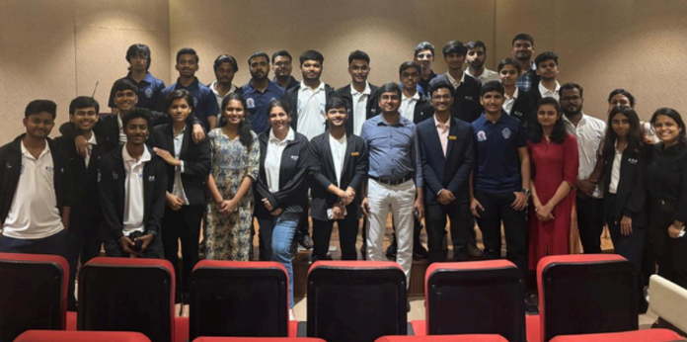

Major Activities & Events

Statewide Outreach & Publicity
Duration: July – October 2024
Publicity was conducted across Marathwada, Pune region, Satara, Sangli, Kolhapur, and in reconnecting with colleges in Nashik, Nagar, Amravati, and Nagpur. The team connected with 15+ E-cells and student activity clubs, building strong relationships with faculty members, Training & Placement Offices, and institutional leaders across Maharashtra.

Inauguration Ceremony
Date: 4th October 2024
Chief Guest: Rahul Rekhawar, IAS
Distinguished Guests: Sanjay Inamdar, Mandar Joshi, Dr. Rajendra Hiremath, Prof. N.B. Dhokey, Dr. V.N. More, and Eaton leadership
The i2i 2024 inauguration was a landmark event that set the tone for the year's innovation journey, bringing together institutional leaders, industry partners, and students committed to social entrepreneurship. 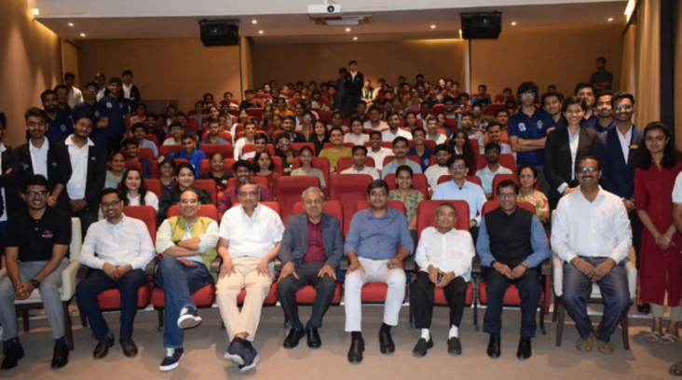

Mentoring & Interactive Sessions
- Insightful session with Dr. Rudiger Lotz, German Consul General.
- Mentoring sessions by Mandar Joshi, Swapnil Mali, and Dr. Vidya More providing strategic direction and strengthening problem-solving capabilities.
- Interactive session with Vice Chancellor Prof. Sunil Bhirud on intellectual property, patents, and transforming academic projects into impactful innovations.
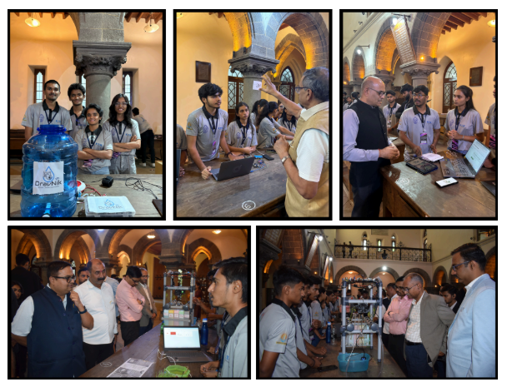

Project Lifecycle
Phase I:
650+ project submissions received from 60+ colleges across Maharashtra.
Phase II:
PPT-based evaluation assessing problem statements, solutions, business models, and funding requirements. 150 projects shortlisted for the next phase.
Phase III:
Shortlisted teams received funding and mentorship from Eaton experts, evaluated on prototype development, teamwork, and execution capability.
Phase IV:
Top 40 projects presented at COEP, with the best 12 projects awarded across sectors.
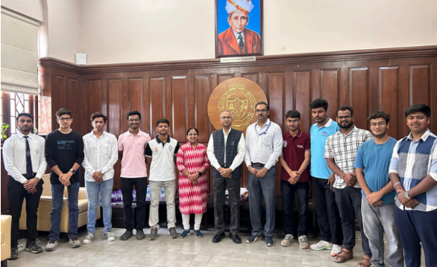

Valedictory Ceremony & Project Exhibition
Dates: 6th – 7th March 2025
Distinguished Guests: Mr. Ketan Deshpande (Founder, FUEL), Mr. Vikas Khule (Engineering Manager, Eaton India), industry leaders, faculty, and students
The two-day valedictory celebration featured startup pitch sessions, a large-scale project exhibition, and interactions with dignitaries. Over 40 visionary projects presented transformative ideas to an expert jury, making the final selection highly competitive. The ceremony concluded with awards honoring innovation, social impact, and ambassador contributions, celebrating months of dedication and execution.

Key Milestones & Achievements
- 650+ project registrations statewide.
- Participation from 60+ colleges across Maharashtra.
- 45+ new colleges connected, expanding the innovation ecosystem.
- 6,000+ students reached through publicity efforts.
- Maximum participation received from the Marathwada region.
- Strong focus on the Agriculture sector alongside six innovation domains.

Awards & Recognition

Best Overall Project
LiftAssist – Developed by students from Dr. Babasaheb Ambedkar Technological University / PVPIT Sangli.

Sector Winners
Environment — Smart Water Management System
Education — Sur Sangam (Indian Music App)
Agriculture — Autonomous Farm Management Setup
3H (Health, Hunger, Humanity) — Health Data Information & Management System
Innovation — Blockchain-enabled Voting System
Entrepreneurship — KrushiSakha

Special Honors
- Best Outside Ambassador – Dyanesh Jawale
- Best COEP Ambassador – Zaid Shaikh & Mihir Khangar
- Best Philanthropist – P.R. Pote Patil College of Engineering and Management, Amravati
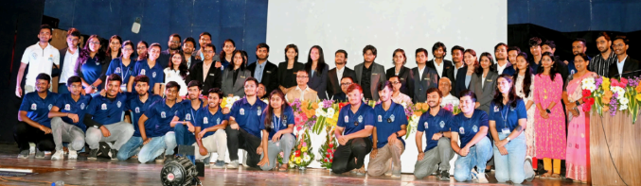

Core Team 2024-25
Publicity Officer: Vikas Kamble
Secretary: Atharva Shingane
Vice Secretary: Ajinkya Gawade
Eaton Relation Heads: Khush Gandhi & Mukul Lohar
Project Management Heads: Vedant Gondhalekar, Ayush Hadge & Aditya Kailaje
Ambassador Relation Heads: Satyajeet Ingle & Aayush Mahind
Web Heads: Mansi Kumar & Skashi Powar
Event Heads: Siddesh Dawange, Mruganksha Kudake & Shubham Dadge
Research Heads: Bhavya Modi & Kunal Chaudhari
Publicity Heads: Poorva Shinde, Aniket Pal, Aditi Verma & Tisya Singh
Design Heads: Jayshree Dhande & Aditya Kasod

