IGNITED INNOVATORS OF INDIA (i2i)
Ignited Innovators of India (i2i) is one of the nation's largest social entrepreneurship communities with a legacy of over 15 years. It is a distinctive initiative of Bhau Institute that operates through a well-defined network of student ambassadors at COEP Technological University and across Maharashtra. Supported by Eaton India Foundation for over a decade, the program provides funding, mentoring, and networking support to student innovators at every stage of their project lifecycle, empowering them to transform ideas into impactful solutions.

Innovation Pipeline
The i2i program follows a structured innovation pipeline:
IDEATE → FUND → BUILD → PRESENT → REWARD

Major Activities & Events (2023–24)

Preliminary Eliminations & Idea Assessment
- Over 400+ ideas were received during preliminary eliminations.
- Around 100+ ideas progressed through assessment stages.
- Approximately 40 projects reached the final stage for evaluation by an experienced jury panel.
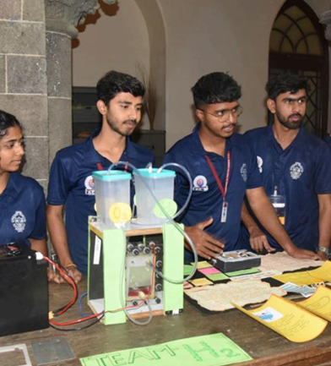
Funding Support
- 100+ projects were selected after rigorous scrutiny.
- Each project received a ₹7,000 allowance to build prototypes and present them within a defined timeframe.
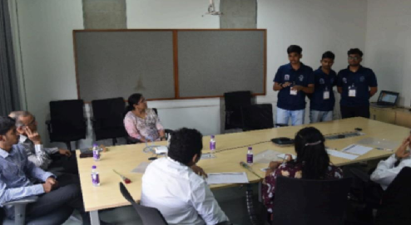
Sector-Based Innovation
Projects were categorized into six major sectors to ensure diversity and breadth of impact:
- Technology
- Agriculture
- Environment
- Education
- 3H (Health, Hunger, Humanity)
- Entrepreneurship
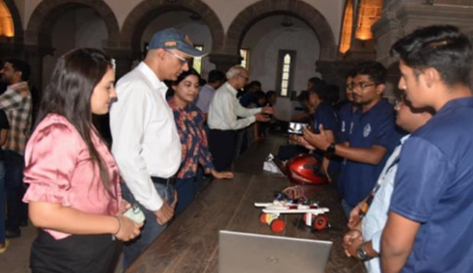

Key Milestones & Achievements
- A total of 436 projects were registered from across Maharashtra.
- After shortlisting, teams were given time to build prototypes, which were then rigorously assessed by a joint team of Eaton mentors and COEP i2i ambassadors.

Awards & Recognition

Sector-Wise Winners
- 3H Sector: MARK 1 – Autonomous Navigation Walker for Elderly and Disabled (Vishwakarma Institute of Technology, Pune)
- Agriculture Sector: IOT Irrigation Monitoring and Control System (P.R. Pote Patil College of Engineering and Management)
- Education Sector: Edict.ai (Vishwakarma Institute of Technology, Pune)
- Entrepreneurship Sector: Smart Medicine Box (COEP Technological University)
- Environment Sector: GC Recycling (Government College of Engineering and Research, Awasari Khurd)
- Technology Sector: Anti-toppling System for Heavy Weights (Vishwakarma Institute of Technology)

Overall Honors
- Best Overall Project: IOT Irrigation Monitoring and Control System
- Best Outside Ambassador: Shreyash Meshram
- Best Outside Faculty Coordinator: Akshay Pundkar
- Best Philanthropist: PR Pote College of Engineering, Amravati
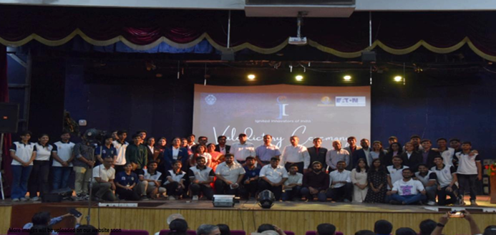

Testimonials & Impact
Participants and mentors highlighted the platform as life-changing, emphasizing leadership development, collaboration, and the opportunity to become social entrepreneurs capable of driving meaningful societal change.
Mentors appreciated the strong coordination by ambassadors and the high technical acumen demonstrated by student teams throughout the program.

Core Team Members (2023–24)

Role | Name
Faculty Advisor | Dr. V. N. More
Publicity Officer | Vikas Kamble
Secretary | Saket Kaswa
Vice Secretary | Shubham Gupta
Publicity Head | Jishan Pathan
Eaton Relations Head | Shruti Ravichandran
Research Head | Shravani Sardeshmukh
Ambassador Relations Head | Prathamesh Agawane
Project Management Head | Vadiraj Joshi
Design Head | Viral Shah

