Ignited Innovators of India (i2i)
- About i2i
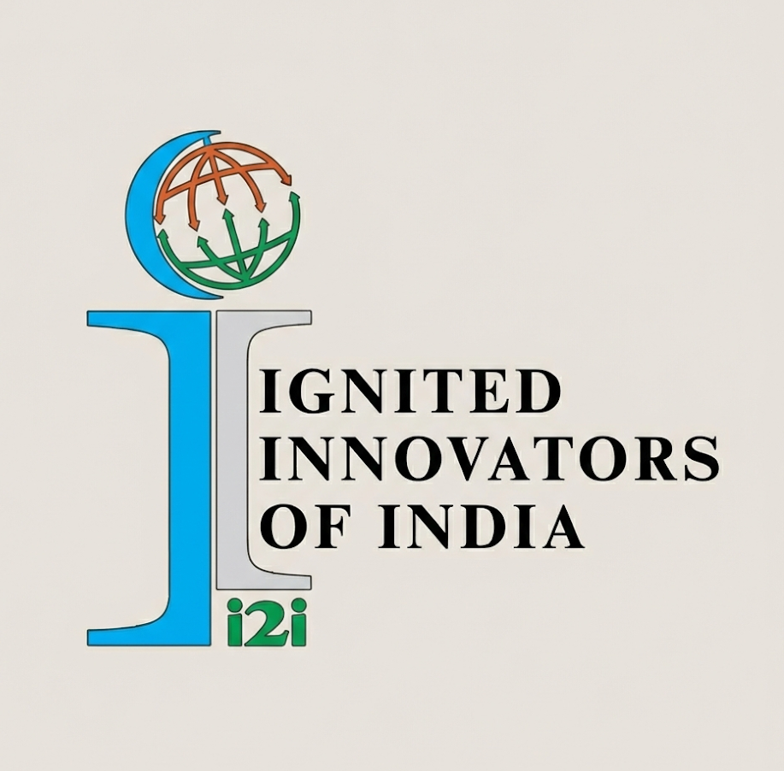
Ignited Innovators of India (i2i) is a flagship techno-social innovation initiative rooted in COEP’s Bhau Institute and supported by the Eaton India Foundation. Inspired by the vision of Bharat Ratna Dr. A.P.J. Abdul Kalam, i2i nurtures student innovators by encouraging them to identify real societal challenges and transform ideas into impactful solutions through mentorship, funding, and industry collaboration. Now in its 15th year, i2i continues to serve as a beacon for social entrepreneurship, fostering leaders who create meaningful change across Maharashtra.

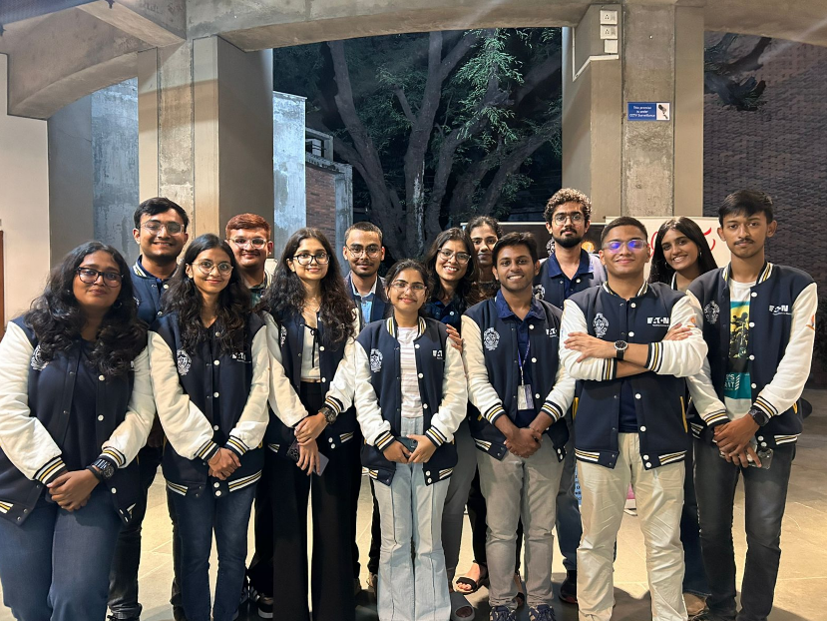

Major Activities/Events conducted
Project Lifecycle
- Phase I: Project submissions from 100+ colleges across Maharashtra.
- Phase II: PPT-based evaluation assessing problem statements, solutions, business models, and funding requirements; 150 projects shortlisted.
- Phase III: Shortlisted teams received funding and mentorship from Eaton experts and were evaluated on prototype development, teamwork, and execution.
- Phase IV: Top 40 projects presented at COEP, with the best 12 projects awarded across sectors.

Publicity, Outreach and Out-Campus Ambassador Program
The publicity campaign, conducted primarily during August and September, adopted a hybrid approach combining strategic calling, offline visits, and targeted follow-ups to maximize engagement. Outreach covered leading Pune institutions, alongside regional visits to Nashik, Chhatrapati Sambhajinagar, Baramati, Dadar, Ganpatipule, Ratnagiri, and Alibaug—significantly strengthening i2i’s visibility across Maharashtra.
To further expand its reach, i2i introduced the Out-Campus Ambassador Program, forming a dedicated team of 40 ambassadors across the state. Acting as institutional representatives, these ambassadors actively promoted i2i within their colleges, connected new institutions, and served as a vital communication bridge—creating a decentralized and highly effective outreach network.
Impact and Achievements
The 2025–26 outreach campaign delivered remarkable results, reflecting i2i’s expanding credibility and influence:
- 700+ total registrations demonstrating strong growth in both quantity and social relevance of projects.
- 300% increase in registrations from COEP over the previous year.
- Collaboration with 20+ E-Cells and student activity clubs to strengthen the innovation ecosystem.
- Contact established with 300+ colleges, with campaigns conducted in around 100 institutions, leading to 25 new colleges joining i2i.
- Outreach extended to 10,000+ students across Maharashtra.
- Successfully connected with 26 new diploma colleges under MSBTE, expanding grassroots innovation.
Collectively, these achievements signal a transformative year for i2i, defined by scale, diversity, and rising student participation.

Inauguration Ceremony: i2i 2025–26
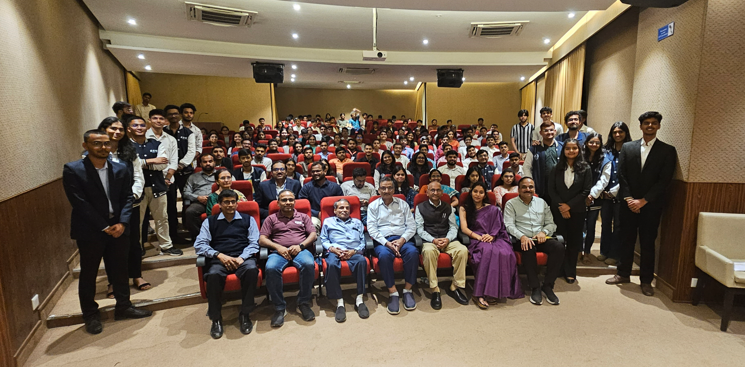
The academic year was formally inaugurated on 29th September 2025 at Bhau Institute, coinciding with the celebration of 15 years of i2i—a milestone reflecting a legacy of empowering student innovators.
The event hosted distinguished dignitaries including Mr. Prashant Sangule (Engineering Manager, Eaton India Innovation Center), Dr. Rajendra Hiremath (Chairman, Bhau Institute), Dr. Prakash Dhoka (Founder & Managing Director, Industrial Metal Powders India Pvt. Ltd.), Prof. Sanjay Inamdar (Co-Founder, Bhau Institute and Founder, i2i), Prof. Sunil Bhirud (Vice Chancellor, COEP Technological University), and Ms. Ishwari Chandekar (HR Business Partner, Everest Technical Services).
The unveiling of new i2i trophies symbolized excellence and motivation for the year ahead, while the induction student innovators as Ambassadors, set the tone for a year centered on leadership, creativity, and social impact.

Social Media & Digital Presence
- Digital Growth & Reach: i2i recorded 300,000+ Instagram content views during the academic year and achieved 100% growth on LinkedIn, significantly strengthening its digital visibility and professional network. The launch of the official YouTube channel further expanded outreach through structured long- and short-form content.
- Startup Success Stories & Apno Ka Innovation: The Startup Success Stories series was introduced to inspire student innovators through real-world brand journeys, while Apno Ka Innovation was successfully implemented to showcase top projects and prototypes, enhancing recognition and motivating future participants.
- Apno Wali Diwali: This social impact campaign encouraged students to support local artisans by purchasing handcrafted products, promoting community engagement, responsible celebrations, and the spirit of social entrepreneurship beyond campus.
- Apno Ka Safar (Upcoming): Currently in development, this mentor-led podcast series will feature industry professionals sharing their experiences and insights, aiming to bridge the mentor-student gap and create a continuous learning resource for innovators.
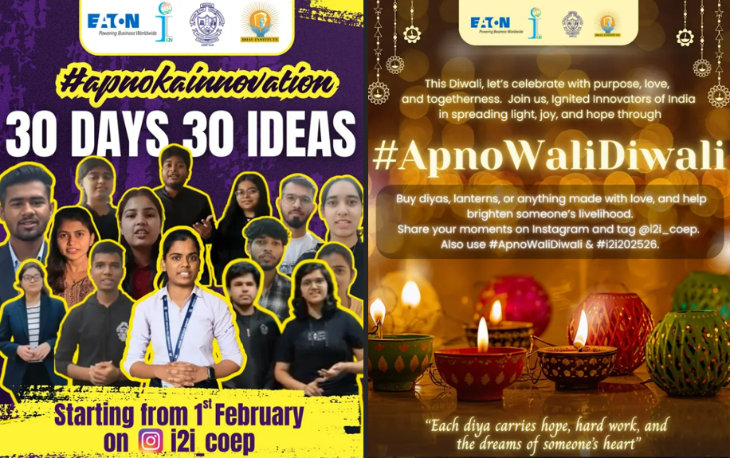

Current Phase and Plan of Action Ahead
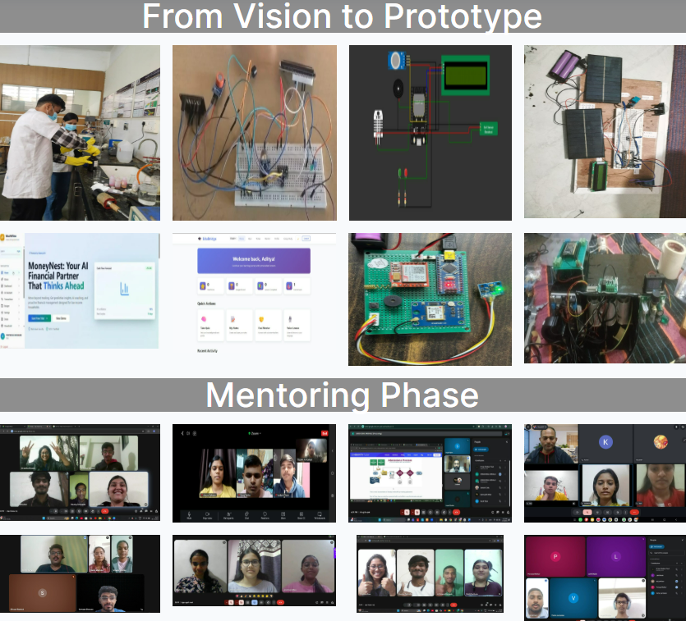
i2i is currently progressing towards Phase IV, where the top prototypes emerging from the funding and mentorship stage will be shortlisted and invited to COEP Technological University for final presentations at the Valedictory Ceremony scheduled on 24th and 25th March 2026, offering innovators a prestigious platform to showcase their solutions to industry leaders, academicians, and the innovation community.
The academic year 2025–26 reflects a defining phase in i2i’s journey—characterized by expanded outreach, digital transformation, stronger industry engagement, and innovative learning initiatives. As i2i celebrates 15 years of impact, it continues to empower young innovators to transform ideas into action and contribute meaningfully to society. With sustained mentorship, strategic collaborations, and a growing innovation network, i2i is poised to shape the next generation of social entrepreneurs across Maharashtra.
Leadership & Institutional Support:
- Prof. Sanjay Inamdar – Co-Founder, Bhau Institute and Founder, i2i
- Dr. Sunil Bhirud – Vice Chancellor, COEP Tech
- Dr. S. P. Mahajan – Director, RIIL
- Dr. V. N. More – Faculty Advisor, i2i
- Mandar Joshi – CEO, Bhau Institute
- Swapnil Mali – AGM, Bhau Institute

- Core Team:
- Publicity Officer: Vikas Kamble
- Secretary: Aditya Kasod
- Eaton Relations Heads: Mihir Khangar & Tanvi Amin
- Project Management Heads: Tanishqa Chopade & Nirvan Mehta
- Ambassador Relation Heads: Amaan Mulla and Aditi Jadhav
- Web Head: Nandini Kharche
- Event Heads: Karan Patil and Srushti Patil
- Research Heads: Angad Mahana and Zaid Shaikh
- Publicity Heads: Swayam Gandhewar & Manaswi Bele
- Design Heads: Priyanshi Pawar & Harshada Nikam

