Drama and Films Club 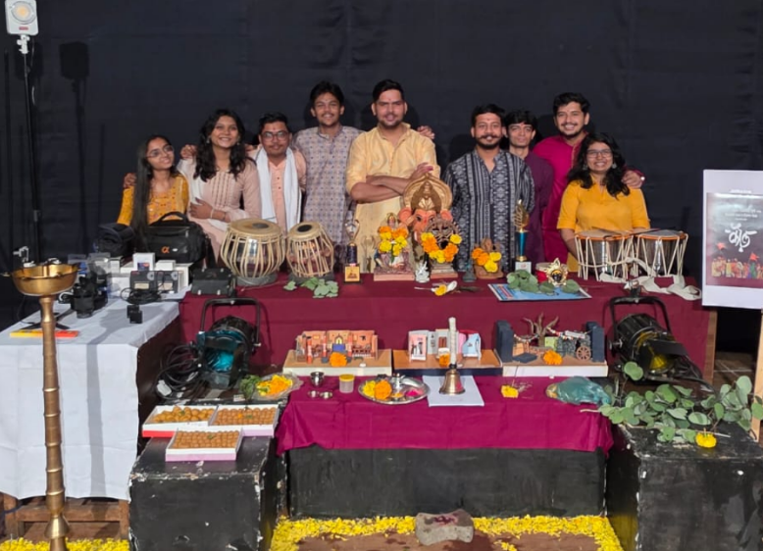

Major Activities
During the academic year 2025–2026, the club actively engaged in theatre productions, film projects, music releases, and creative documentation.
The film wing released the short film It’s a Match on YouTube, which explored contemporary relationships and provided members with hands-on experience in acting, cinematography, editing, and production workflows. Another short film, Life, is in its final stage and scheduled for release, with plans to represent COEP at upcoming national film festivals.
The club produced the folk-art-based music video Dashavatar, celebrating traditional Maharashtrian cultural heritage through cinematic storytelling. Additionally, a behind-the-scenes documentary titled The Making of Dear Tirtharoop was created to document the creative and production journey of the theatre team.
In theatre, the club achieved a significant milestone by representing COEP at the 64th Maharashtra Rajya Natya Spardha, performing the two-act play Dear Tirtharoop at Bharat Natya Mandir, Pune. The production received appreciation at the state level and is being staged for multiple shows during the COEP Annual Gathering.
The club also released the official Title Track of Dear Tirtharoop, strengthening its musical portfolio and contributing to promotional outreach.
A major institutional achievement during the year was the signing of a Memorandum of Understanding (MoU) with the newspaper Dainik Punya Nagri, establishing it as the official media partner of the club and enhancing public visibility for all major productions.


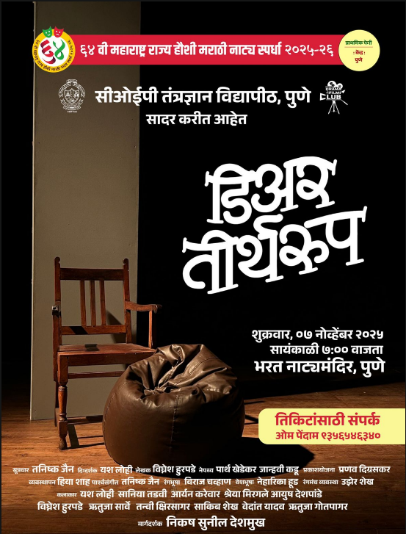
Key Milestones / Achievements
• Successful participation in 64th Maharashtra Rajya Natya Spardha (state-level theatre competition)
• Performance of Dear Tirtharoop at Bharat Natya Mandir, Pune
• Release of short film It’s a Match on YouTube
• Upcoming short film Life selected for future festival representation
• Release of folk-art music video Dashavatar
• Production of documentary The Making of Dear Tirtharoop
• Official Title Track of Dear Tirtharoop released
• Signing of MoU with Dainik Punya Nagri for media partnership
• Multiple successful live shows of Dear Tirtharoop during COEP Gathering

Core Team Members
Tanishque Jain – Secretary
Yash Lohi – Director
Harshvardhan Diwate – Director of Photography
Heads of Departments:
Tanishque Jain – Music
Aryan Karewar – B.Tech Head
Parth Khedekar – B.Tech Head

Ayush Deshpande – Acting
Neharika Hood – Acting,Design & Social Media
Vighnesh Hurpade – Scriptwriting, Editing
Janhavi Kadu – Production & Set Design
Hiya Shah – Finance & Documentation

