YOUTH EMPOWERING CENTRE (YEC)
The Youth Empowering Centre (YEC) had an impactful year in 2024-25, fostering personal growth, leadership, and social responsibility through various initiatives. The centre continued its mission of nurturing the inner potential of students through mindfulness, reading, digital wellness, and community engagement.

Events and Activities

1. Visit to Niwara Old Age Home
The year began with a heartfelt visit to Niwara Old Age Home, where YEC members spent meaningful time with elderly residents. The visit promoted empathy and social bonding, reinforcing the centre's commitment to community welfare and compassion.
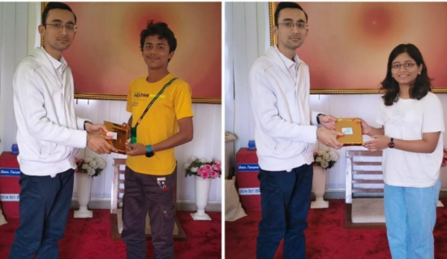

2. Mindfulness Drive for Freshers
Date: 15th October 2024
Venue: In front of E&TC Extension Building
Participants: 300+
As part of 'Freshers Fiesta', the Mindfulness Drive engaged over 300 first-year students in self-reflection and mindfulness practices. The event consisted of thoughtfully planned value games followed by a group competition aimed at team building.
Value Games:
- Dear Tomorrow — participants wrote letters to their future selves (150 letters collected), setting personal goals and reflecting on their current mindsets.
- Mirror and Share — an ice-breaking activity where students exchanged handwritten blessing cards and personally thanked the writer, spreading positivity and gratitude.
- The Game of Powers — participants matched eight spiritual powers (e.g., power to withdraw, power to tolerate) with corresponding images, exploring personal and spiritual development in a fun way.
- Gratitude Board — participants wrote what they were grateful for, deepening the mindfulness experience.
The Group Competition saw 28 groups compete across four rounds. Three winning groups were felicitated with Gratefulness Diaries and special handcrafted trophies.

3. NIRMAN Camp Introduction by Amrut Bang
A key highlight of the year was the visit by Amrut Bang, who introduced YEC to the NIRMAN Camp — a prestigious program inspiring members to explore social leadership and nation-building. The interaction motivated YEC members to look beyond campus and engage with larger societal challenges.

4. Reading Inspiration 2025
Date: 2nd January 2025
Venue: YEC Main Building (Top Floor)
Conducted under: Vachan Sankalp Maharashtracha Initiative (Government of Maharashtra)
Reading Inspiration 2025 aimed to inspire and instill a habit of reading among participants, bringing readers together to share ideas and celebrate the joy of books.
Reading Marathon (11:30 AM – 1:30 PM):
Participants chose books from four curated sections — Spirituality, Biographies, Inspirational Stories, and Self-Development — and read in a quiet, phone-free environment for two focused hours.
Storytelling Competition:
After reading, participants crafted short stories or shared key lessons from their books. The competition was judged by Harshal Atmaramani — ANANTA Aspen Emerging Leaders Fellow, Facilitator, and Rajyoga Meditation Counselor. All participants were felicitated with a pen and a blessing card; winners received diaries.
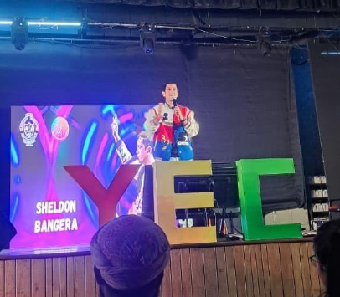

5. Digital Wellness Stall – Pune Startup Fest 2024
Date: 11th and 12th January 2025
Venue: Stall No. 92 & 95, near Main Building
Participants: 1,000+
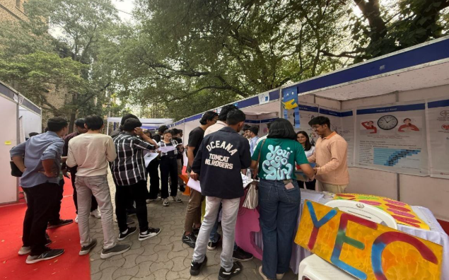
At Pune Startup Fest 2024, YEC's Digital Wellness Stall raised awareness on digital addiction, reaching over 1,000 students. The stall featured informative posters and value-based games, and introduced key concepts such as neuroplasticity and 'brain switching penalty' to help visitors understand the cognitive effects of gadget addiction.
Visitors received an assessment form to evaluate their digital addiction levels, and were given a 7-week Digital Wellness Plan with actionable steps to minimize unnecessary screen time. The initiative was supported by posters provided by the Brahma Kumaris, and was well appreciated by faculty, alumni, and investors.
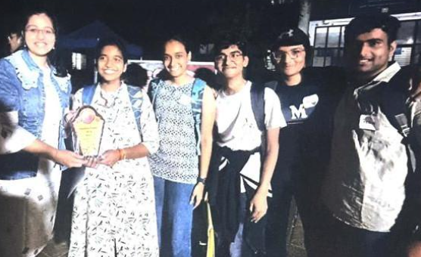

6. YEC 2nd Anniversary Celebrations
Celebrating its 2nd anniversary, YEC hosted enriching sessions on goal-setting, resilience, and overcoming challenges, including:
- 'How to Be a Winner' — session on mindset and achievement.
- 'How to Help Back with a Setback' — resilience and recovery.
- Addiction Awareness Discussion.
- Musical Healing Session — promoting emotional well-being through the power of music.

