YOUTH EMPOWERING CENTRE (YEC)
Vision: To empower youth to be the embodiment of virtues to build a world of love, peace and happiness through the means of Science and Spirituality.

Mission:
- To create spiritual ambience for learning meditation and experiencing inner peace.
- To fulfil the divine potential; amplifying the inner powers.
- To realize the true human nature and nourishing the core innate values.
- To create zeal, enthusiasm, love and happiness among relationships.
- To provide a platform for research on spiritual dimensions of life.
- To empower youth at thought level, increasing focus, efficiency and effectiveness.
- To enable and empower individuals to regulate their thoughts, feeling, and emotions by self-management trainings.
- To create a better world of love, peace and happiness to live.

Events and Activities

1. Get-Together – Core Team Formation
Date: 7th February 2023
Participants: 30+
Guests: Mr. Mukul Pal Choudhary (GM, Training Academy, multinational car manufacturing group); Dr. Mukesh Motwani (IT Consultant, US & UK)
The inaugural get-together was intended to form the YEC Core Team and was appreciated by the Vice Chancellor, HoDs, Professors, and students. The event was enriched by empowering guest talks that benefited 30+ students.
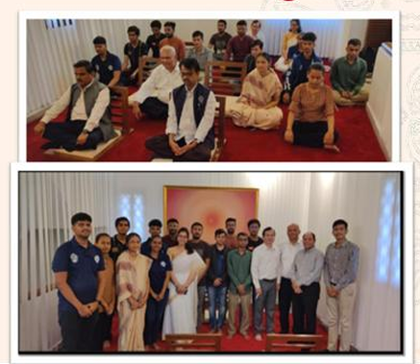
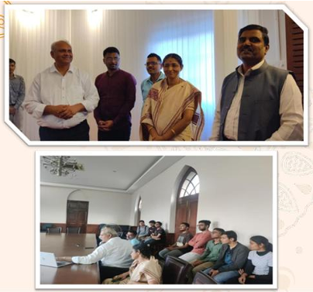

2. 'Remaining Calm in Crises' Talk
Date: 11th February 2023
Speaker: Charlie Hogg (International Speaker, Australia – 45+ years Rajyoga practitioner)
Chief Guest: Vice Chancellor Dr. Mukul Sutaone
Participants: 500+
The talk aimed to create awareness about Rajyoga meditation and its ability to help individuals stay calm and centered in challenging or critical situations. Charlie Hogg has helped transform the lives of millions of people worldwide. The event was glorified by Vice Chancellor Dr. Mukul Sutaone's presence, and was attended by Directors, Principals, Heads of Institutes in Pune, Directors of Technical Education and Higher Education, teachers, researchers, and working professionals.
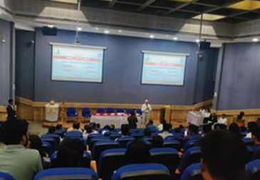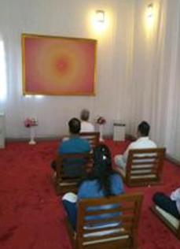

3. Visit by Pattern Team from the US
Date: 28th February 2023 (Evening)
Jason Wells (Chief Technology Officer at Pattern, Brigham Young University Lehi, Utah, USA), David Wright (Co-Founder & CEO at Pattern), and Aaron Smith (Chief Product Officer at Pattern), along with the Training and Placement Head Raju Sir and Professors from various departments, visited the Youth Empowering Centre and appreciated the steps taken by the students and the university.
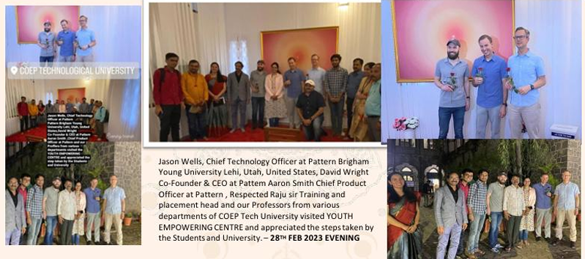
4. Visit by Brother Jitendra, Mt. Abu
Date: 28th February 2023
National Executive Committee member of Youth Wing Rerf, Brother Jitu visited the Youth Empowering Centre and conducted a mindful activity for the students in association with Science Club students.
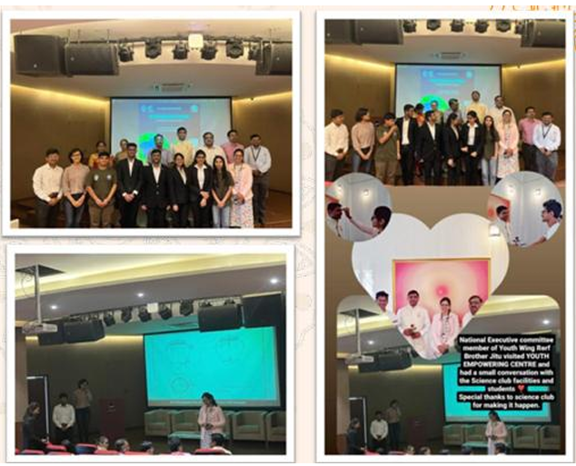

5. YEC Promotional Event – Pune Start Up Fest Valedictory
Date: 12th March 2023
A promotional event of YEC was held at the Valedictory Session of the Pune Start Up Fest in the Auditorium, helping expand YEC's reach and visibility across the startup and entrepreneurship community of Pune.
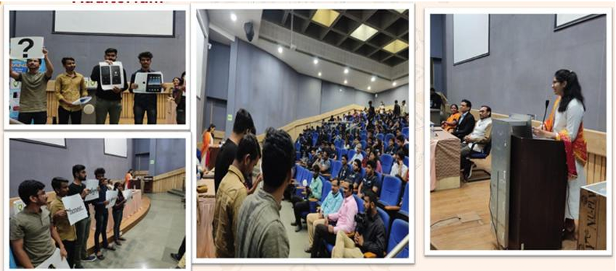

6. Inauguration Ceremony of YEC
Date: 19th March 2023
Venue: Mini Auditorium
Chief Guest: Hon. Prof. Anil Sahasrabudhe (Chairman, National Educational Technology Forum – NETF)
Topic of Discussion: Leadership in Youth is Life
The formal inauguration of the Youth Empowering Centre was presided over by the honourable Prof. Anil Sahasrabudhe, graced also by Prof. Mukul Sutaone (Vice Chancellor), Prof. B.G. Birajdar (Faculty Advisor, Chief Rector), and Dr. M.P. Khond (Director, Student Development).
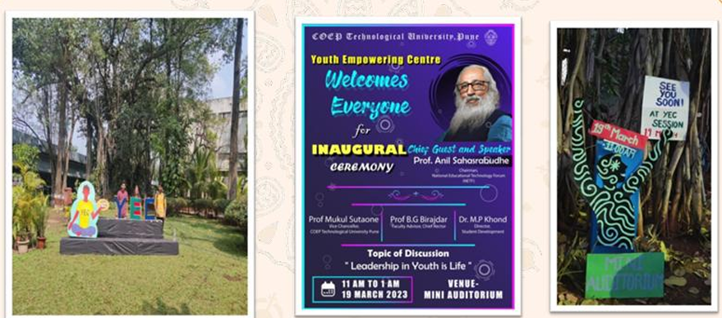

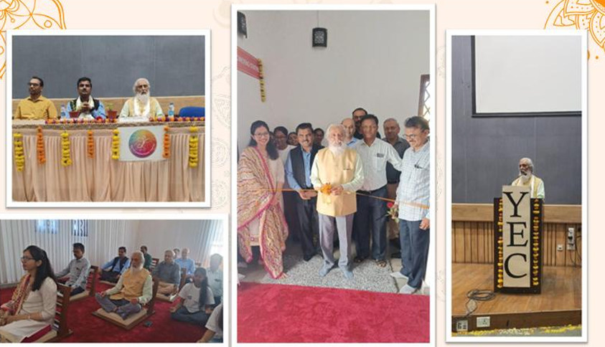
7. Meditation Session for Army Family
Date: 20th March 2023
A special meditation session was organized at the Youth Empowering Centre for Indian Army personnel and their families, who visited COEP Tech and participated in the mindfulness activity — reflecting the broader outreach of YEC beyond the campus community.
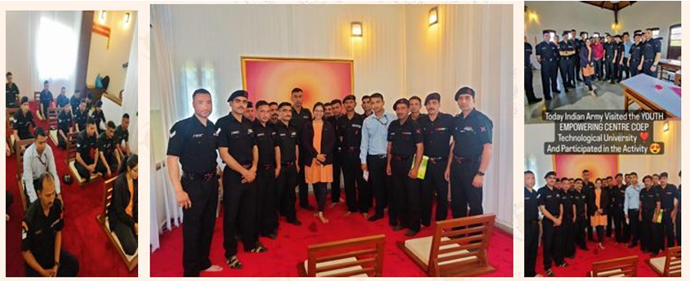

8. Train the Trainer – 2 Days Workshop
Dates: 27th and 28th March 2023
Venue: Kirloskar Auditorium
Participants: 60+
Facilitator: Datta Rokade (Personal Empowerment Coach, 13 years)
The 2-day workshop on creative meditation covered: improving retention power, how to stay focused, enhancing creativity, reducing stress, and how to sleep better. The program aimed to expand students' skillsets and improve overall well-being.
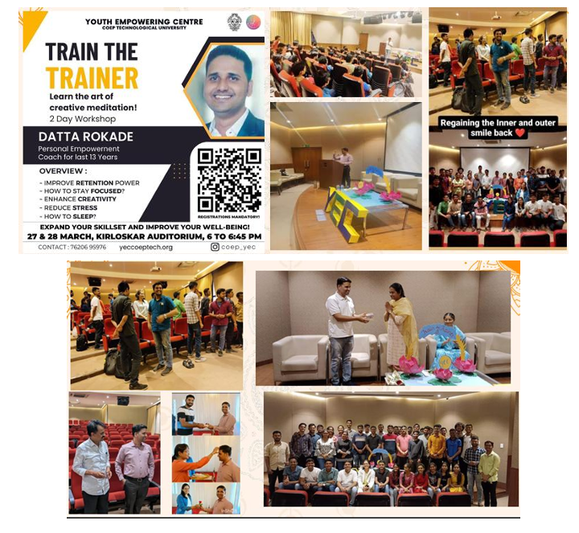

9. Association with Y20 – Youth Chaupal
Date: 10th April 2023
Venue: Kirloskar Auditorium
Participants: 50+
Chief Guests: Mr. Kunal Tilak (Y20 India Chair) and Mr. Sanmay Paranjape (Founder, India Khelega)
YEC collaborated with Y20 (India's G20 engagement group for youth) to organize a Youth Chaupal on the topic 'Participation of Youth in New India'. Mr. Kunal Tilak — the youngest delegate to represent India as an official election observer for the US Presidential Elections and an LLM graduate from the University of Strathclyde — and Mr. Sanmay Paranjape, an international table tennis player coach, led the inspiring discussions.
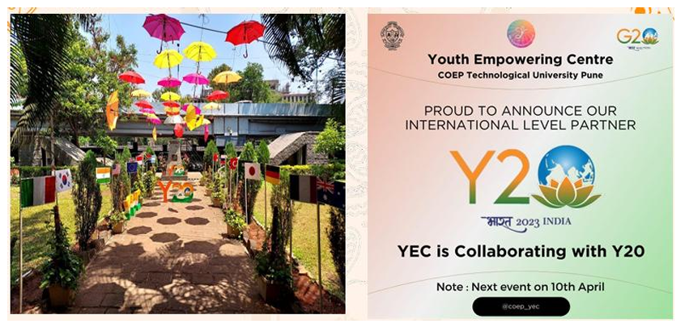

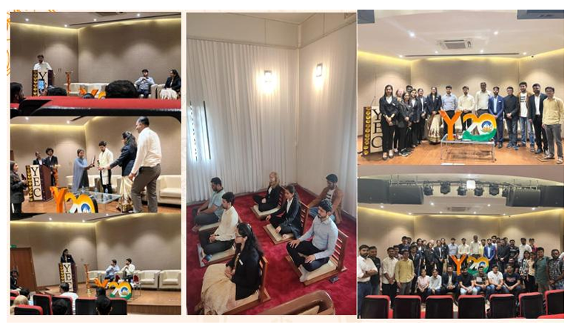

10. National Civil Service Day and Earth Day Celebration
Date: 21st April 2023
Chief Guest: Mr. Anil Kawade (Commissioner Cooperation)
YEC celebrated both National Civil Service Day and Earth Day (22nd April) together, with activities including placing bird feeders in the college campus and organizing Tug of War, Open Quiz, and other energetic campus activities at the Hostel Ground.
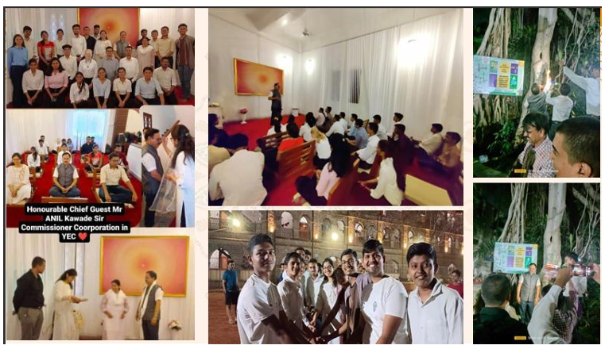

11. World Environment Day Celebration
Date: 5th June 2023
YEC organized a large-scale tree plantation drive on World Environment Day, planting 100+ trees at the Hostel Campus. The event was supported by faculty and students alike and served as a strong environmental commitment by the centre.
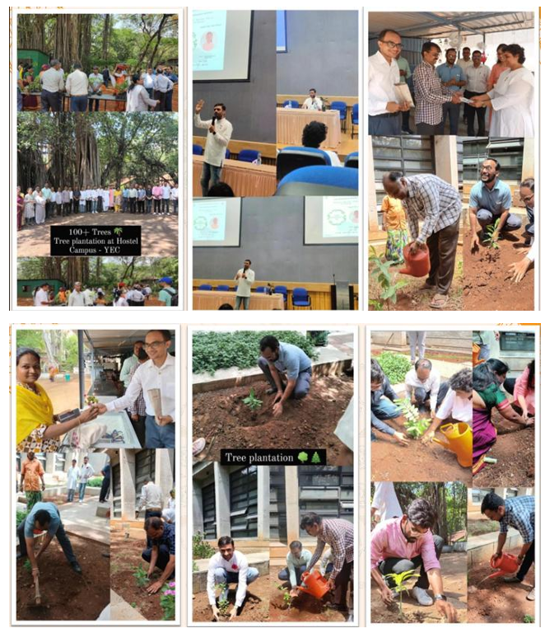

12. Y20 Talk – Inner and Outer Technology: Future of Work Industry 4.0
Date: 21st July 2023
Venue: COEP Tech University
Speakers: Mr. Amol Ravetkar (MD, Traveller Group); Adv. Maitreye Bagul (Research Associate, Y20); Mr. Sateesh Jain (Founder, ERP Solutions)
In association with Y20 and PVG's COEP & GKPIOM, Pune, this talk explored Future of Work, Industry 4.0, Innovation and 21st Century Skills. The session combined perspectives on inner technology (self-management) with outer technology (AI, automation, Industry 4.0) for a holistic view of the future.
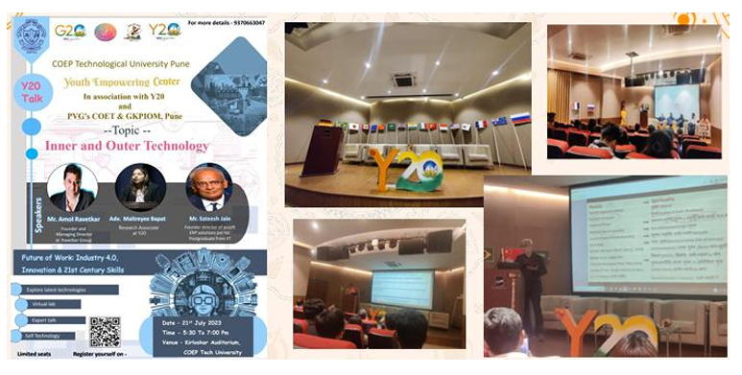

13. 2 Days Y20 Model Summit
Dates: 29th and 30th July 2023
In association with the Y20 Team, YEC organized a 2-day Model Y20 Summit covering themes such as Future of Work, Peace Building and Reconciliation, Climate Change, Mental Future of Health, and Digital Economy and Shared Opportunities for Youth.
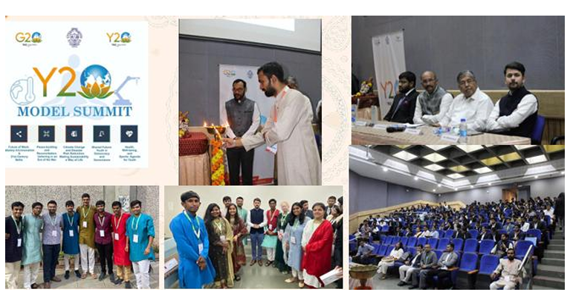

14. Engineer's Day – Fresher's Fiesta
Participants: 700+
YEC organized a Techno-Spiritual (Value-Based) Exhibition for incoming first-year students on Engineer's Day, welcoming them with an immersive experience that combined technological awareness with inner development values. The event saw an extraordinary participation of 700+ students.
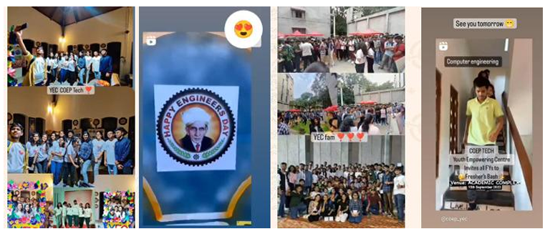

15. Cyclothon – Understanding Cycle of Thoughts
Date: 8th October 2023
Participants: 500+
A Cyclothon was organized with the theme 'Understanding Cycle of Thoughts', creatively linking the physical activity of cycling with the introspective practice of understanding thought patterns. The event saw enthusiastic participation of 500+ students.
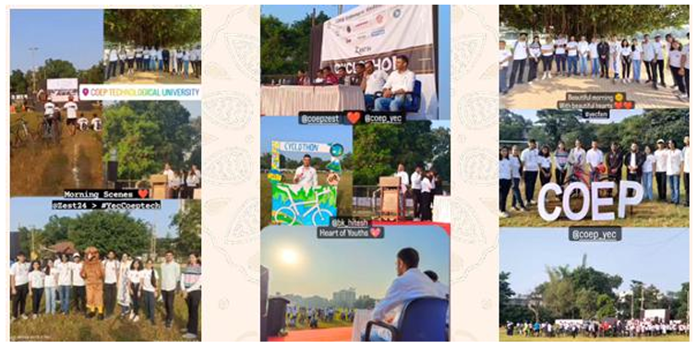

16. Mind Stability and Inner Beauty – Talk by BK Shivani
Date: 18th December 2023
Venue: Main Auditorium, COEP Tech
BK Shivani, one of India's most beloved spiritual teachers and motivational speakers, addressed the COEP community on Mind Stability and Inner Beauty. The event drew a packed auditorium and was received as a deeply inspiring and transformative experience by students, faculty, and guests.
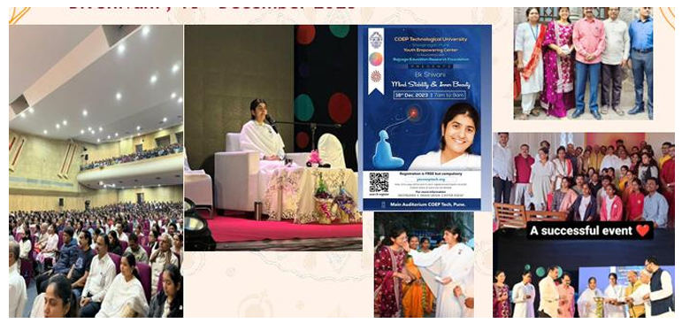

17. Educational Tour to Mt. Abu
Dates: 19th – 26th December 2023
Participants: 120 students and 7 faculty members
YEC organized an educational tour to Mt. Abu, the spiritual headquarters of the Brahma Kumaris World Spiritual University. 120 students and 7 faculty members experienced the serene spiritual atmosphere, meditation sessions, and guided self-discovery programs at the global campus, making it one of the most immersive and transformative YEC activities of the year.
