VOLLEYBALL CLUB
Volleyball continues to be one of the most dynamic and well-coordinated sports at COEP Technological University. During the academic year 2025-26, the volleyball section placed strong emphasis on enhancing technical skills, building teamwork, and improving competitive readiness. Regular practice sessions, match simulations, and fitness training were conducted to elevate overall performance and strengthen on-court communication. Focus was also given to developing emerging players and ensuring sustained growth of volleyball at COEP.

Practice Matches

1. COEP vs IISER, Pune
Date: 4th October 2025
Result: COEP Win
The COEP volleyball team played a practice match against IISER Pune, providing valuable exposure to assess coordination, strategy, and overall match readiness. The team demonstrated effective serving, precise setting, and powerful spiking, along with a well-organised defence. The match contributed to improving team synergy and refining on-court communication and gameplay strategies.
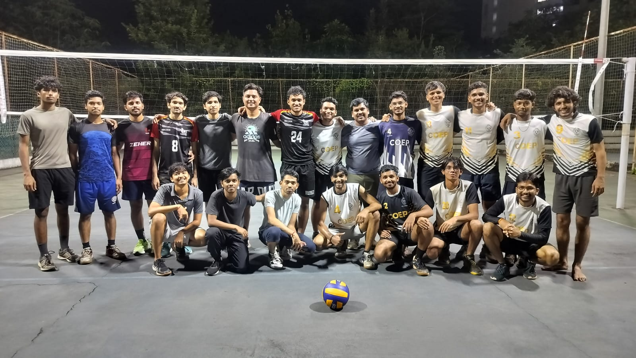

2. COEP vs NICMAR
Date: 12th October 2025
Result: COEP Win
The COEP volleyball team played a practice match against NICMAR, showcasing strong serving, accurate setting, and effective attacking skills, along with a disciplined defensive approach. The match helped enhance team coordination and refine on-court communication and overall gameplay.

3. COEP vs FLAME University
Date: 4th November 2025
Result: COEP Win (Boys & Girls)
Both the COEP boys and girls volleyball teams played practice matches against FLAME University. Both teams showcased strong serving, precise setting, and effective attacking skills, along with disciplined defensive play, resulting in impressive performances for both sides. The matches contributed to improving team coordination and refining on-court communication for both squads.
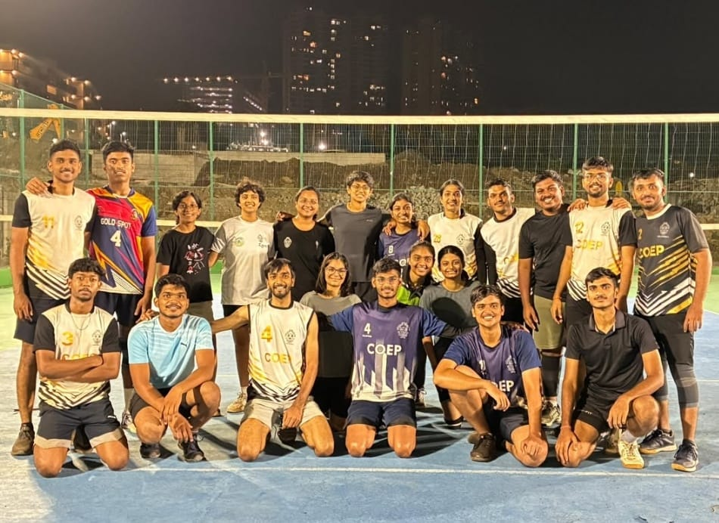

Tournament Performances

1. Rajashri Shahu Maharaj Krida Mahotsav 2026 [AISSMS] – Boys Team
Date: 5th February 2026
Stage: Semi-Finals
The COEP boys volleyball team delivered a commendable performance at the Rajashri Shahu Maharaj Krida Mahotsav 2026, reaching the semi-finals of the tournament. The team showcased strong coordination, effective attacking, and consistent defensive play throughout their matches. Their disciplined approach and strategic execution were key factors in their successful run.
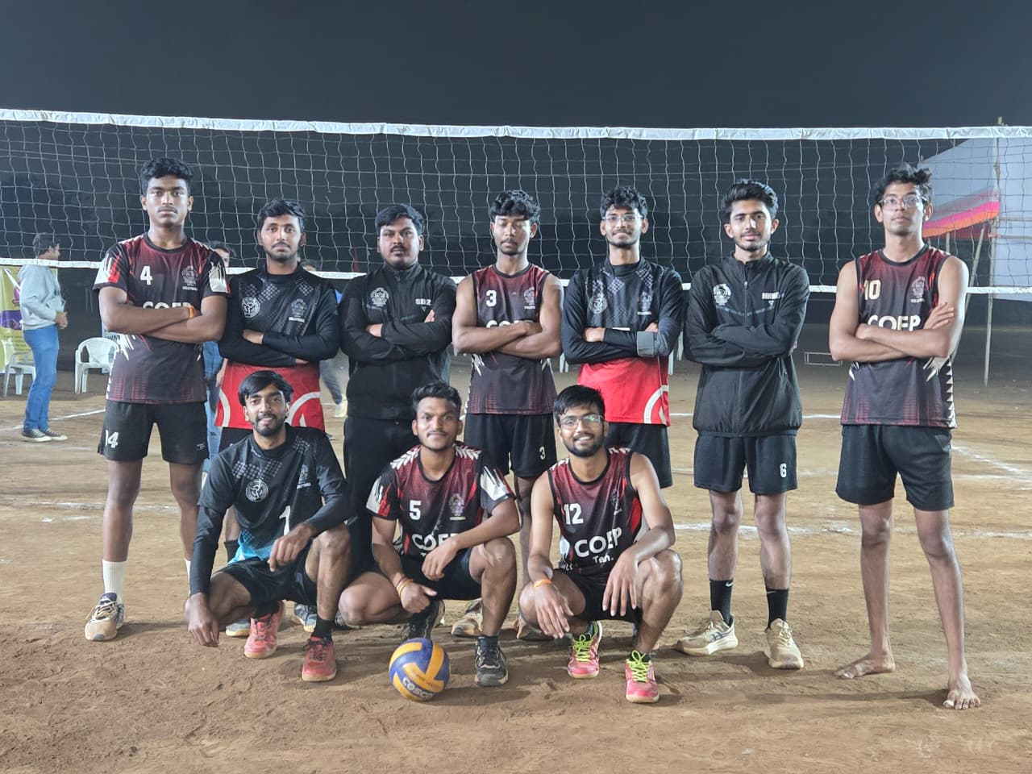

2. ELEVATE 2026 [PICT] – Girls Team
Date: 16th February 2026
Stage: Quarter-Finals
The COEP girls volleyball team delivered a commendable performance at the Elevate Tournament organized by PICT College, reaching the quarter-finals. The team showcased strong coordination, effective attacks, and consistent defensive play throughout the competition. Their disciplined approach and teamwork contributed to their steady progress in the tournament.
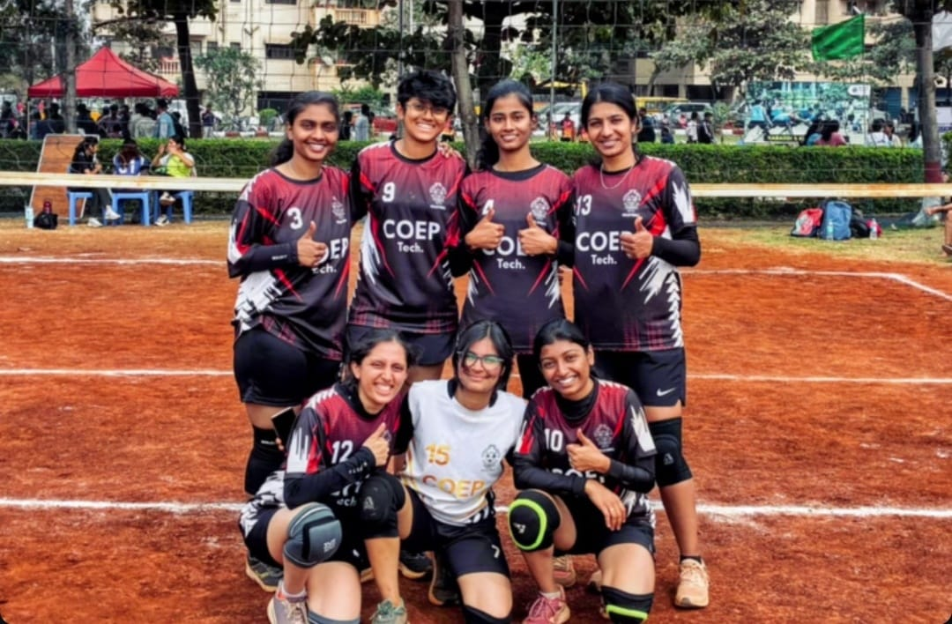

3. ZEST '26 – Boys Team
Date: 25th February 2026
Stage: Semi-Finals
The COEP boys volleyball team delivered a strong performance at ZEST '26, reaching the semi-finals of the tournament. The team displayed excellent coordination, powerful spiking, and solid defensive skills in crucial matches. Their consistent efforts, strategic gameplay, and determination were evident throughout the competition.

4. ZEST '26 – Girls Team
Date: 25th February 2026
Position: Runner-Up
The COEP girls volleyball team secured the Runner-Up position at ZEST '26, showcasing impressive performance and determination throughout the tournament. The team demonstrated strong coordination, effective communication, and consistent gameplay in all matches, reflecting their growing competitive strength.
