TELEMATCHES
96th COEP Regatta
Telematches is a flagship fire-based water showcase event of the COEP Regatta, known for its synchronized fire and firecracker effects executed by teams seated in boats. The event combines precision, coordination, and disciplined execution, making it one of the most impactful visual attractions of Regatta.

Theme – Bhagavad Gita
For the 96th COEP Regatta, Telematches was presented as a theme-based performance inspired by the Bhagavad Gita. The philosophical essence of duty, discipline, righteousness, and inner conflict was reflected through symbolic use of fire, structured boat movements, and carefully timed firecracker sequences.

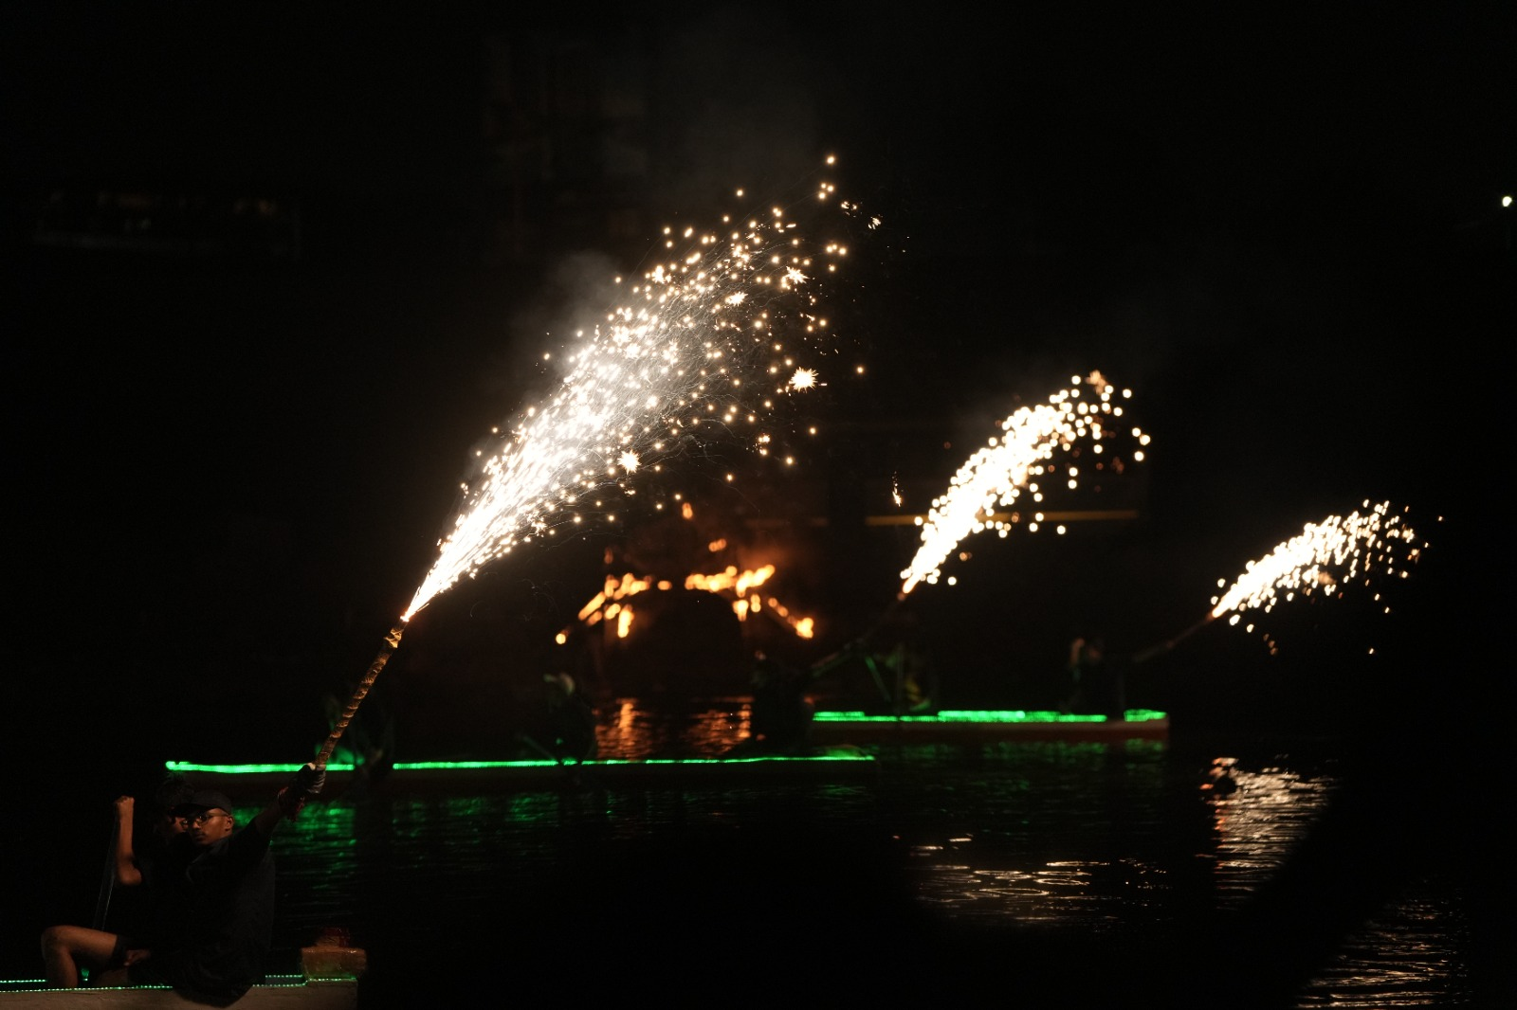

Narration and anchoring supported the on-water performance, allowing the theme to be conveyed clearly to the audience while retaining the traditional intensity of Telematches. The combination of philosophical depth with the visual spectacle of fire and water created a memorable and meaningful performance for all attendees.

Organizing Team
Secretary: Tanvi Lad

Telematches Organisers:
- Aashutosh Raut
- Deep Oak
- Hrutuja Pawar
- Paarth Bhagwat
- Tanmay Chhatre
- Sankalp Patil

