SPANDAN CLUB
Spandan Club at COEP Technological University is a social responsibility and community engagement club dedicated to making a meaningful positive difference in the lives of the people around it. Through a range of initiatives spanning elderly care, blood donation, village development, donation drives, and cultural awareness, Spandan consistently embodies the values of compassion, camaraderie, and service.

Activities and Events

1. Visit to Ananddham Old Age Home
Date: 23rd May 2023
Spandan members organized an interactive and heartfelt visit to Ananddham Old Age Home, conducting engaging activities that fostered warm connections and spread joy among the elderly residents. The visit reflected the club's core commitment to acknowledging and appreciating the senior citizens of our community.
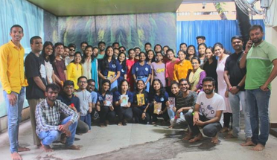
2. Rakshabandhan Celebration
Date: 2nd September 2023
Spandan celebrated Rakshabandhan by exchanging handmade rakhis, symbolizing enduring bonds of love and protection. The initiative reinforced the club's spirit of warmth and inclusivity while creating meaningful connections between members and the broader community.

3. 'Abhishta – Spandan Week' (20th Anniversary)
Dates: 3rd October – 8th October 2023
Venue: COEP Tech Campus
The pinnacle of Spandan's endeavors this year was the 'Abhishta – Spandan Week', held to commemorate the club's 20th anniversary. The week-long event featured a rich program of activities addressing societal issues including traffic safety awareness, women empowerment, and 'Soulful Supports' — stalls run by people in need. Special recognition was given to unsung social contributors through a gratitude-presenting ceremony.
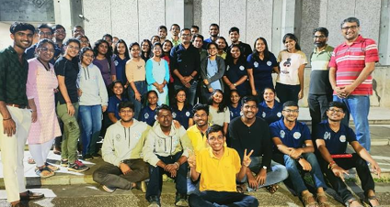

4. Blood Donation Camp
Donors: 279
The annual Blood Donation Camp organized by Spandan saw an overwhelming response from the COEP community, with 279 donors contributing to this noble cause. The club also partnered with NGOs to facilitate access to scribes for physically disabled individuals, reflecting its inclusive approach to social welfare.
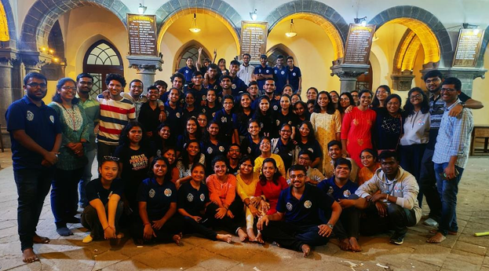

5. Donation Drive
Spandan embarked on a comprehensive donation drive, visiting various locations in need and distributing collected items. Locations visited included PMC, Railway Station, FC Road, JM Road, Shivajinagar Railway Station, and Aniket Sevabhavi Arshram for disabled individuals at Urawade. The drive demonstrated the club's direct action approach to community support.
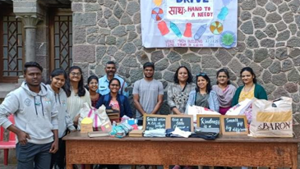

6. Village Camp at Ranje, Bhor
Dates: 1st – 3rd March 2024
Location: Ranje, Bhor, Pune
As a new and significant initiative, Spandan organized a three-day Village Camp at Ranje, Bhor, Pune. The camp included a wide range of impactful activities:
- Women's hygiene awareness sessions
- Computer and soft skills teaching
- Cleanliness drives
- Seed collection drives
- Tourism survey to identify opportunities for community development
The camp exemplified Spandan's expanded vision of rural outreach and community upliftment.

7. Non-Budget Activities
- Vrukshabandhan – A tree plantation activity conducted at members' own places on Friendship Day.
- Ek Diva Krutagnatecha – Gratitude-presenting activities conducted during Diwali.
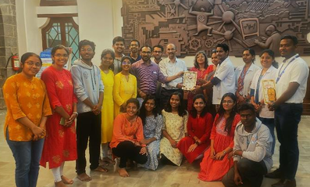

Club Details
Secretary: Omkar Pardeshi
Faculty Advisor: Dr. A.G. Thosar

