STUDENT WELFARE FORUM

Introduction
The Student Welfare Forum (SWF) of COEP Technological University worked actively during the Academic Year 2025–26 to promote student welfare, inclusivity, social awareness, and academic support. The forum organized national celebrations, academic initiatives, awareness programs, and support activities aimed at holistic student development.

Major Activities and Events Conducted

Independence Day Celebration
The Independence Day Flag Hoisting Ceremony was conducted with dignity and discipline. University authorities, faculty, staff, and students participated in the celebration, which included flag hoisting, National Anthem, and ceremonial proceedings.
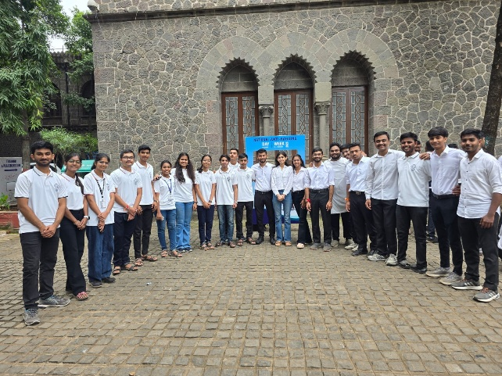

Student Induction Programme (SIP)
The four-day Student Induction Programme welcomed first-year students and introduced them to academic systems, university culture, human values, research opportunities, and departmental orientation.
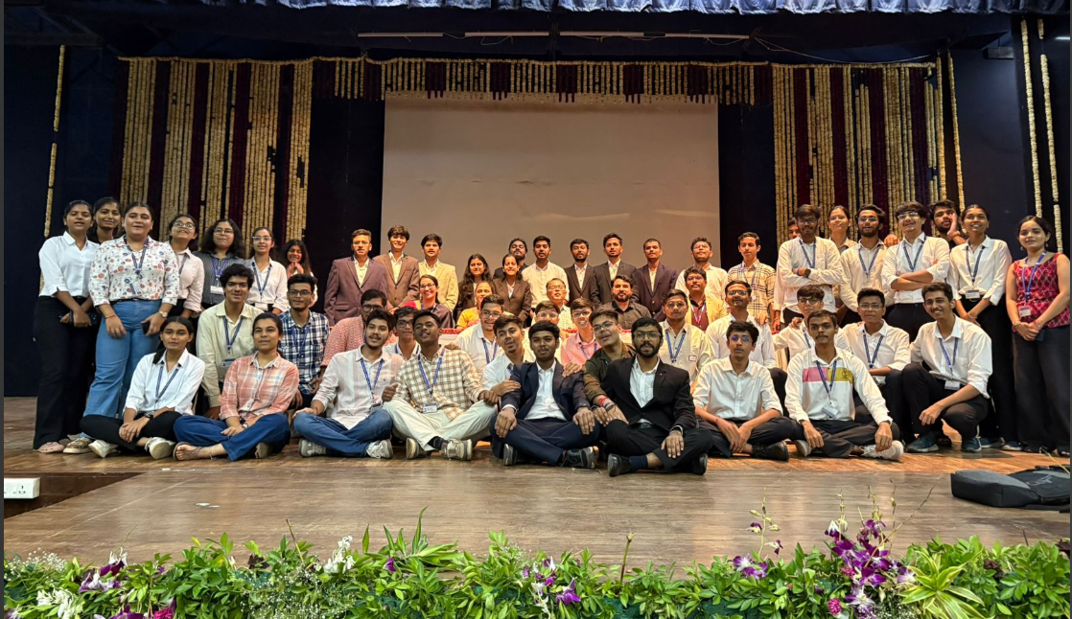

Scholarship Camp (A.Y. 2025–26)
A scholarship assistance camp was organized to help students with MahaDBT scholarship registration and document verification. The initiative supported students across programs.
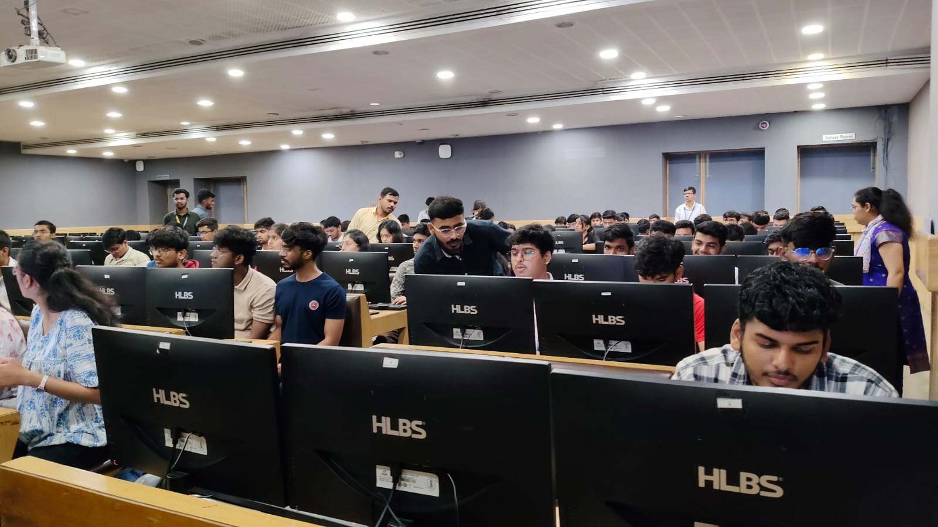

Constitution Day Celebration
Constitution Day was observed in the college library to spread awareness about constitutional values. Activities included reading of the Preamble and book exhibitions.

Mahaparinirvan Day
Mahaparinirvan Day of Dr. Babasaheb Ambedkar was solemnly observed with floral tributes and reflection on his contributions to social justice and education.

Guest Lecture on Social Equality
A guest lecture on social equality emphasized inclusiveness, justice, and the role of youth in societal development.

Republic Day Celebration
Republic Day was celebrated with patriotism through flag hoisting, national salute, and pledge, reinforcing respect for the Constitution of India.

Key Milestones and Achievements
• Successfully conducted national and constitutional celebrations with active participation.
• Organized structured academic induction for first-year students.
• Provided scholarship assistance to a large number of students.
• Promoted constitutional values, social equality, and civic responsibility.
• Ensured effective coordination between students, faculty, and administration.

Core Team
- Faculty Advisor: Dr. Vijay Khadse (Computer Engineering)
- Associate Faculty Advisor: Dr. Adil Ata Azami (Civil Engineering)
- Secretary: Virbhadra Baviskar (Civil)
- Joint Secretary: Suhas Kulkarni (Manufacturing)
- Auditor: Prem Lokhande (Mechanical)
- Events Head: Abhishek Chavhan (Mechanical)
- Documentation Heads: Om Khandagale (Mechanical), Prem Dupargudhe (Metallurgy)
- Media & Design Heads: Nakul Sangamnere (Electrical), Krishna Sapkal (Planning)
- Scholarship & Assistance Heads: Anjali Mane (Computer), Vedant Mundhe (Electrical)
- Purchase Head: Karan Bonde (Mechanical)
- Public Relations Heads: Ruturaj Malode, Vaishnavi Pawar, Sanskruti Patil
- Campus Decor Heads: Riddhi Sharma (Planning), Atharva Ghule (Civil)
- Refreshment Head: Atharv Patil (Mechanical)

