SPIC MACAY & CLASSICAL MUSIC CLUB
SPIC MACAY (Society for the Promotion of Indian Classical Music and Culture Amongst Youth) is a non-political, nationwide, voluntary movement in its 43rd year, aimed at promoting Indian classical music, dance, folk music, yoga, crafts, and other aspects of Indian culture.
The Classical Music Club (CMC), affiliated with the SPIC MACAY Pune Chapter, aims to promote, practise, and discover the many branches of India's great and deep heritage of music, dance, and art. The club provides a platform for students to learn from legendary artists, perform at cultural events, and engage with classical arts in meaningful ways.

Events and Activities

1. Interactive Session with Padma Shri Kiran Seth Ji
Date: 23rd May 2023
Guest: Padma Shri Kiran Seth Ji – Founder, SPIC MACAY; Professor Emeritus, IIT Delhi; Renowned Musician and Educator
An interactive session was organized with the founder of SPIC MACAY, Padma Shri Kiran Seth Ji. A renowned musician, educator, and visionary, he spoke about the importance and significance of practising classical music in the day-to-day lives of youth, inspiring students to explore and embrace India's classical heritage.

2. 'Santwani' – Inhouse Concert on Ashadhi Ekadashi
Date: 27th June 2023
On the auspicious occasion of Ashadhi Ekadashi, the club organized an inhouse concert titled 'Santwani', in which members of the club showcased their musical talent. The intimate concert provided a platform for club members to perform devotional and classical compositions in a celebratory setting.

3. Teacher's Day Classical Music Performance
Date: 5th September 2023
Conducted in collaboration with: Impressions '23
On the occasion of Teacher's Day, the club organized a Classical Music performance in collaboration with Impressions '23. The event was graced by the presence of Gymkhana Vice-President Dr. Nilima Kolhare Ma'am. The performance honoured educators through the medium of classical music, blending artistic expression with heartfelt tribute.

4. Nrityamanjiri – Kathak Concert
Date: 9th October 2023
Venue: COEP Main Auditorium
Audience: 300
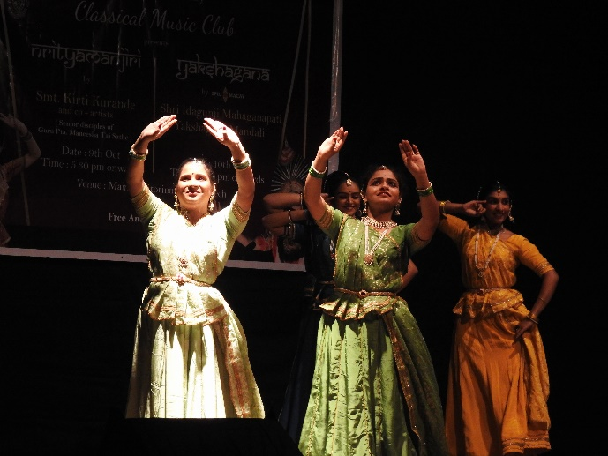
Main Artist: Smt. Kirti Kurande Ji (Kathak Performer and her dance and live music group)
Special Presence: Maneesha Tai Sathe (Guru of Kirti Kurande Ji)
The event showcased the great talent of classical artists and helped spread awareness about the fascinating and divine world of classical arts. Smt. Kirti Kurande Ji performed a classical Kathak recital accompanied by her disciples and co-artists on Tabla, Harmonium, and Vocals. The approximately 2-hour performance comprised 8–10 compositions with live commentary guiding the audience through each piece. The event concluded with a token of appreciation presented to the artists by Dr. M.P. Khond Sir and the club's Faculty Advisor Dr. Avinash Khandizod.

5. Yakshagana – Folk Dance-Drama Concert
Date: 10th October 2023
Venue: COEP Main Auditorium
Audience: 300
Performing Group: Shri Idagunji Mahaganapati Yakshagana Mandali (SPIC MACAY Artists)
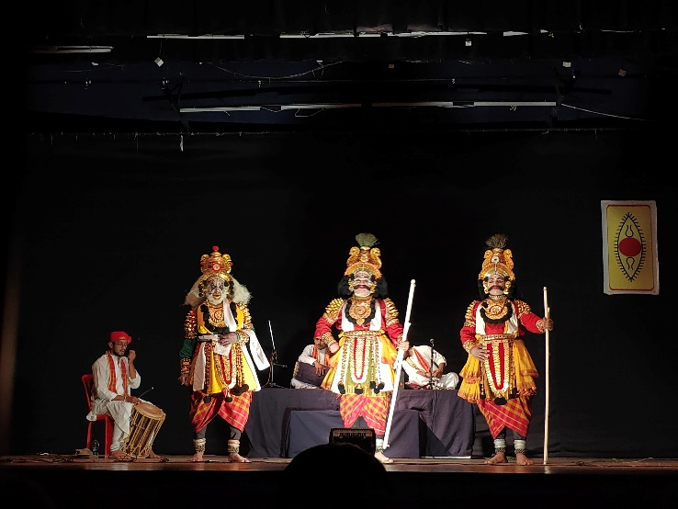
The event showcased the great talent of folk artists from coastal Karnataka and helped spread awareness about the exuberant world of folk art. The Shri Idagunji Mahaganapati Yakshagana Mandali performed a dance-drama in the Yakshagana tradition, beginning with a brief overview of the troupe's origins and global reach. A digital synopsis was provided to the audience to follow along. Despite the script and songs being in regional languages, the powerful expressions and emotions of the artists made the performance universally captivating.
Alongside the Yakshagana concert, the club also organized a poster-making competition on the theme of Yakshagana, with the top entries featured on the club's Instagram page.

6. Club Members' Participation at Impressions '23
Club members actively showcased their talent in various competitions at Impressions '23, COEP's Annual Cultural Festival, as well as in external intercollegiate competitions — representing the club and the university with distinction.

7. 'Swar Sadhana' – Inhouse Concert
Date: 30th January 2024
Venue: COEP Mini Auditorium
Audience: 100
Faculty Guest: Dr. Avinash Khandizod
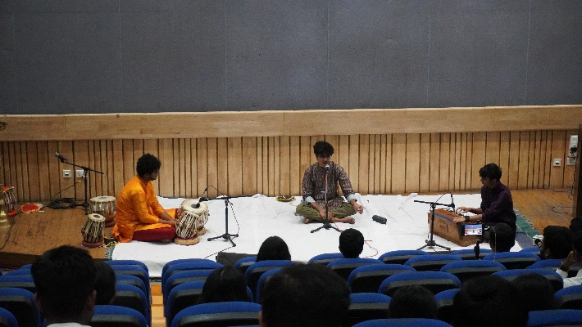
The 'Swar Sadhana' inhouse concert provided a platform for new members — especially first-year students — to perform with enthusiasm and talent. The objective was to cultivate an appreciation for classical music by hosting an intimate concert, while also fostering a sense of cultural enrichment within the campus community.
The event commenced with the ceremonial lighting of the lamp by faculty and parents. The program opened with two dance performances — Bharatnatyam and Kathak — including 'Saraswati Vandana' and 'Ganesh Kautukam'. The classical vocal session began with a 'Nandi' sung by first-year members, followed by vocal recitals by all club members. The program also included Tabla duets and a mesmerizing performance on the Sarod. The concert concluded with a group Raag Bhairavi recital by second-year members.

8. YouTube Channel Relaunch
Occasion: Diwali 2023
On the auspicious occasion of Diwali, the club relaunched its YouTube channel, posting the remarkable performances of club members to reach a wider audience and digitally preserve the club's artistic output.

9. Year-Round Jamming, Riyaaz & Recording Sessions
Throughout the academic year, the club held regular jamming and riyaaz (practice) sessions for the development of musical skills among club members and other interested students. Recording sessions were also conducted, with content posted on the club's social media handles to build a digital presence and inspire a broader audience.

10. Kathakali Performance by Vidushi Renjeni KP
Date: 23rd January 2025
Venue: COEP Main Auditorium
Audience: ~400
Performer: Vidushi Renjeni KP – Renowned Kathakali Performer
The event provided students and attendees with an immersive experience in the traditional art of Kathakali. The objective was to highlight the rich storytelling, expressive gestures, and musical elements that define this classical Indian dance-drama, and to inspire cultural appreciation through a live performance by a celebrated artist.
The event opened with an introduction to Kathakali — its origins, significance, and artistic components — to help the audience appreciate the nuances of the performance. Vidushi Renjeni KP mesmerized the audience with powerful portrayals of mythological characters through intense expressions, rhythmic footwork, and precise mudras (hand gestures). The performance depicted scenes from Indian epics, with live music and vocal narrations creating a truly immersive experience.
A post-performance interaction allowed the audience to engage directly with Vidushi Renjeni KP, who shared her journey in Kathakali, the rigorous training involved, and the significance of preserving classical arts in the modern era. The event concluded with a heartfelt vote of thanks.

Club Details
Secretary: Anushka Shalu
Faculty Advisor: Dr. Avinash Khandizod

