ROBOT STUDY CIRCLE (RSC)
The Robot Study Circle (RSC) at COEP Technological University is dedicated to advancing robotics research, competitions, and education. The club participates in national-level competitions, conducts workshops for school and college students, organizes flagship robotics events, and undertakes cutting-edge R&D projects in robotics and automation.

Competitions & Events

Competitions at External Venues (First Quarter)

Robo Soccer – Newton School of Technology
Robo Soccer is a competitive event where robots play soccer autonomously. Teams of robots equipped with sensors and actuators compete to score goals, highlighting challenges in real-time coordination, decision-making, and teamwork.
Team A: Shreyas, Pranav, Shrisha, Kshitij, Prathamesh
Team B: Ranveer, Vedant, Tushar, Atharva
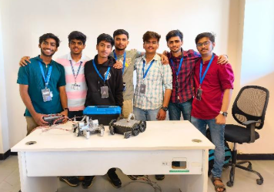
Robo Races – Bharti Vidyapeeth
Robo Races are competitions where robots race against each other, navigating complex tracks or obstacles. These tests assess robots' speed, agility, and precision as they autonomously make decisions to reach the finish line.
Participants: Ranveer, Yaasir, Tushar

Line Follower – Bharti Vidyapeeth
A line follower competition involves designing and building an autonomous robot that navigates a track marked with a black line on a white surface, completing the course as quickly and accurately as possible.
Team A: Omkar, Varad, Sumit, Shaunak
Team B: Harsh, Aditya, Partik
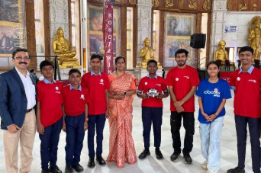
MindSpark 2024 – Robotica Event
RSC participated in various competitions held in MindSpark 2024 for better exposure and hands-on experience. The club also conducted the Robotica Event under MindSpark 2024, organizing and conducting 7 different competitions:
- Bot Wrestling
- RoboRaces
- RoboWars
- Search N Destroy
- RoboRoyal
- RoboSoccer
- Virtual Robotics
The club's primary role was to organize the teams and referee the matches, ensuring smooth execution of all events.

Achievement: Third Rank in Robo Royal

Robotex 2025 – MIT Alandi
RSC played a major role in organizing, coordinating, and volunteering for the national-level Robotex event held at MIT Alandi. In addition to organizing, the club also competed in:
- Maze Solver
- Girls Fire Fighter — Third Rank
- Line Follower
- Entrepreneurship Challenge

DD Robocon 2025 – IIT Delhi
Date: 12th and 13th July 2025
Competition: Asia Pacific ABU Robocon 2025, held as DD Robocon 2025 by IIT Delhi
Stage 1 Score — 96
Stage 2 Score — 100
Overall Rank — 5th in India
MathWorks Modelling Award — Third Rank

Workshops

Camp Education School – Line Follower Workshop
RSC conducted a workshop and training session on making line follower robots at Camp Education School. Students were provided with robotics kits to enhance hands-on learning, introducing them to fundamental concepts in robotics, programming, and sensor-based navigation. RSC members helped school students assemble the kits and program the ESP32 using Scratch-like programming blocks, making it accessible and easy to follow.
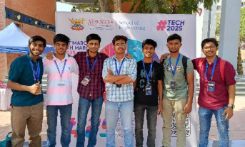

ROBOTEX India – Camp Education Society, Cyrus Poonawala
ROBOTEX India and Robot Study Circle jointly organized a robotics camp at Camp Education Society, Cyrus Poonawala, where students were provided with robotics kits. The initiative aimed to introduce participants to fundamental concepts in robotics, programming, and sensor-based navigation. RSC members guided school students through the complete process of assembling line follower robots and programming them over the course of multiple sessions.
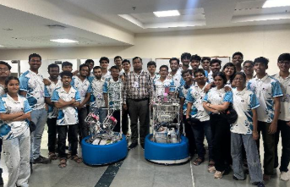

School Connect 2.0
A hands-on workshop was conducted for school students featuring interactive demonstrations of various robots, including the NAO humanoid robot and Genebo, a quadruped dog robot. These live demonstrations provided students with an exciting glimpse into real-world robotics applications and inspired them to explore the field of robotics.

Projects Undertaken 2024-25
- Ornithopter V6
- OpenCV Terrain Detection
- Snake Robot
- 6 Degree of Freedom Compact Robotic Arm
- Autonomous Legged Tracked Robot
- Maze Solver

Core Team Members

Sr. | Name | Year | Branch
1. | Hridhay Kutty | B.Tech | Mechanical
2. | Atharva Neglur | B.Tech | Instrumentation
3. | Jiten Topiwala | B.Tech | Mechanical
4. | Yash Gavit | B.Tech | Mechanical
5. | Aditya More | B.Tech | Manufacturing
6. | Anish Patil | B.Tech | Mechanical
7. | Anish Patil | B.Tech | EnTC
8. | Aayush | B.Tech | Computer Science

