Robot Study Circle

A.Y. 2025-26
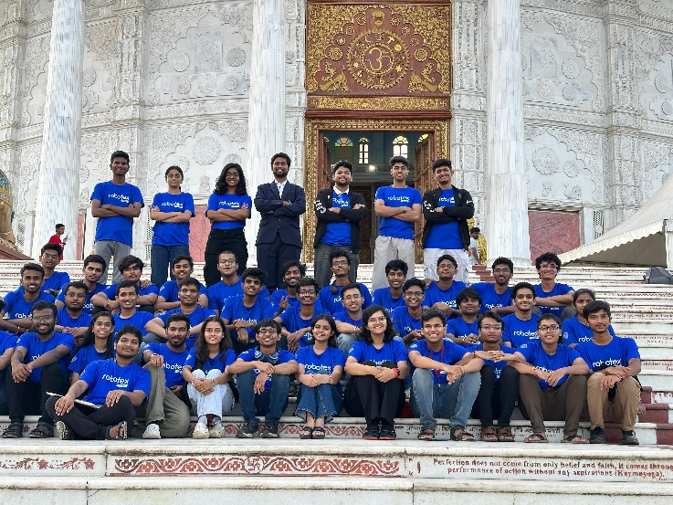

Major Activities Conducted:

Projects Undertaken:
- Capstan Drive Mechanism
- Wall Climbing Robot
- Simple FOC
- Image Processing using Jetson nano
- Integrating ROS2 with hardware

Mindspark 2025:
- Participated in various competitions held in MindSpark 2025 for better exposure and hands-on experience of building the robots.
- Conducted the Robotica Event under MindSpark 2025, in which we played a role in organising and conducting 7 different competitions, including Bot Wrestling, RoboRaces, RoboWars, Search N Destroy, RoboRoyal, RoboScoccer, and Virtual Robotics. The main role played was to organise the teams and referee the matches.

Robotex 2025:
- Participated in competitions like Maze Solver, Girls Fire Fighter, Line Follower, and Entrepreneurship Challenge.
- Played a major role in organising, coordinating and volunteering for the National Level Event Robotex held at MIT Alandi.
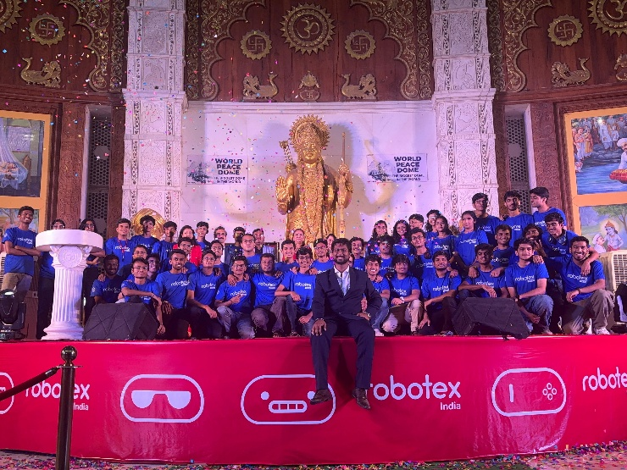

Workshop for School Students:
- Conducted workshop and training session on making line follower robots at Camp Education School.

Drone Workshop:
- Organised and volunteered for a 3-day hands-on drone building workshop in collaboration with The Robotics Society. There were over 50 undergraduates and working professionals who were technically assessed for the Drone Workshop.

ROSCon 2025:
- ROSCon, a national-level robotics conference, volunteered for the smooth conduction of the event.
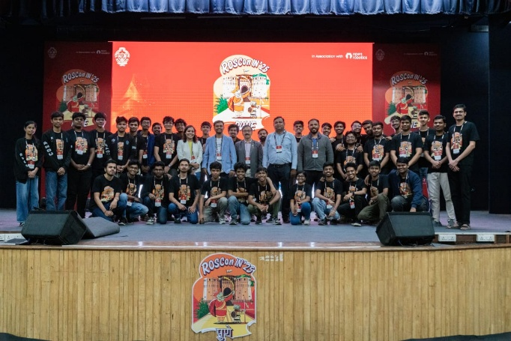

Robocon 2026:
- Currently preparing for DD RoboCon 2026 (An Asia Pacific Competition held by IIT Delhi in India). Focusing on prototyping different mechanisms and manufacturing, along with testing, making progress in image processing and testing of Jetson Nano and Raspberry Pi.

Achievements:

Mindspark 2025:
- First Rank in Robo-Royal
- First Rank in Search N Destroy
- Second Rank in Search N Destroy
- Second Rank in Virtual Robotics
- Third Rank in Virtual Robotics
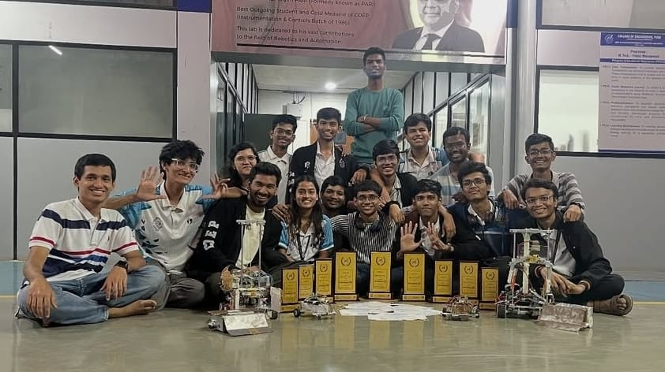

Robotex 2025:
- First Rank in Girls Fire Fighting (National Winner).
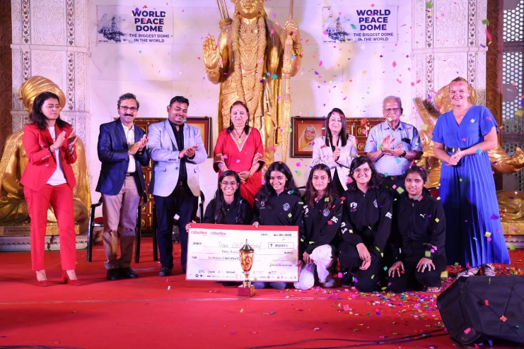

Core Team Members:
Sr. No. | Name | Year | Branch
 | Sumit Madane | B.Tech | Mechanical
 | Tanvi Chalke | B.Tech | Mechanical
 | Kunal Pawar | B.Tech | Mechanical
 | Vedant Divekar | B.Tech | Mechanical
 | Omprakash Dumre | B.Tech | Mechanical
 | Diya Shetty | B.Tech | Mechanical
 | Onkar Shete | B.Tech | Manufacturing
 | Harshavardhan Ligade | B.Tech | Metallurgy
 | Dishant Kinake | B.Tech | Mechanical

