RAMANUJAN MATHEMATICS AND SCIENCE CLUB (RMSC)

About the Club
The Ramanujan Mathematics and Science Club (RMSC) serves as a cornerstone for intellectual engagement at COEP, dedicated to fostering a vibrant community where students explore the profound applications of mathematical and scientific principles. Driven by the objectives of promoting critical thinking through healthy competition, the club bridges the gap between theoretical classroom learning and advanced research.

Events and Activities

1. Guest Session – 'Dynamical Systems: Mathematical Foundations and Real-Time Applications'
Date: 6th June 2025
Mode: Online
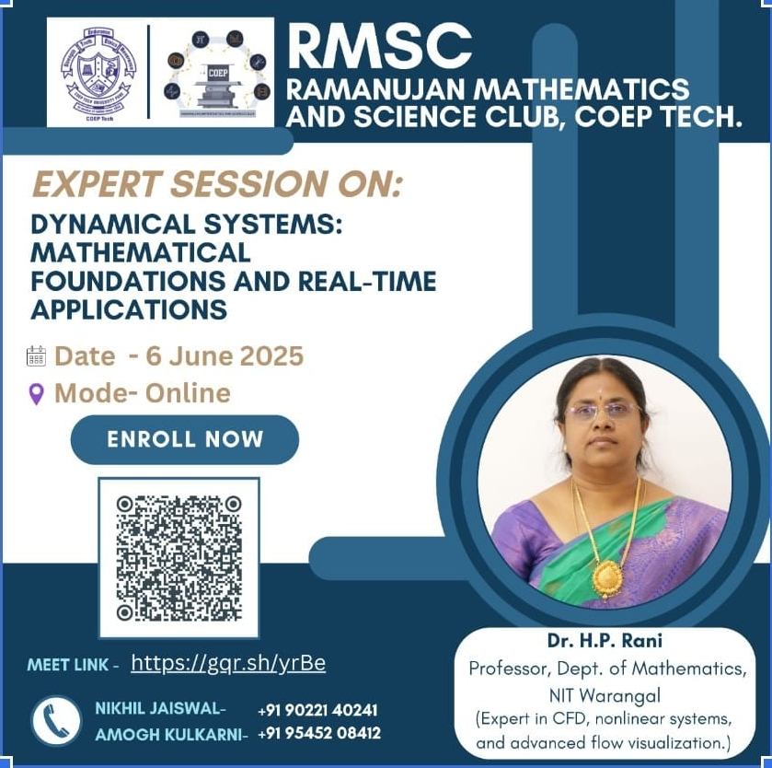
Speaker: Dr. H.P. Rani – NIT Warangal
The academic year commenced with an insightful online session delivered by Dr. H.P. Rani from NIT Warangal. The talk bridged the gap between abstract mathematics and fluid flow visualization, providing students with a deeper understanding of how dynamical systems theory applies to real-world engineering and physical phenomena. The session gave students early motivation to engage with higher mathematics beyond the standard curriculum.

2. Sudoku Shockwave
Month: November 2025
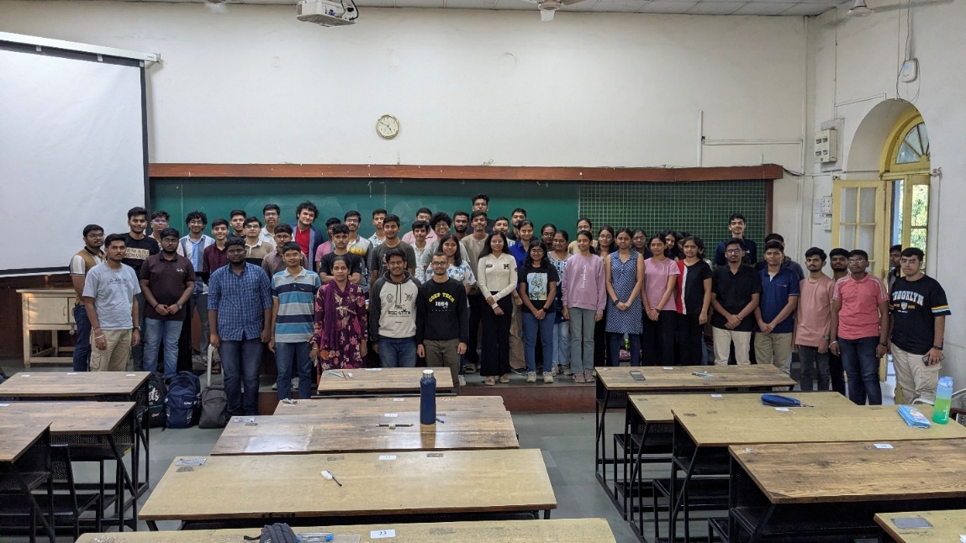
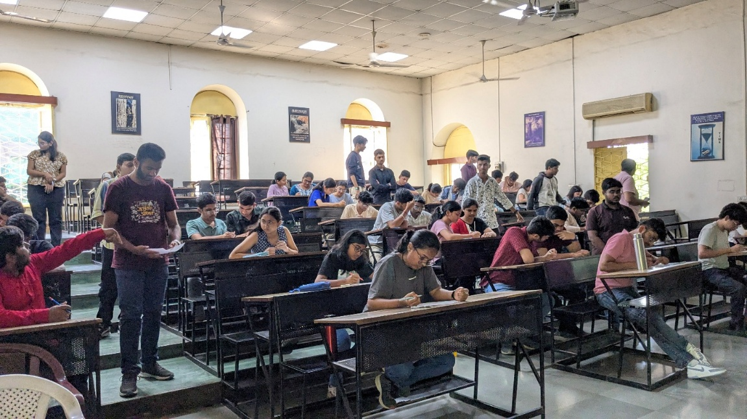
Participants tested their logical reasoning and pattern recognition skills in a complex puzzle-format competition. The Sudoku Shockwave event challenged students to think analytically under competitive conditions, promoting mathematical thinking in a fun and engaging format.

3. Linear Algebra Using SageMath
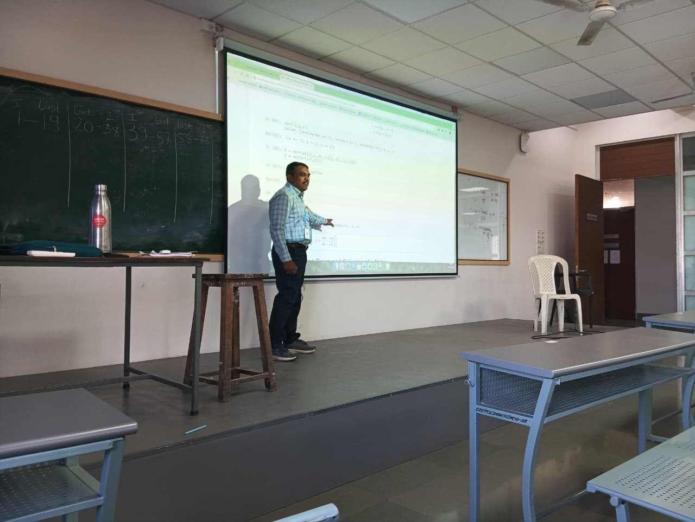
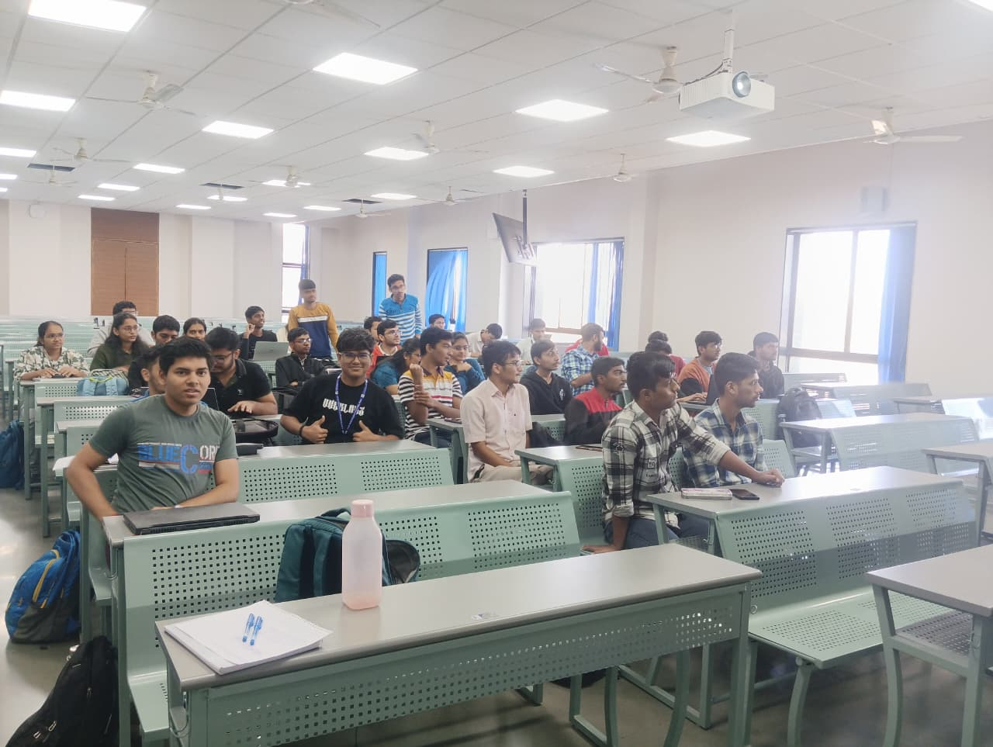
Occasion: National Mathematics Day
To mark National Mathematics Day, the club hosted a hands-on workshop on 'Linear Algebra Using SageMath'. The session provided students with practical experience in analytical thinking using open-source mathematical software, demonstrating the power of computational tools in solving linear algebra problems and making abstract concepts tangible and intuitive.

4. National Science Day – Expert Lectures and Poster Competition
Date: 21st February 2026
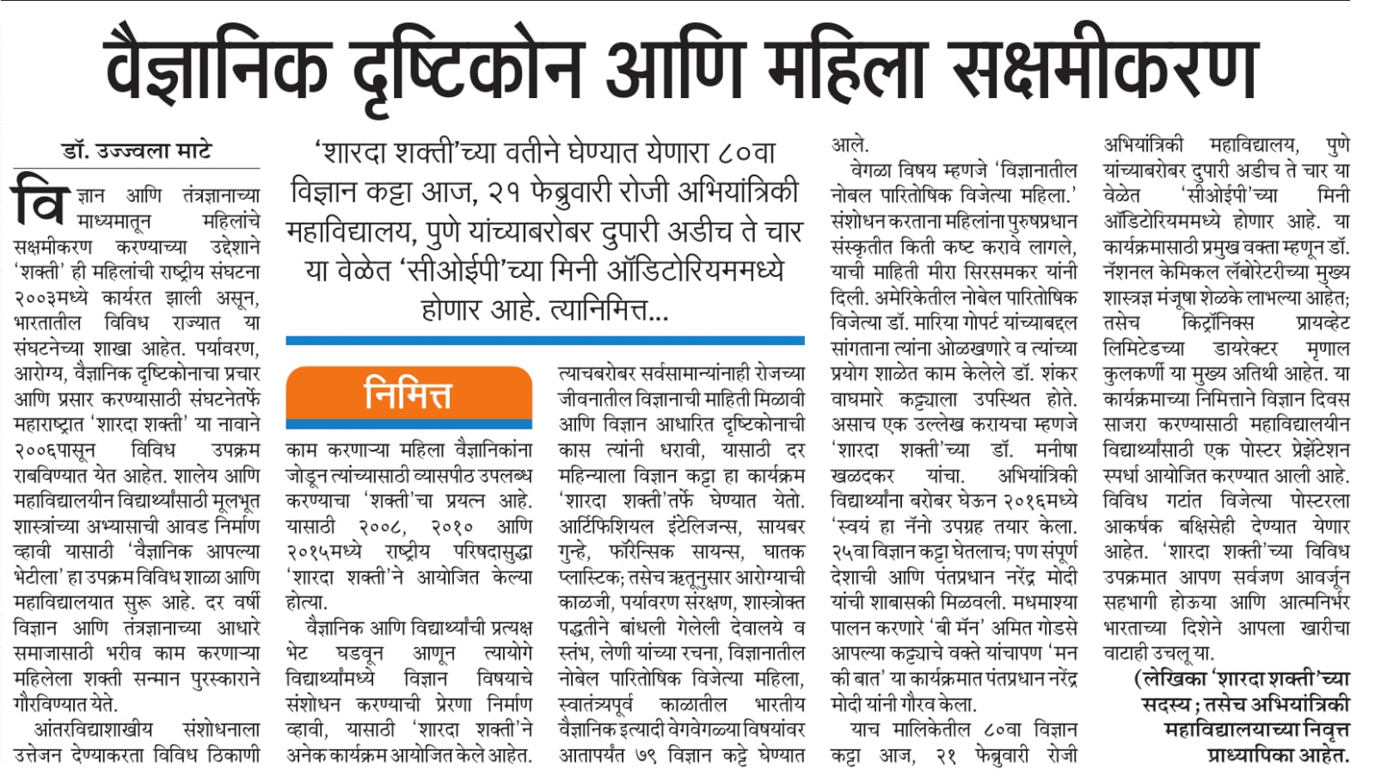
Organized in collaboration with: Sharada Shakti and Swayamsiddha
The RMSC celebrated National Science Day in collaboration with Sharada Shakti and Swayamsiddha, organizing expert lectures and a poster competition. The event showcased student research, scientific thinking, and interdisciplinary engagement, reflecting the club's commitment to fostering a scientific culture beyond mathematics alone.

5. Code Uncode
Date: 29th March 2026
Format: ACM ICPC-style programming competition
Scale: 1,000 registered participants across Mumbai and Pune
Organized in collaboration with: DJSCE and SPIT
'Code Uncode' is a prestigious inter-collegiate programming showdown in the ACM ICPC style, bringing together 1,000 registered participants from colleges across Mumbai and Pune. The collaborative effort with DJSCE and SPIT aims to solidify the coding culture within the region, making it one of the largest competitive programming events organized by COEP.

6. Integration Bee
Date: 4th April 2026
Theme: Pi Day Celebration
The academic calendar concludes with the 'Integration Bee', a competitive integral calculus event featuring five rounds of progressive challenges. Designed to transform high-level mathematics into an engaging, intuitive, and rewarding experience, the Integration Bee celebrates the beauty of calculus and has become one of the club's most anticipated events among mathematics enthusiasts at COEP.

