ROCKET PROPULSION CENTRE (RPC)

About the Rocket Propulsion Centre
The Rocket Propulsion Centre (RPC), established in 2023 under the Applied Mechanics Department at COEP Technological University and guided by Prof. B. G. Birajdar, was created to meet students' growing demand for hands-on experience in aerospace propulsion. It provides a dedicated platform for researching, designing, and testing rocket systems, aiming to bridge the gap between theoretical learning and practical application. Driven by India's expanding role in space exploration and access to modern simulation and manufacturing tools, the club empowers students to develop and test high-powered rockets in-house.

Objectives 2025-26
- To advance rocket propulsion research through iterative design improvements and testing.
- To develop and validate K class motor systems through static fire testing.
- To improve avionics, recovery systems, and altitude performance of H class rockets.
- To participate in space outreach events and showcase club activities to wider audiences.
- To build on previous year's achievements and push toward higher performance benchmarks.
- To cultivate a rigorous engineering culture focused on safety, precision, and innovation.

Activities Conducted
1. Second H Class Rocket Launch
Date: 13th October 2025
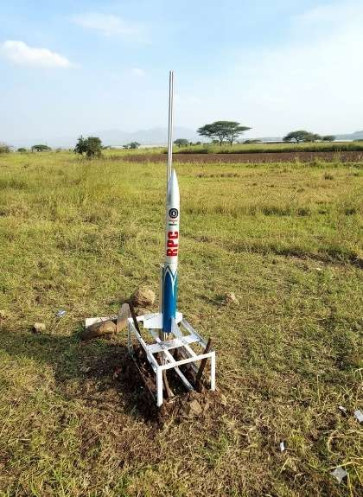
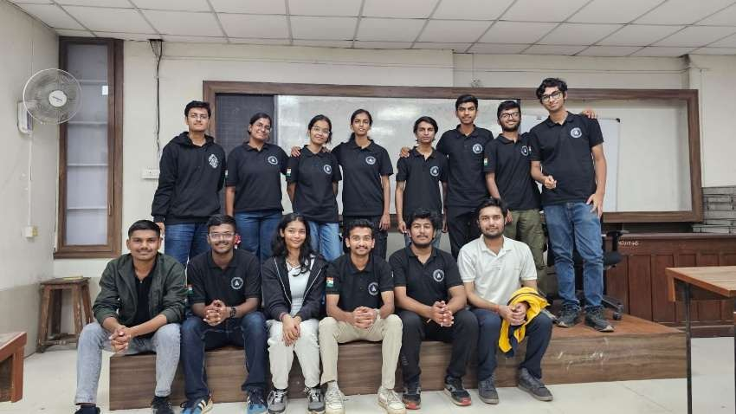
RPC conducted its second launch of the H class motor rocket, targeting an altitude of 600m. The rocket achieved a nominal flight with notable improvements over the previous launch, reflecting the team's iterative development approach and incorporation of lessons learned from the first launch. The successful flight validated the enhancements made to the rocket's design and propulsion systems.

2. Classroom to Cosmos (C2C) Event
Date: 30th October 2025
Chief Guest: Prasanth Nair (ISRO Astronaut, Group Captain)
RPC volunteered at the Classroom to Cosmos (C2C) event, a large-scale outreach initiative held at COEP. The club set up exhibition stalls showcasing its rocket systems, motor development, and avionics projects to guests and the audience. The event was graced by ISRO Astronaut Group Captain Prasanth B. Nair and drew significant engagement from students and visitors.
3. K Class Motor Static Fire Test
Date: 12th December 2025
Venue: COEP Tech University, Chikali Campus
Witnessed by: Honourable Vice Chancellor Prof. Sunil Bhirud
RPC conducted its first K class motor static fire test at the Chikali Campus, in the presence of the Honourable Vice Chancellor. The test was designed to verify material compatibility of the motor casing and components to sustain the required temperature and pressure conditions under K class motor operation. The test was conducted successfully, marking a significant step forward in the club's progression to higher-impulse propulsion systems.

4. Third H Class Rocket Launch
Date: 3rd February 2026
RPC conducted the launch of its third H class rocket, incorporating improvements to the avionics systems from the previous launch. The rocket reached an altitude of 500.9m, closely approaching the target altitude of 600m. The rocket successfully carried out a partial recovery, and further refinements to the recovery system are planned for subsequent launches. The flight data collected will inform the next phase of avionics and recovery development.

Outcomes and Impact
- Conducted three H class rocket launches with progressive improvements in performance and avionics.
- Successfully performed the first K class motor static fire test, validating material compatibility.
- Achieved an altitude of 500.9m in the third launch, approaching the 600m target.
- Active participation in the C2C event, showcasing RPC's work to ISRO astronaut and public audiences.
- Demonstrated iterative engineering development from first launch to significantly improved third launch.
- Progressed toward partial rocket recovery capability, with further improvements planned.

Faculty Advisor
Faculty Advisor: Prof. B. G. Birajdar

Core Team 2025-26
Yadnesh J. Nandgaonkar: TY Mechanical
Samkit Jain: TY Electrical
Abdul Rehaan: TY Metallurgy
Atharva Manohar: TY Civil
Sanskruti Pratapwar: BTech Manufacturing

