QUANTUM COMPUTING CLUB

About the Club
The Quantum Computing Club of COEP Technological University is dedicated to introducing students to emerging fields of computing and technology. The club conducts academic programs, lecture series, workshops, and events to build foundational knowledge, foster curiosity, and encourage engagement with cutting-edge technologies among students across all years.

Academic Activities for First-Year Students
The Quantum Computing Club conducted a series of academic activities for first-year students with the objective of introducing them to foundational technical concepts and encouraging early engagement in emerging fields of computing and technology. These activities were designed to support academic development while fostering curiosity, critical thinking, and participation in technical learning beyond the regular curriculum.

1. Introductory Orientation Session
Prior to the lecture series, an introductory session was organized for first-year students. The structure and curriculum of the program were explained in detail. Students were provided with an overview of topics to be covered, along with expected learning outcomes and the evaluation process. This orientation helped students gain a clear understanding of the program's purpose and prepared them for upcoming academic activities.
2. Structured Lecture Series
A structured series of lectures was conducted to guide students through the planned curriculum. The lectures focused on explaining fundamental concepts in a clear and organized manner, enabling students to build a strong conceptual foundation. Sessions were interactive in nature, encouraging active participation, questions, discussions, and clarification of doubts.
3. Viva Examinations
As part of the evaluation process, viva examinations were conducted for first-year students. The viva sessions assessed students' understanding of topics covered during the lectures, evaluating conceptual clarity and communication skills. This interactive method of assessment provided an opportunity for students to demonstrate their knowledge while receiving constructive feedback.

Outcomes of Academic Activities
- Strengthened conceptual foundation in computing and technology among first-year students.
- Enhanced communication skills and technical confidence through viva assessments.
- Encouraged active involvement in technical learning beyond the regular curriculum.
- Built an engaged cohort of first-year students ready for deeper club participation.

Events Conducted

FINSPARK 2025 Hackathon

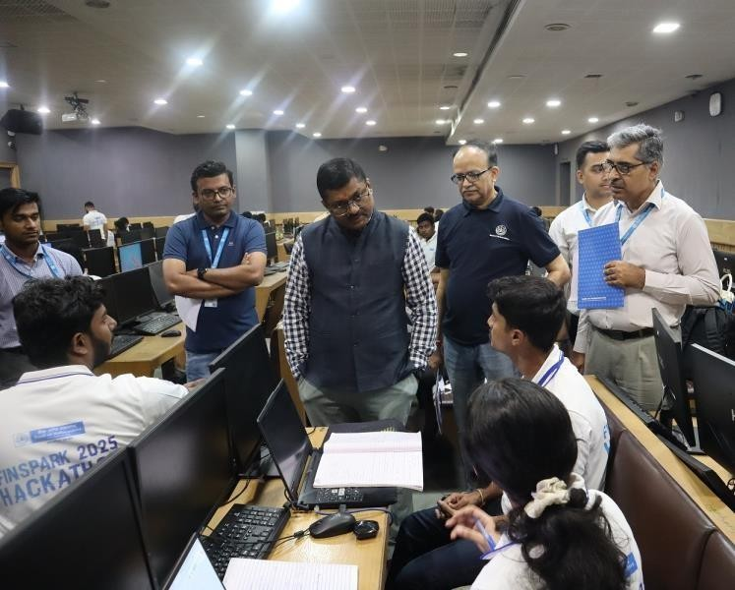

Overview
As part of the Government of India's vision to promote innovation in financial services, the Department of Financial Services (DFS) and the Indian Banks' Association (IBA) directed Public Sector Banks to organize hackathons in collaboration with premier institutions. Bank of Maharashtra partnered with COEP Technological University, Pune, to conduct FINSPARK 2025 — a two-day hackathon held on 9th and 10th August 2025. The event showcased the synergy between academia, banking, and technology partners including TCS, setting a template for future collaborations.

Problem Statements
In line with the directions of DFS & IBA and the evolving needs of the banking industry, the following problem statements were identified for the hackathon:

Sub Area | Problem Statement | Problem / Background | Challenge | Impact / Outcome
Cyber Security | Automated Log Analysis for Threat Detection | Banks generate massive volumes of logs from various sources — firewalls, servers, applications, and end-user devices. Traditional rule-based monitoring systems often fail to detect sophisticated attacks, leading to unnoticed critical security breaches. | Develop an automated log analysis system using machine learning and data analytics to detect security anomalies, generate real-time alerts, and support proactive threat management while minimizing false positives. | Early detection of cyber threats with minimal false positives. Improved visibility into suspicious activities. Automated alerts and early response mechanisms to reduce reaction time.
Fintech | Bridging the Language Gap in Indian Banking | India's diverse regional languages create barriers in digital banking. A large portion of the population is more comfortable using native languages, restricting financial inclusion. | Design a multilingual, end-user-friendly banking platform offering seamless communication in different Indian languages via voice and text interfaces, catering to users with limited digital literacy. | Increased accessibility for non-English speakers. Enhanced customer satisfaction through personalized language support. Strengthened financial inclusion, especially in rural and semi-urban areas.

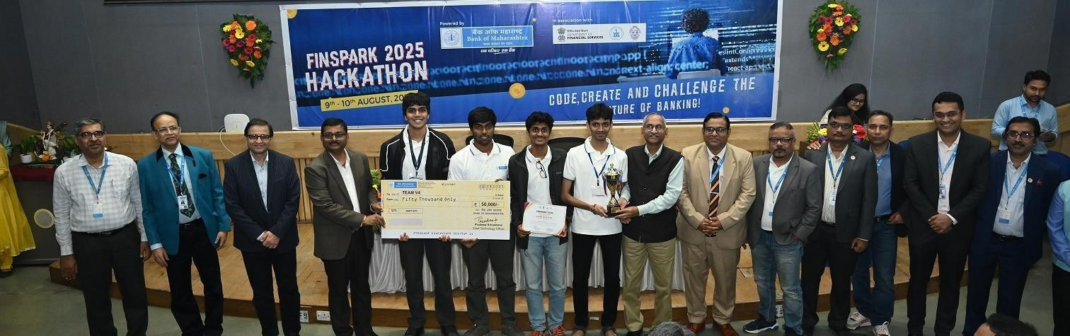

The Teams' Journey Through the Hackathon
The hackathon attracted over 40 team registrations, with 20 shortlisted teams and 16 teams competing on campus. The journey included:
- Inauguration Ceremony graced by senior dignitaries from Bank of Maharashtra, TCS, and COEP.
- 36 hours of non-stop coding where students collaborated intensively.
- Mentorship from bank executives and industry leaders providing real-world insights.
- Multiple evaluation rounds assessing innovation, functionality, scalability, code quality, and impact.
- Final Valedictory Ceremony chaired by Mr. Asheesh Pandey (ED, Bank of Maharashtra) and Prof. Sunil Bhirud (Vice Chancellor, COEP Technological University).

Role of Bank of Maharashtra
Bank of Maharashtra played a central role throughout the event:
- Problem Statement Design – ensuring challenges were rooted in real-world banking and cybersecurity issues.
- Knowledge Transfer Sessions – equipping students with domain knowledge prior to the hackathon.
- Mentorship – senior officers and technocrats, including the CTO, CDO, GM Digital Transformation, and CISO, guided participants with industry insights and technical feedback.
- Evaluation – bank executives served on the jury alongside industry experts from TCS and GoDaddy.
- Resource Support – ensuring seamless event management in collaboration with COEP.
This active involvement reinforced the Bank's commitment to fostering innovation and bridging academia with the financial sector.

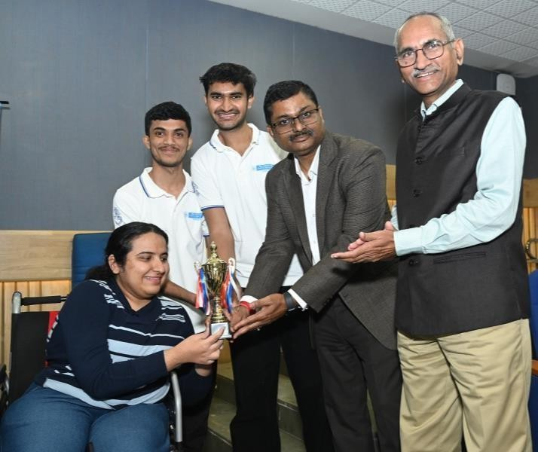

Winning Solution: ALATDS
The first prize was awarded to Team V4 for their solution — Automated Log Analysis and Threat Detection System (ALATDS). Their prototype was designed as a lightweight, machine-learning augmented log analysis pipeline capable of mimicking real-world Security Operations Center (SOC) practices.

Key Features:
- Real-time log ingestion and categorization for modular analysis.
- Log-type-specific ML models covering employee logs, server logs, NetFlow, and Windows event logs.
- Anomaly detection engine with autoencoder neural networks and statistical algorithms.
- Threat scoring system with classification into Low, Medium, High, and Critical levels.
- Correlation engine linking multiple anomalies into a chain of events for root cause analysis.
- Centralized dashboard and UI offering intuitive monitoring, raw log access, and alert investigation workflows.
- Scalable architecture leveraging efficient retrieval systems.
This innovation enhances early threat detection and minimizes the need for static rule-based detection, improving SOC efficiency across banks and financial institutions.

Outcomes, Learnings, and Future Plans
- Prototype Development: Winning teams created deployable prototypes within 36 hours, demonstrating the immense potential of student innovation.
- Scalability of Solutions: Feasibility studies will be undertaken to explore adoption of ALATDS within banking cybersecurity frameworks.
- Visibility & Proposed Internship Opportunity: The event enhanced the Bank's image as a forward-looking institution championing innovation, with internship opportunities proposed for deserving students.
- Future Presentations: DFS has proposed that winning teams present at the Global FinTech Fest 2025, offering global exposure to student innovations.

