PUNE STARTUP FEST 2026 (PSF'26)

About Pune StartUp Fest
Pune StartUp Fest (PSF) is the annual entrepreneurial summit organized by the Innovation and Entrepreneurship Cell of COEP Technological University. The fest brings together startups, students, industry professionals, mentors, and investors on a common platform to promote innovation, experiential learning, collaboration, and entrepreneurial thinking. A major highlight is the Startup Expo (Launchpad), where startups showcase their products and ideas while students gain exposure to internships, live projects, and startup culture. PSF features keynote sessions, panel discussions, workshops, pitching events, competitions, and networking forums curated to deliver practical insights and guidance from experienced entrepreneurs and industry leaders.

Objectives of PSF'26
- To promote entrepreneurial thinking and startup culture among students.
- To provide a platform for startups to showcase innovative ideas and business models.
- To facilitate meaningful interaction between investors, founders, industry experts, and students.
- To enhance practical learning through competitions, workshops, and panel discussions.
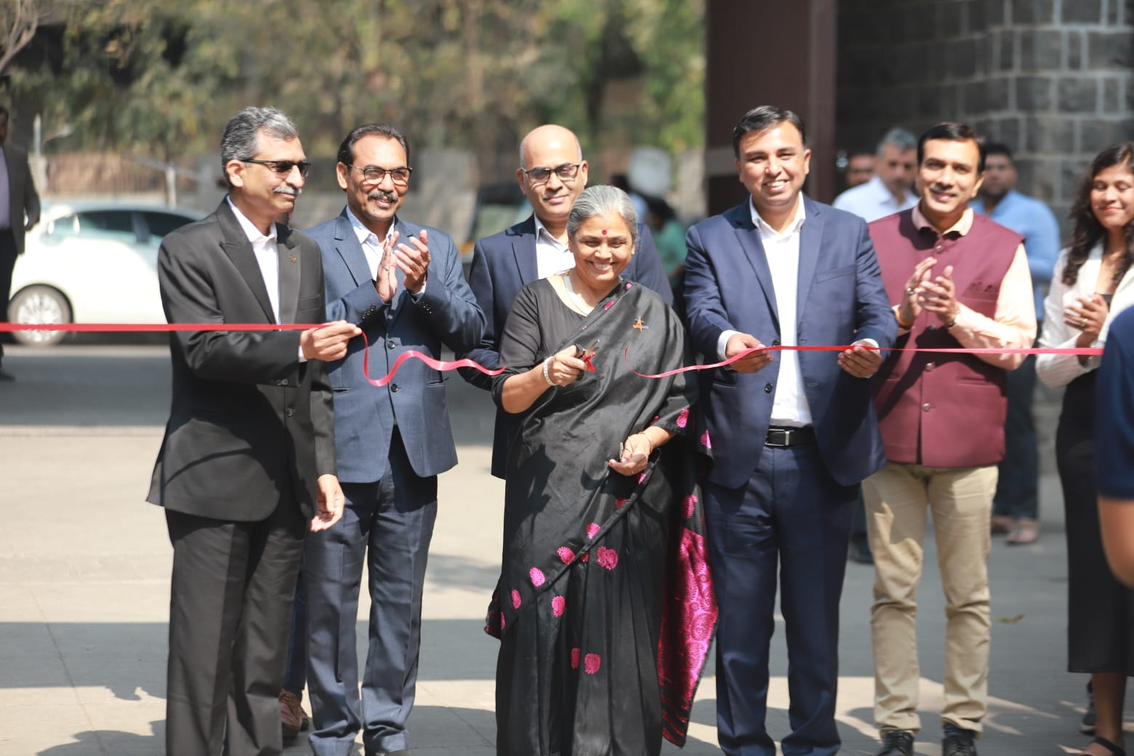
- To bridge the gap between academia and industry.

Activities and Events Conducted
1. Internship Fair – Where Opportunities Meet Ambition
The Internship Fair served as a dedicated platform connecting students with startups, corporates, and emerging organizations. It offered opportunities across internships, entry-level roles, and career-oriented engagements, enabling students to interact directly with recruiters, understand industry expectations, and explore pathways aligned with their skills and aspirations.
2. Founder's Ascent
Speakers: Gaurav Taneja and Pallavi Mohadikar
Founder's Ascent was an inspirational leadership session featuring renowned entrepreneurs. The session focused on entrepreneurial mindset, decision-making, resilience, and the journey of building scalable ventures. Rather than a conventional talk, it aimed to instill clarity, confidence, and ambition among aspiring founders by sharing real-life experiences and lessons from successful entrepreneurial journeys.
3. Defence & Tech Panel and Showcase
The Defence & Tech Panel brought together experts from DRDO, the Indian Army, and prominent technology-driven organizations, providing insights into defence innovation and advanced technologies. The accompanying Showcase featured live demonstrations across Defence Expo, AI and Machine Learning, Space Technology, Robotics, Drones and Anti-Drone Systems, and Geospatial and Remote Sensing technologies.
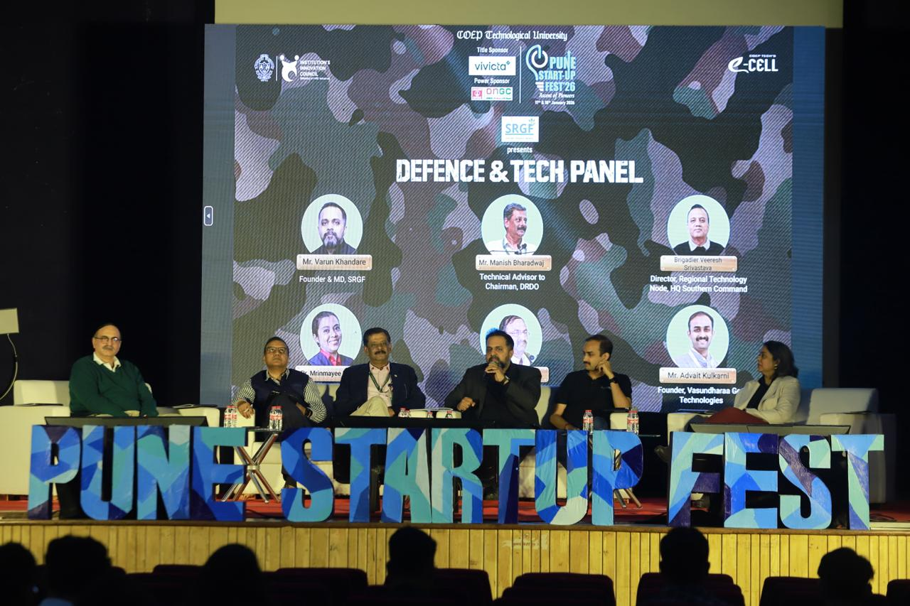
4. CXO Conclave
The CXO Conclave was a high-level leadership forum bringing together senior executives including CMOs, CFOs, CTOs, and COOs from leading organizations. Discussions focused on business transformation, technology integration, artificial intelligence, and strategic leadership, offering participants insights into how industry leaders navigate innovation and shape the future of their organizations.
5. The Startup Boardroom
The Startup Boardroom was an exclusive, closed-door discussion simulating a real boardroom environment. Featuring startup founders and seasoned investors, the event enabled in-depth conversation on funding decisions, long-term vision, and governance, offering participants an authentic view of high-stakes entrepreneurial discussions.
6. The Pitchers Valley
The Pitchers Valley was a flagship live pitching event where ten shortlisted startups presented their business models to a panel of five experienced investors in a Shark Tank-style format. The event facilitated real-time feedback and capital infusion of Rs. 1.15 crore, establishing PSF as a significant startup launch platform.
7. The Lightning Pitch
The Lightning Pitch was a fast-paced pitching competition where fifteen startups each presented their ideas to seven investors within a strict three-minute limit. Startups receiving investor interest advanced to one-on-one discussions, creating direct opportunities for funding and collaboration.
8. Competitions Conducted
PSF'26 featured a wide range of competitive events designed to test entrepreneurial, analytical, and strategic skills. These included Spectra (national-level startup idea pitching), CEO Challenge (leadership and business strategy), Innovator's Relay (multi-stage innovation challenge), Fund Arcade (venture capital simulation), BullRun (virtual stock trading), Survive & Thrive (startup crisis simulation), BrandScan (branding challenge), BidWars (IPL-inspired auction strategy), and Shishya (report writing for school students).

Masterclasses and Workshops Conducted
1. The Startup Playbook – Tactics for Startups Masterclass
Conducted by: Vijay Nihalchandani, Founder, Travinities
A practical masterclass on proven startup frameworks, execution strategies, and real-world lessons from successful ventures.
2. Video Editing Workshop
Conducted by: Shobhit Gaur, Founder, Editing Edition
A hands-on workshop on professional video editing workflows, creative techniques, and industry-relevant tools for digital storytelling.
3. Scale with Strategy – Scaling Business Masterclass
Conducted by: Dipak Sanghavi, Chairman and MD, Nilon's India
A masterclass on strategic planning, sustainable scaling, operational efficiency, and leadership-driven growth.
4. Brand & Beyond – Brand Management Masterclass
Conducted by: Sanjay Arora, Founder and CEO, Skills Advertising
A session focused on brand building, storytelling, and marketing strategy for creating strong brand identities in competitive markets.
5. Generative AI Workshop
Conducted by: Vishnu Vijayan, Creative Ambassador, Morphic
An introductory workshop on generative AI tools and applications, highlighting their role in enhancing creativity, productivity, and innovation.
6. Personal Finance Masterclass
Conducted by: Ujjwal Gadhvi, MBA and Chartered Accountant
A masterclass on wealth creation, smart investing, and financial planning for students and young professionals.

Outcomes and Impact
- Enhanced entrepreneurial awareness and practical skill development among participants.
- Direct interaction facilitated between startups and investors, including Rs. 1.15 crore capital infusion at Pitchers Valley.
- Practical exposure to business strategy, finance, branding, defence tech, and AI.
- Strengthened industry-academia connections through the Internship Fair and CXO Conclave.
- Opportunities for internships, mentorship, and collaboration created for students.
- Enthusiastic participation from students and professionals across institutions nationwide.
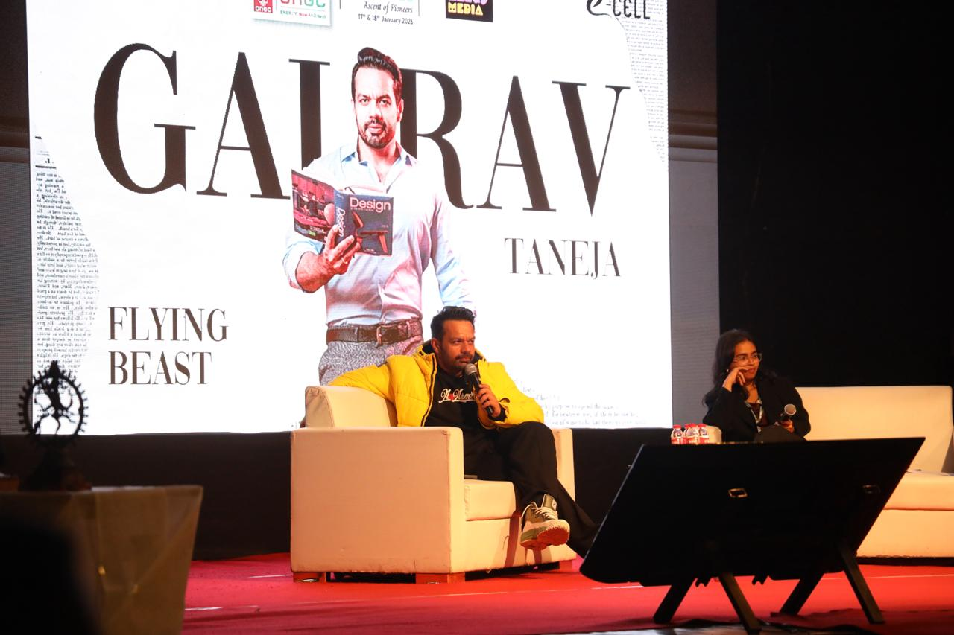

Core Team 2025-26
Secretary: Nehal Agrawal
Joint Secretary: Preet Damani
Accounts & Documentation: Anuj Kalbende, Mrunmayee Saigan
Graphic Design: Ankit Raj, Gauravi Jadhav, Sanika Deolikar
Corporate Outreach Group: Nishant Kamble, Shahir Sheikh
Events & Networking: Aryan Pillai, Siddharth Karandikar, Shrushti Maskare
Web & Tech: Aman Morghade, Soumya Pachpor
Finance & Sponsorship: Mayank Aher, Ved Joshi
Innovation & IPR: S. N. Subhashree, Swapnil Naik
Investor Relations: Avanee Waikar, Maithili Rajput
Media: Anshul Chaudhari, Presha Rane
Marketing: Avinash Gadade, Kartik Mirashi, Nirmit Dharmale
VFX: Keshav Purohit, Purvesh Chaudhari
Operations & Logistics: Megh Shidam, Mohit Kandalkar, Parth Dhote
Campus Decoration: Abhijeet Gajbhiye, Khushi Chavan
Public Relations: Arham Naqvi, Shravani Rithe
