PUNE STARTUP FEST 2025 (PSF'25)
Theme: Voyage of Visionaries
Innovation and Entrepreneurship Cell (Bhau's IEC) – COEP Technological University

About Pune StartUp Fest
Pune StartUp Fest (PSF) is the annual entrepreneurial summit organized by COEP Technological University in collaboration with Bhau's Innovation and Entrepreneurship Cell. PSF'25 marked the 7th edition of the fest, held under the theme 'Voyage of Visionaries.' The fest brings together startups, students, investors, mentors, and industry professionals on a common platform to foster innovation, experiential learning, and entrepreneurial thinking. Through keynote sessions, panel discussions, live pitching events, masterclasses, and competitions, PSF is committed to bridging the gap between academic learning and the startup ecosystem.

Objectives of PSF'25
- To ignite the entrepreneurial spirit among students and promote innovation and collaboration.
- To provide a platform for startups to pitch ideas and gain visibility with leading investors.
- To facilitate meaningful interaction between investors, founders, industry experts, and students.
- To enhance practical knowledge through expert-led masterclasses and competitions.
- To bridge the gap between academia and the global entrepreneurial ecosystem.

Inauguration
Opening Ceremony
Date: 11th January 2025
Venue: Main Auditorium, COEP Technological University
Attendees: ~600 including students, investors, and dignitaries
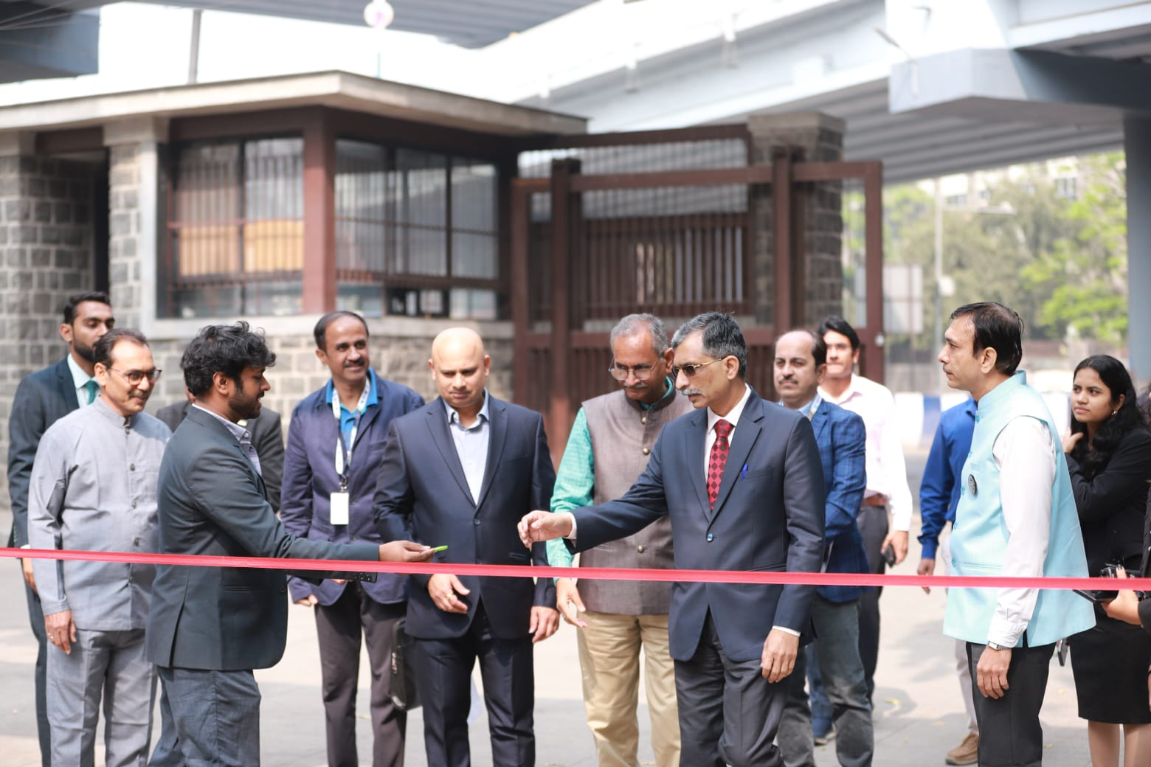
PSF'25 commenced with an impressive inauguration ceremony in the Main Auditorium, attended by around 600 individuals. A total of 80 investors attended the fest, adding significant value to the event's networking and investment opportunities. The Chief Guest, Mr. Amit Vaidya (Head of Franchise Development and Operations, PNG Jewellers), the Guest of Honor, Mr. Ravi Pandit (Chairman and Co-founder, KPIT), and esteemed dignitary Mr. Vivek Tongaonkar (Director Finance, ONGC) officially opened the event. The ceremony was marked by a ribbon-cutting and the activation of the Launchpad, symbolizing the beginning of an exciting entrepreneurial journey.

Events and Activities Conducted
1. Lightning Pitch
Attendees: ~250
One of the most anticipated events of PSF'25, the Lightning Pitch was held in the LP Arena. This event allowed 15 startups to present three-minute pitches to a distinguished panel of investors including Yamika Mehra, Dinesh Singh, Ganesh Natrajan, Yagnesh Sangrajka, Madhukar Bhatia, and Devansh Lakshmi. Audience polls added an interactive dimension, and shortlisted startups were invited for private discussions with investors, creating direct opportunities for funding and collaboration.
2. Pitchers Valley
Pitchers Valley is PSF's flagship live pitching event where top shortlisted startups present their business ideas to leading investors. PSF'25 featured a distinguished panel of investors including Mahavir Pratap Sharma (Chairman, TiE India Angels), Sushil Sharma (Co-founder & CEO, Marwari Catalyst), Bhawna Bhatnagar (Co-founder, We Founder Circle), Shashank Randev (Co-founder, 100X.VC), and Mandar Joshi (Partner, Venture Catalyst++). The event served as a flagship platform for startups to gain visibility and secure funding opportunities.
3. Startup Boardroom
The Startup Boardroom was a focused discussion between investors and startups, held in the LP Arena. The session featured startups Puskaraj Salunke and Yogesh Shinde engaging with investors Mohit Gulati and Rohit Goyal. The debate explored entrepreneurship challenges and opportunities, offering valuable insights to both participants and the audience regarding the real dynamics of startup funding and scaling.
4. BidWars
Participants: 170 participants, 80 teams
BidWars was an auction-based competition held in the South Campus where participants were challenged to build the ultimate cricket team within a virtual budget, showcasing their analytical and strategic skills. 80 teams with 170 participants competed, with 17 teams advancing to the second round held the following day in the LP Arena.
5. CEO Challenge
Participants: 70
The CEO Challenge provided a platform for aspiring business leaders to analyze and solve real-world challenges faced by companies, presenting their innovative solutions to a panel of judges. 70 participants engaged in this event, testing their leadership, business acumen, and decision-making skills under simulated corporate conditions.
6. Courtroom Clash
Participants: 15 teams
Courtroom Clash was a debate-style event held in the Manufacturing Department where 15 teams debated legal and ethical dilemmas in the entrepreneurial world. The event sharpened participants' critical thinking and argumentation skills in the context of business and startup governance.
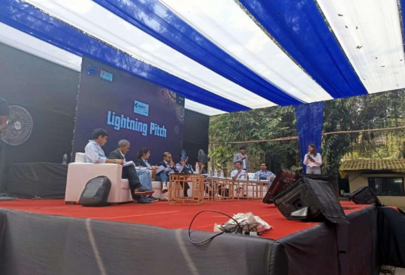
7. Shishya
Participants: 200 (school students, Grades 8–12)
Shishya is a multi-stage competition designed for school students from grades 8 to 12. Round 2 of Shishya was held in the Main Auditorium, involving 200 participants in activities including case studies, quizzes, and report writing. The event aims to nurture entrepreneurial thinking and professional writing skills at an early stage.
8. BullRun
Participants: 198
BullRun is a virtual stock market trading competition conducted online over five days from January 6 to January 10, using the Stockgro platform. 198 participants gained real-time trading experience, testing their market knowledge, risk appetite, and investment strategies in a simulated stock market environment.
9. Spectra
The Spectra Competition was held in the AC classrooms, providing students with an opportunity to showcase their entrepreneurial ideas and receive constructive feedback from industry experts. Participants presented detailed business plans highlighting innovation, market feasibility, and execution strategies, making it a valuable platform for aspiring entrepreneurs.
10. BrandScan
Participants: 45
BrandScan was a quiz held in Seminar Hall 2 that tested participants' knowledge of business logos, personalities, and brand marketing. 45 participants engaged in this challenging activity that tested their observation, recognition, and brand awareness skills across multiple rounds.
11. Bizwatch
Participants: 50
The Bizwatch event was held in the LP Arena, engaging 50 participants in a competitive business awareness environment that tested their knowledge of current market trends, business events, and entrepreneurial developments.
12. Budge-It
Participants: 50
The Budge-It event was held in the Manufacturing classrooms. Participants were tasked with designing a budget for a hypothetical event based on a provided description and a maximum budget limit, strategically allocating funds to maximize anticipated profits. The participant achieving the highest profit was declared the winner, showcasing budgeting and financial planning skills.

Keynote Session
Keynote Address – Mr. Pravin Pardesi (IAS)
The keynote session by Mr. Pravin Pardesi (IAS) was a significant highlight of PSF'25. His talk emphasized the evolving role of entrepreneurship in shaping the future, motivating participants to embrace innovation and leadership. He discussed GDP trends globally and delved into the financial frameworks of the country, offering valuable macroeconomic insights to aspiring entrepreneurs. The session was followed by a one-on-one discussion with the audience, allowing for an engaging exchange of ideas and perspectives.

Masterclasses Conducted
PSF'25 featured six expert-led masterclasses held in the Management Department, attended by around 100 participants each, providing practical knowledge and industry insights:
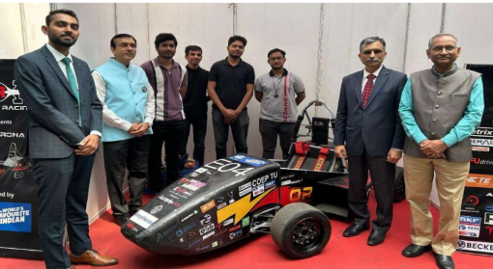
1. Finance & Stock Market
Conducted by: Mr. Harsh Goela, Stock Market Investor & Co-founder, Goela School of Finance LLP
A masterclass on stock market investing, financial literacy, and wealth creation strategies tailored for students and young professionals.
2. Design
Conducted by: Mr. Saptarshi Prakash, AVP of Design, Swiggy
An insight-driven session on design thinking, product design, and the role of design in building successful consumer-facing startups.
3. Data Security
Conducted by: Mr. Vinayak Godse, CEO, Data Security Council of India
A masterclass covering data security frameworks, cybersecurity challenges for startups, and the importance of building secure digital ecosystems.
4. Entrepreneurial Wisdom: Turning Vision into Venture
Conducted by: Ms. Pooja Shah, Founder & Managing Director, MIDAS School of Entrepreneurship
A session focused on the entrepreneurial mindset, translating ideas into viable ventures, and the practical realities of building and sustaining a startup.
5. Content Creation Blueprint: From Idea to Impact
Conducted by: Mr. Manish Pandey, Content Creator, Mentor, and Author
A masterclass on content strategy, storytelling, and building impactful digital presence — covering the full journey from ideation to audience engagement.
6. LinkedIn Growth: Connect & Conquer
Conducted by: Mr. Teja Gudluru, Founder & Career Growth Coach
A practical session on leveraging LinkedIn for professional networking, personal branding, and career growth for students and entrepreneurs.

Valedictory Ceremony
Date: 12th January 2025, 5:00 PM
Venue: Main Auditorium
Chief Guests: Dr. Samir Kamat (Secretary, DDR&D and Chairman, DRDO) and Mr. Sanjay Ghodawat (Chairman, Ghodawat Groups)
The Valedictory Ceremony marked the conclusion of PSF'25 with an inspiring close. Dr. Samir Kamat and Mr. Sanjay Ghodawat shared their valuable insights on the importance of innovation, leadership, and perseverance in the world of entrepreneurship and technology. Their speeches provided a fitting and motivating end to the fest, leaving participants inspired and eager to apply their learning in future ventures.

Outcomes and Impact
- Successful 7th edition of PSF with 600+ inauguration attendees and 80 investors participating.
- 15 startups pitched at Lightning Pitch; Pitchers Valley connected top startups with leading national investors.
- 198 participants engaged in BullRun; 170 participants competed in BidWars across two rounds.
- Six expert-led masterclasses delivered practical knowledge to 100+ participants each.
- School students empowered through Shishya with 200 participants from grades 8 to 12.
- Impactful keynote and valedictory sessions featuring IAS officers, DRDO Chairman, and industry leaders.

Faculty Advisor
Faculty Advisor: Dr. Prakash S. Shinde

Core Team 2024-25
Secretary: Deep Ghadia
Joint Secretary: Piyush Ladda
Accounts & Documentation: Prathmesh Golhar, Preet Damani
Alumni Outreach Group: Siddhi Sukesh, Vedanti Watekar
Campus Decoration: Aditi Kadam, Vaishnavi Gaikwad
Design & VFX: Himanshu Prasad, Soumyajit Das, Yash Ramesh Pawar
Events & Networking: Samina Ali, Shlok S Chilatre, Yash M Pawar
Finance & Sponsorship: Anushka Bidkar, Nilay Kotru
IIPR x IIC: Aishani Limaye
Investor Relations: Akash Mestha, Sakshi Khanorkar
Marketing: Atharva Pankaj Khadloya, Sanika Jogipethkar
Media & Photography: Srushti Avhad, Vedant Meshram
Operations & Logistics: Kaivalya Raut, Rana Deshmukh, Shubham Dengane
Public Relations: Nehal Agrawal, Soham Haldankar
Web & Tech: Abhijeet Jadhav, Tejas Vishwanath Kolhe

