NATIONAL SERVICE SCHEME (NSS)
"NOT ME, BUT YOU."

AAROH – 7 Days Special Winter Camp
Dates: 8th – 15th December 2024
Location: Shilimb Village, Taluka: Maval, District: Pune
Volunteers: 50 dedicated volunteers and 2 regular faculty members
Faculty In-charge: Prof. Rashmi Kulkarni

COEP Tech NSS Unit organized a 7-day residential camp named AAROH at Shilimb village, Taluka Maval, District Pune. The purpose of the camp was to engage in various activities aimed at the betterment of the village and its community. Activities included beautification of the village, estimation of solar panel streetlights and digital classrooms, contour mapping, contour model development, water testing, soil testing, and a Public Biodiversity Register (PBR) survey.

Day-wise Report

Day 1 – Camp Setup & Inauguration (Udghatana Samarambh)
NSS volunteers arrived at Shilimb, surrounded by lush greenery, and began by setting up a central hub, arranging medical kits, stationery, and tools. A detailed orientation session aligned the team with the camp's mission. The inaugural ceremony brought together villagers, elders, and children. Prof. Rashmi Kulkarni formally inaugurated the camp, inspiring collaboration and shared purpose. The day ended on a note of enthusiasm, setting a strong foundation for a week of learning, growth, and community engagement.
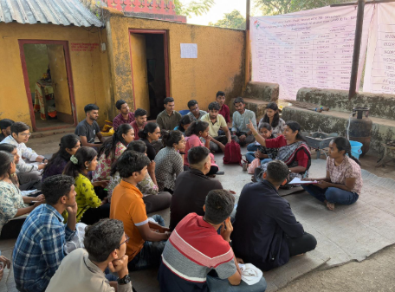

Day 2 – Morning Procession & Green Energy Awareness (Prabhatapher)
- Morning Yoga Session – Energized volunteers physically and mentally.
- Awareness Procession – Motivational rally promoting community development and unity.
- Guest Lecture – Ashwini Billare (Jeevitnadi NGO, Pune) shared insights on solar and wind energy.
- Hands-on Demonstration – Villagers learned practical applications of renewable energy.
- Interactive Q&A Session – Discussions on sustainable energy adoption in daily life.
- Future Planning – Volunteers brainstormed small-scale renewable energy projects for the village.
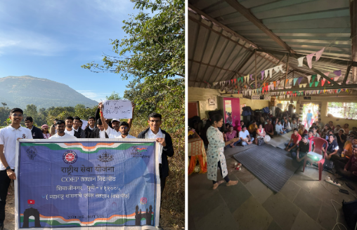

Day 3 – Health Check-Up Camp (Aarogya Ankar)
Medical Support: Surya Sahyadri Hospital, Pune
- Free health camp organized to provide essential healthcare services to villagers.
- Medical services included BP monitoring, blood sugar tests, eye check-ups, and general health consultations.
- Volunteers assisted in patient registration, guiding villagers, and distributing medicines and supplements.
- Inauguration by the eldest village member, symbolizing community well-being.
- Addressed rural healthcare challenges and strengthened the bond between volunteers and villagers.
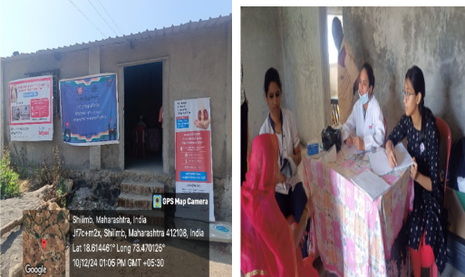

Day 4 – School Activities & HIV/AIDS Awareness
- Educational activities — storytelling, reading sessions (Akshar Bharti), drawing competitions, and games to boost confidence and creativity in children.
- Interactive learning environment created by volunteers to foster a love for learning.
- HIV/AIDS Awareness Session by Sayali Ghadkari — educated villagers on causes, prevention, and misconceptions, promoting open discussions.
- Community engagement — villagers actively participated, addressing stigma and the importance of early detection.
- Solar Estimation Survey — conducted by COEP Tech faculty to assess feasibility of solar panel installations.
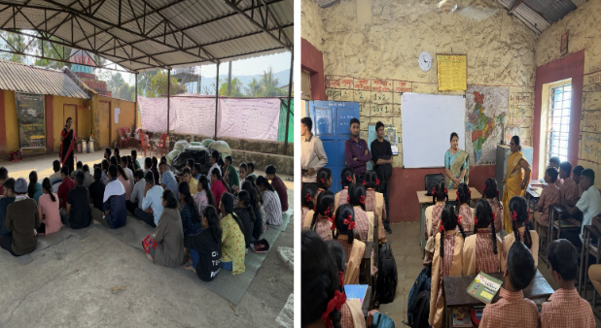

Day 5 – Mahila Bachatgat Yojana (Haldi-Kunku Upakram)
- Career guidance for 10th-standard students — experts shared information on scholarships and competitive exams.
- Digital readiness assessment — volunteers evaluated internet connectivity and digital infrastructure in the village.
- Financial literacy workshop for women by Prof. Sneha Patil — focused on Mahila Bachatgat Yojana and entrepreneurship skills.
- Women's interactive sessions including Sangeet Khurchi, fostering self-reliance and community bonds.
- Solar survey — evaluation of rooftops for future solar panel installations.
- Tree plantation drive — bringing villagers and volunteers together for long-term environmental commitment.
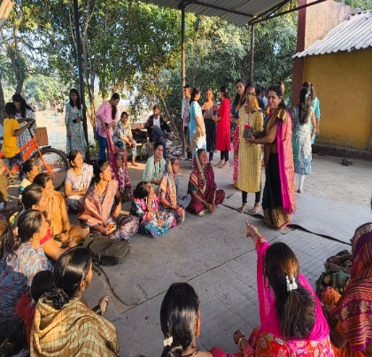

Day 6 – Disaster Management Workshop (Aapatti Prabodhana Karyashala)
Resource Person: Shree Yogesh Pardesi (Civil Defence Officer, Pune)
- Hands-on workshop on handling emergencies effectively.
- Life-saving techniques — first aid, CPR, injury management, and rescue using minimal resources.
- Live demonstrations and drills — evacuation drills, rope-tying, and assembling emergency kits.
- Volunteers simplified complex concepts, ensuring villagers could apply techniques confidently.
- Community left the session better prepared, more resilient, and committed to proactive disaster management.
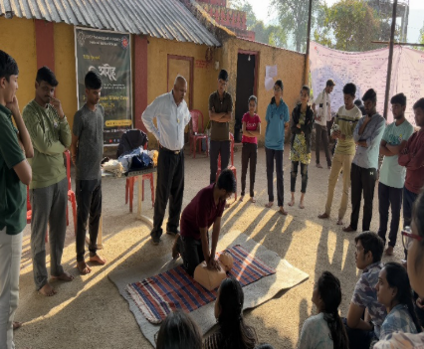
Day 7 – Fort Conservation, Contour Mapping & Model Preparation (Gad Samvardhan)
- Tikona Fort Visit — volunteers conducted a cleanliness drive to maintain the heritage site's historical significance.
- Contour mapping — villagers and volunteers collaborated to identify resources and areas for sustainable growth.
- Physical 3D contour model of Shilimb village built as a blueprint for future infrastructure planning.
- People's Biodiversity Register (PBR) Survey — documented the region's flora, fauna, and natural ecosystems for conservation.
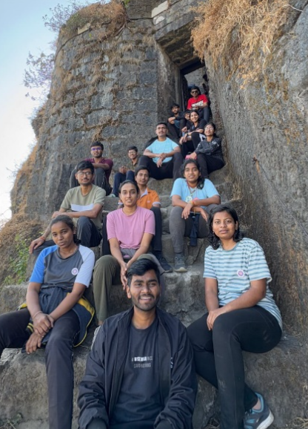
Day 8 – Street Play, Tree Plantation & Valedictory (Patnatya & Vrukshavruti)
- Street play (Patnatya) — a thought-provoking performance raising awareness on education, healthcare, and environmental conservation.
- Tree plantation drive — volunteers encouraged long-term environmental responsibility among villagers.
- Farewell ceremony — villagers and volunteers shared experiences, gratitude, and promises of continued connection.
- Volunteers restored the campsite as a gesture of respect and appreciation for the community.
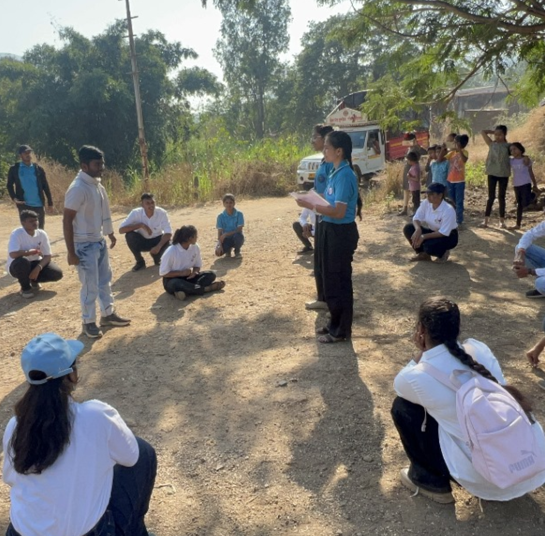

Camp Outcomes & Reports

Solar Estimation & Survey
The solar survey conducted during AAROH identified that many streetlights and electric poles in Shilimb were non-functional, affecting safety and daily activities. Temporary wiring solutions were unreliable, and frequent electricity disruptions — especially in the rainy season — impacted village life and tourism. Solar power was proposed as a sustainable alternative.
- PM-KUSUM Yojana and PM Surya Ghar Yojana identified as funding options for implementation.
- Collaboration with energy experts and local authorities recommended.
- Reliable solar street lighting to enhance safety, security, and enable night-time economic activities.

Public Biodiversity Register (PBR) Survey
A systematic documentation of the flora, fauna, and natural ecosystems of the Shilimb region was carried out to establish a community-level biodiversity record, supporting future conservation efforts.

Digital Classroom Estimation for School
An estimation and proposal for setting up a digital classroom at the local school was prepared, aiming to bridge the digital divide for students in the village.

Program Officer
NSS Program Officer: Prof. Rashmi Kulkarni
