NATIONAL SERVICE SCHEME (NSS)
"NOT ME, BUT YOU."
The National Service Scheme (NSS) is one of India's largest student volunteer programs, with the primary objective of fostering social consciousness and a sense of responsibility, empathy, and service among young people. Established in 1969, NSS operates under the Ministry of Youth Affairs and Sports in collaboration with universities, colleges, and other educational institutions across the country.

List of Activities Conducted
Every year, the NSS unit of COEP carries out different social activities to evoke the feeling of community service in the students. Activities conducted this year:
- Participation in SPPU's 'Ashadhi Wari Palakhi Sohala'
- Various college level competitions under 'Meri Maati Mera Desh'
- Amrit Kalash activity under 'Meri Maati Mera Desh'
- Tree Plantation on Teacher's Day
- Participation in various district level competitions under 'Meri Maati Mera Desh'
- Awareness Workshop at SPPU
- Amrit Kalash Collection Event
- Vegan Outreach Webinar
- Cleanliness Drive in college campus
- Participation in Sancheti Walkathon
- Purandar Fort Visit to promote 'Meri Maati Mera Desh'
- Viksit Bharat program broadcasting
- Dnyansaritha Granth Dindi
- FY Orientation (NSS Orientation 2023-24)
- Participation in SPPU's Kavya Sammelan
- 7 Days Special Winter Camp
- Women's Day Celebration

1. Ashadhi Wari Palakhi Sohala – 2023
Dates: 12th June – 13th June 2023
Savitribai Phule Pune University organized the activity 'Swachh Wari – Swasth Wari – Nirmal Wari – Harit Wari – Lokshahi Wari'. NSS volunteers of COEP Tech participated with great enthusiasm. On 12th June, SPPU organized a state-level program 'Rajyastariya Wari Y-20: Yuva Samvad aani Panchapran', attended by the Vice-Chancellor Mr. Suresh Gosavi and Maharashtra State Governor Mr. Ramesh Bais. Volunteers guided devotees, assisted the elderly, and helped maintain cleanliness along the Wari route. On 13th June, a Dindi ceremony was organized at SPPU, and volunteers participated wholeheartedly, gaining a deeply spiritual and positive experience.
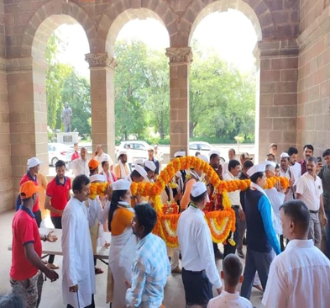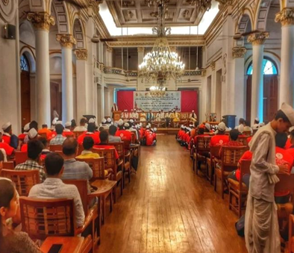

2. Competitions under 'Meri Maati Mera Desh'
Date: 28th August 2023
Under the joint organization of SPPU, NSS, and the Student Development Society, various competitions — essay writing, speech, folk singing, street play, folk instrumental music, and poster design — were conducted. The competitions were inaugurated by the honorable Prime Minister's initiative.
Speech Competition winners: 1st Rank — Anjali Pandey (Hindi), Harshvardhan Nikam (Marathi), Kshitija Metkari (Marathi); 2nd Rank — Tanaya Govardhan (Marathi), Kavish Patil (English).
Poster Design winners: 1st Rank — Swarnika Karale; 2nd Rank — Mrunmayi Sangale.
Essay Writing winner: 1st Rank — Pragati Shete.
Indian Folk Singing winner: 1st Rank — Devi Lavekar.

3. 'Amrit Kalash' Activity
Dates: 5th – 6th September 2023
Registrations: 315+
In response to the PM's call under 'Meri Matti Mera Desh', NSS organized the Amrit Kalash activity where participants photographed themselves placing a handful of soil in the Kalash. The NSS team set up a photo booth, and the activity saw 315+ registrations over two days with enthusiastic participation from faculty and students. The initiative was led by Dr. D.N. Sonawane Sir (Registrar, COEP Tech).
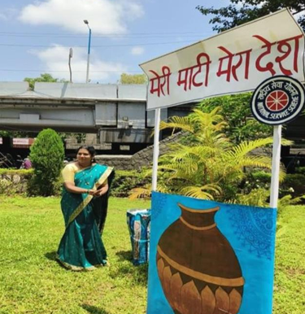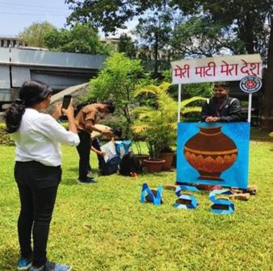

4. Tree Plantation on Teacher's Day
Date: 5th September 2023
A tree plantation program was organized on the COEP college ground by COEP Tech NSS and the Green Club under the guidance of NSS Program Officer Mrs. Rashmi Kulkarni. Vice Chancellor Prof. S.D. Agashe, Chief Rector Birajdar Sir, and Director of Student Development Board Khond Sir were present. Five species were planted: Mango (10), Peepal (17), Neem (3), Bakul (10), and Paras Peepal (10). NSS coordinators committed to nurturing 50 saplings.
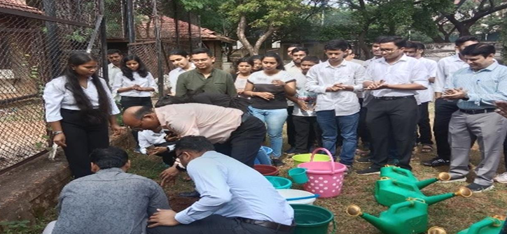
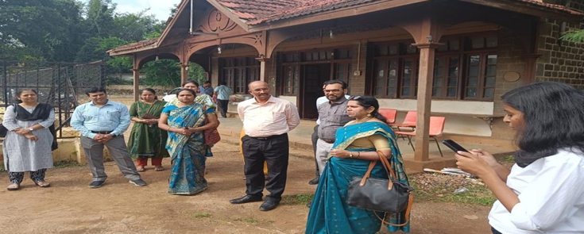

5. District Level Competitions
Date: 6th September 2023
Venue: Appasaheb Jedhe Art, Commerce, and Science College, Pune
Three students represented COEP Tech NSS at the district-level competition: Anjali Pandey (FY) in Speech Competition, Swarnika Karale (FY) in Poster Design Competition, and Pragati Shete (FY) in Essay Writing. All three performed remarkably well, earning certificates for their outstanding contributions, under the mentorship of Prof. Rashmi Kulkarni.
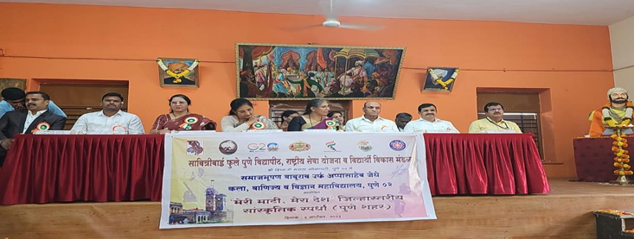
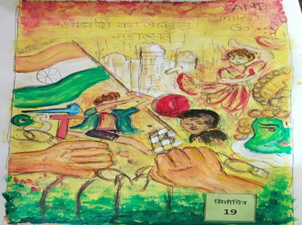

6. Awareness Workshop at SPPU
Date: 11th September 2023
On the occasion of 130 years of Swami Vivekananda's historic speech in Chicago, SPPU organized a one-day awareness workshop for NSS volunteers from affiliated colleges. 200 volunteers attended. COEP Tech NSS Secretary Atharv Patil participated in the program. The chief guest, BJP National Secretary Mr. Sunil Deodhar, spoke about Women's Empowerment and India's G20 presidency.
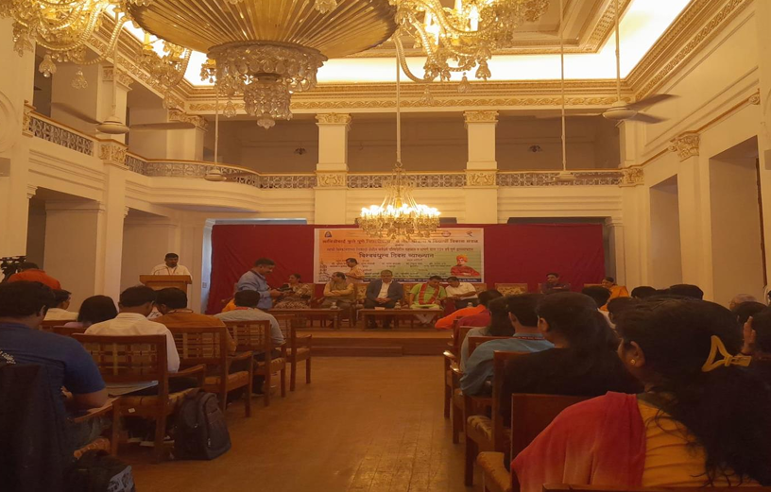

7. 'Amrit Kalash' Collection Event
Date: 26th September 2023
Venue: Main Auditorium, COEP Technological University
The consolidation of Amrut Kalashas collected from 22 universities across the state took place at COEP's Main Auditorium. Distinguished guests included BJP National President Shri J.P. Nadda, Minister of Higher and Technical Education Shri Chandrakant Patil, and BJP Maharashtra President Shri Chandrashekhar Bawankule. Nearly 2,000 NSS volunteers from 86 colleges attended. The event was managed by COEP Tech NSS volunteers under Dr. Rashmi Kulkarni.
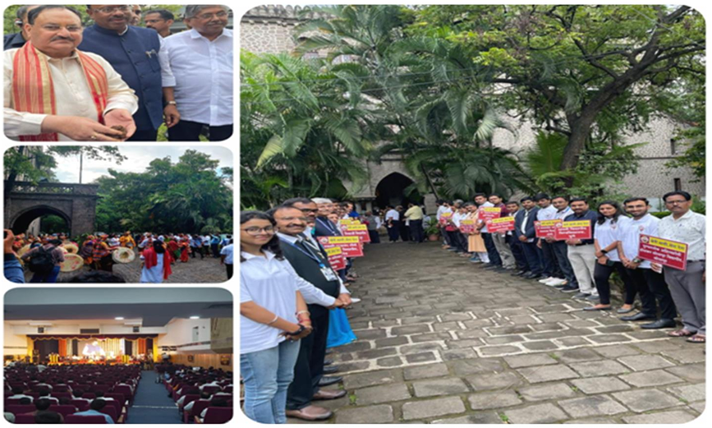

8. Vegan Outreach Webinar
Date: 30th September 2023
Participants: 35 (of 50+ registered)
COEP Tech NSS and Vegan Outreach organized an online volunteering webinar on the topic 'Food-Planet-Health'. Speaker Astha Gupta (Outreach Coordinator, Vegan Outreach India) advocated for a vegan diet and addressed the impact of food choices on animals and the environment. Participants received a certificate of attendance.
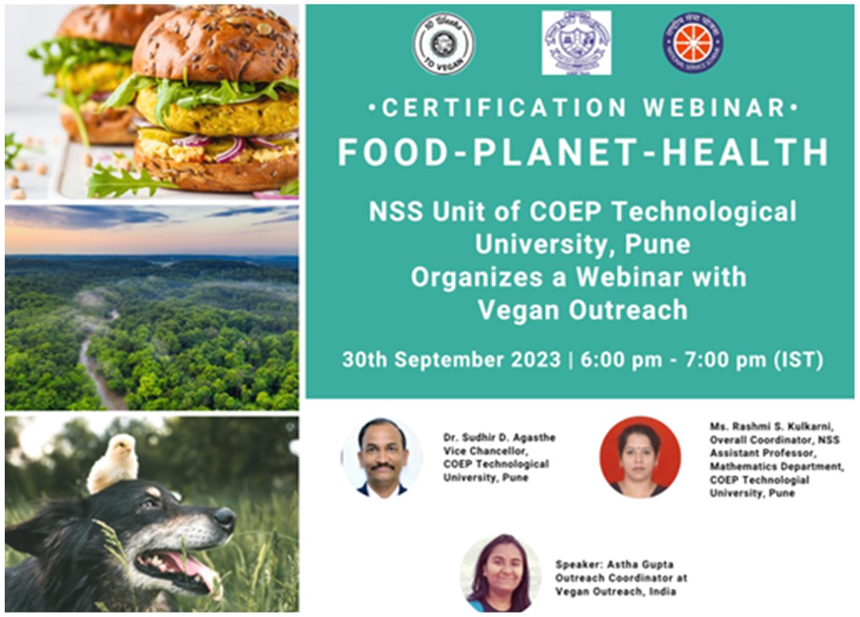

9. Cleanliness Drive — 'Ek Tareekh, Ek Ghanta, Ek Saath'
Date: 1st October 2023
Organized by COEP Team NSS in collaboration with Team Spandan and SWF as a tribute to Mahatma Gandhi, the cleanliness drive saw participation from the VC, Prof. Sudhir Agashe, Mr. Khond Sir, and other dignitaries along with college staff and volunteers. Participants took a pledge to dedicate 100 hours per year to cleanliness and cleaned both the North and South campuses.
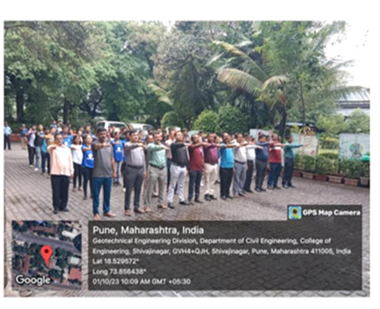
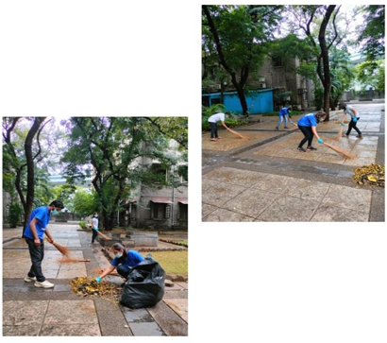

10. Sancheti Hospital Walkathon 2023
Date: 22nd October 2023
Volunteers: 104
COEP Tech NSS was invited to participate in the Sancheti Hospital Walk-A-Thon, an annual event aimed at raising awareness for arthritis prevention and treatment. 104 NSS volunteers participated under the guidance of Prof. M. Khond Sir and Prof. Neelima Kolhare Ma'am. Prof. Khond Sir was honored with a trophy for his significant contribution. Volunteers received T-shirts, refreshments, and certificates.
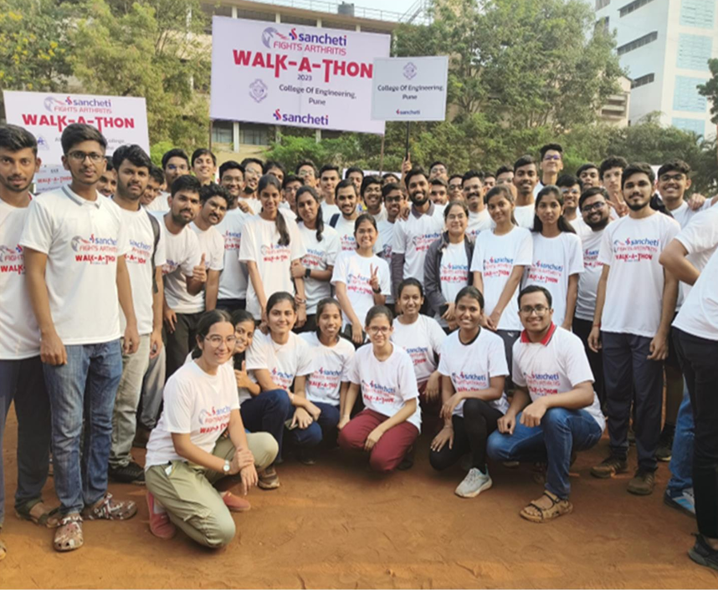

11. Purandar Fort Visit — 'Meri Maati Mera Desh'
Date: 29th October 2023
Participants: 54
COEP NSS, along with Spandan, the History Club, and EBSB, organized a visit to Purandar Fort. Significant maati (soil) was collected for the Amrit-rop-vatika creation. Visitors were encouraged to take selfies with the pavitra maati to spread awareness. On 30th October, the collected soil was used to create 75 Amritvatikas, symbolizing India's unity and heritage. The Vice-Chancellor and Registrar of COEP graced the event.
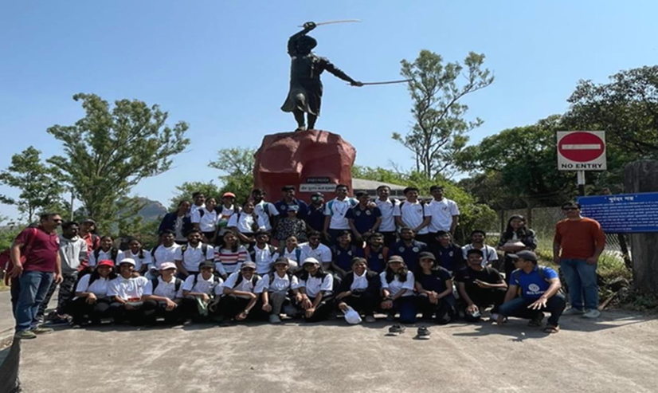

12. Viksit Bharat@2047 – Voice of Youth Program Broadcasting
Date: 11th December 2023
Venue: Mini Auditorium, COEP Tech University
Attendees: 100+
COEP Tech University NSS organized a live broadcast of the 'Viksit Bharat@2047: Voice of Youth' program, led by the Prime Minister. The program was attended by Dr. D.N. Sonawane Sir (Registrar), Dr. M. Khond Sir (BOSD), and Prof. Neelima Kolhare (Gymkhana VP). The aim was to engage college students and align their efforts with India's development objectives.
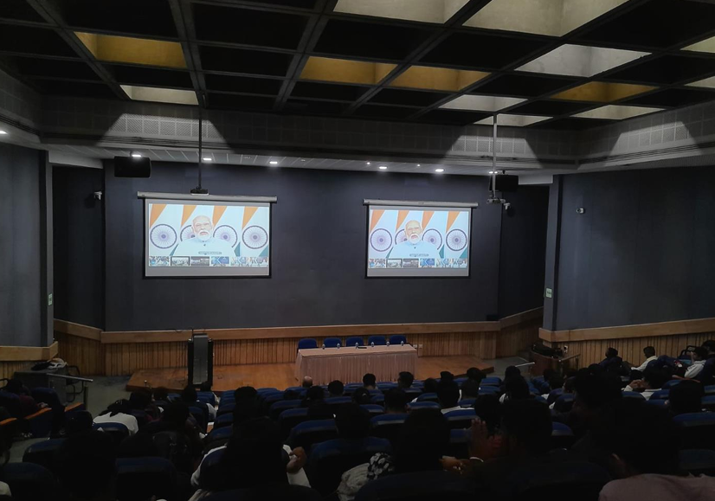

13. Dnyansarita Granth Dindi
Date: 15th December 2023
COEP Tech NSS, in coordination with Modern College of Arts, Commerce and Science NSS, organized the Dnyansarita Granth Dindi to pay homage to the life and legacy of Vasudev Balwant Phadake. A spirited rally progressed from the Old CID Office to COEP Tech's main building and towards Garware College. The event was part of the National Book Trust's Pune Book Festival held from 16–24 December 2023 at Fergusson College Ground. 29 dindis from various colleges participated.
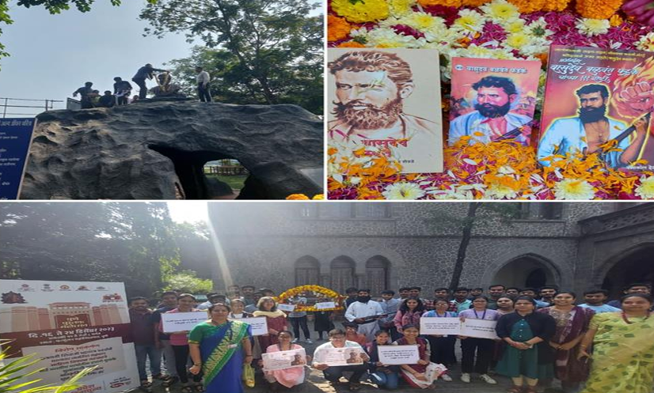

14. NSS Orientation 2023-24
Date: 29th January 2024
Volunteers: 60
COEP Technological University inaugurated its NSS Unit for AY 2023-24. Program Officer Rashmi Kulkarni welcomed the gathering. Chief Guest Dr. Prabhakar Varade, NSS Programme District Coordinator of SPPU, outlined upcoming activities. Volunteers were reminded of the NSS motto 'NOT ME, BUT YOU' and reaffirmed their commitment to working for society's welfare.
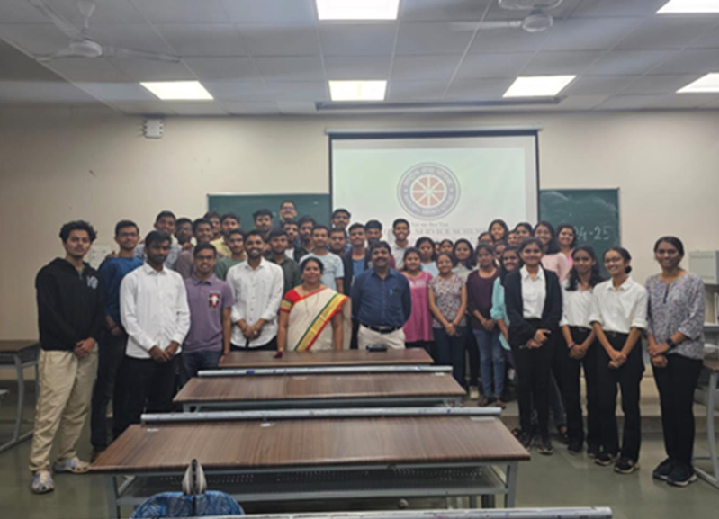

15. Participation in SPPU Kavya Sammelan
Date: 6th February 2024
Venue: Abasaheb Garware College, Karve Road, Pune
A team of COEP Tech students participated in the Kavya Sammelan (poetry competition) organized as part of the Amrit Mahotsav celebrations at SPPU. The competition focused on patriotic and environmental themes. Students proficient in Marathi, Hindi, and English poetry represented the university under the guidance of Prof. Rashmi Kulkarni.
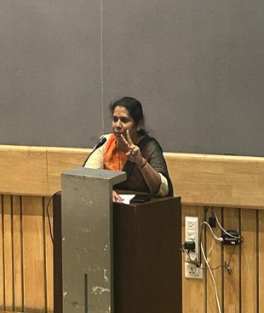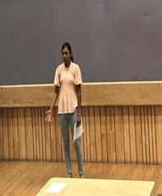

16. 7 Days Special Winter Camp
Duration: 23rd February – 29th February 2024
Venue: Wagheshwar, Taluka: Maval, District Pune
A 7-day residential camp was organized at Wagheshwar village under the guidance of Prof. Rashmi Kulkarni. The camp aimed at the betterment of the village and its community through activities including beautification of the village, estimation of solar panel streetlights, contour mapping, contour model development, water and soil testing, population control awareness, and voter awareness.
Key highlights included: a village survey and interaction with locals on Day 3; contour mapping and solar survey on Day 4; Marathi Rajya Bhasha Din celebration on Day 5; a visit to Tikona Fort on Day 6; and a concluding pathnatya performance at the Wagheshwar Bhairav Nath Temple on Day 7. Reports on solar estimation, contour mapping, and development proposals were submitted to the Gram Panchayat.
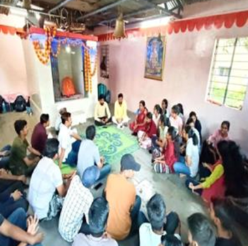
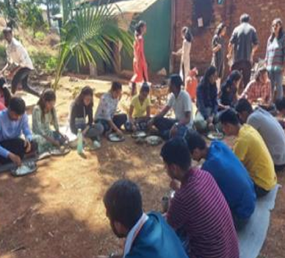
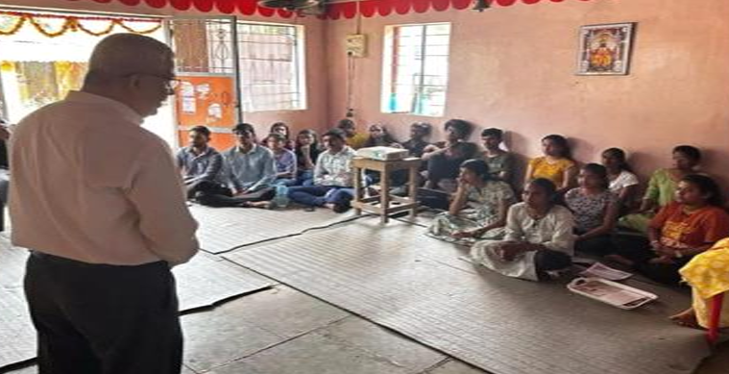
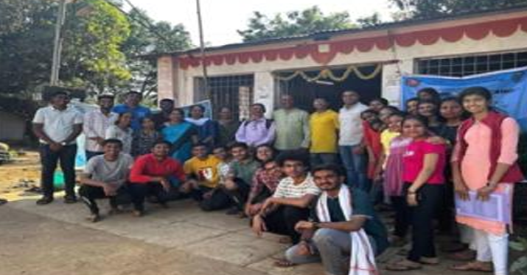

17. International Women's Day Celebration
Date: 7th March 2024
Venue: Mini Auditorium, COEP Tech
Participants: ~95
COEP Tech NSS participated in a special celebration organized by Team SWE and EBSB commemorating International Women's Day under the theme 'Inspire Inclusion'. The event featured an inspiring keynote address by Anita Iyer Narayan, Founder of EKansh Trust. Notable achievements of female students and faculty were recognized, and NSS volunteers expressed commitment to fostering inclusivity.
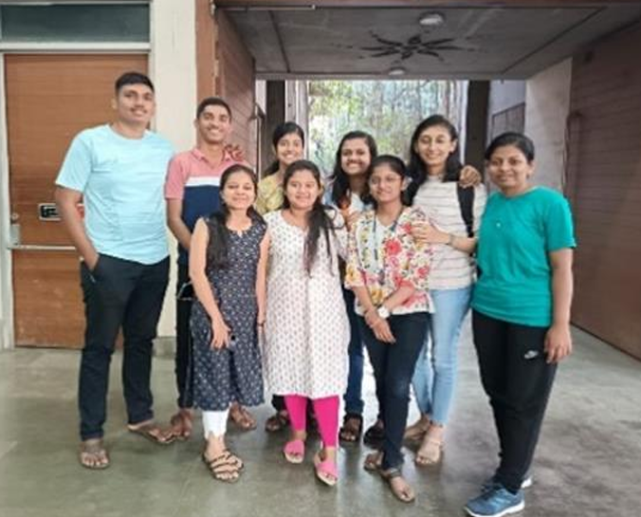

NSS Program Officer
Program Officer: Prof. Rashmi Kulkarni

