NATIONAL SERVICE SCHEME (NSS)

About COEP TECH NSS
The National Service Scheme (NSS) Unit of COEP Technological University is dedicated to developing the personality of students through community service. Every year, the NSS unit carries out different social activities to evoke the feeling of community service among students. This year, COEP Tech NSS conducted several innovative and impactful social activities aligned with national campaigns and the theme “NOT ME, BUT YOU”.

Objectives 2025-26
• To instill the spirit of community service and social responsibility among students.
• To promote awareness on health, cleanliness, environment, and national unity.
• To organize meaningful activities that connect students with real societal issues.
• To develop leadership, teamwork, and empathy through hands-on service projects.
• To contribute actively to national campaigns like Swachhata Hi Seva and village development.
• To strengthen the bond between the institute and the community through impactful initiatives.

Activities Conducted

1. State-Level “Tanavmukti & Vyasanmukti Dindi” under Swachh Wari – Swasth Wari – Nirmal Wari – Harit Wari (Pune to Pandharpur Ashadhi Wari)
Dates: 29th June to 6th July 2025
Participants: 156 NSS volunteers and program officers from various colleges
Under the guidance of Savitribai Phule Pune University, COEP Tech NSS volunteers participated in the state-level Dindi. Volunteers performed pathnatya (street plays), bharud performances, cleanliness drives, and acted as Police Mitras. They also managed accommodation, food arrangements, and received appreciation from local authorities for their exemplary service.
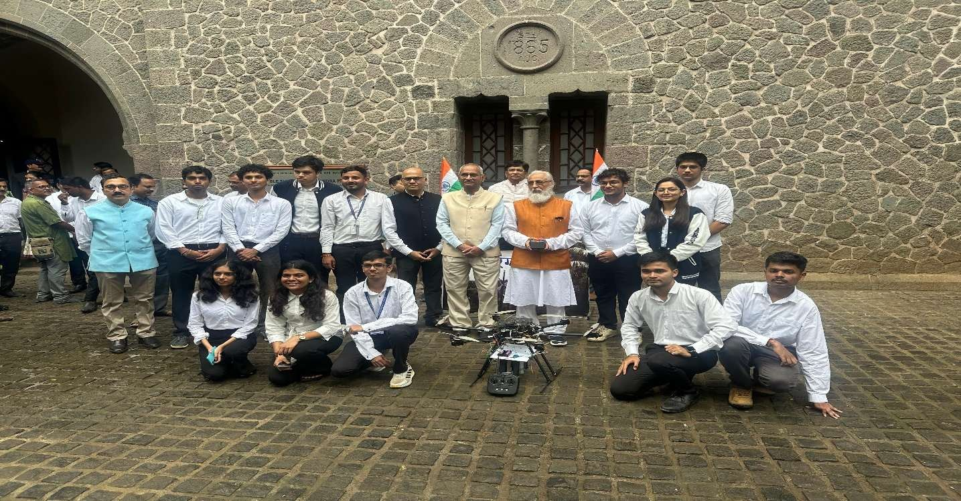
2. International Yoga Day – Varkari Bhaktiyog 2025
Date: 21st June 2025
Venue: Khashaba Jadhav Sankul, SPPU
Participants: NSS volunteers along with university dignitaries
The program was organized jointly by the Higher and Technical Education Department and SPPU. It featured a grand Yoga session in the presence of Deputy Chief Minister Shri. Devendra Fadnavis and other dignitaries. Volunteers contributed to the successful execution of the event.
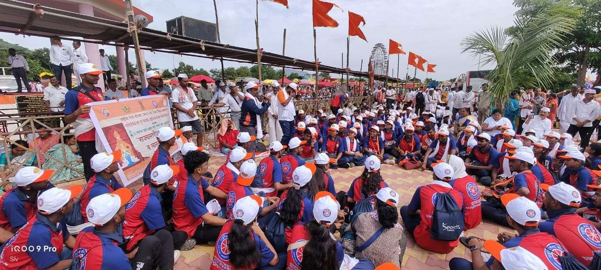

3. Independence Day Celebration – Har Ghar Tiranga & Partition Remembrance Program
Date: 15th August 2025
Participants: Large number of students and faculty
The university organized a poster exhibition “Vibhajan Vibhishika Smruti”, tri-colour Rangoli competition, flag-making activity, and a grand rally under the Har Ghar Tiranga campaign. Inspirational speeches by Dr. Anil Sahasrabudhe and partition survivor Dr. Raina were the highlights. Drone shows and flower vandana added a unique patriotic touch.

4. NIO Marathon for Blind Participants – Volunteer Support & Coordination
Date: 14th September 2025
Venue: Sports Complex, Savitribai Phule Pune University
Participants: Dedicated NSS volunteer team
NSS volunteers provided complete support to visually impaired runners by guiding them during the run, managing registration, safety, and refreshment stations. The event promoted inclusivity in sports and was organized by Guinness World Record holder Mr. Ashish Kasodekar.

5. Hypertension Awareness Camp – Beat The Pressure (in collaboration with Glenmark Pharmaceuticals)
Date: 20th September 2025
Venue: Seminar Hall 2, COEP Tech
Participants: Students, faculty, and staff
The camp included free BP check-ups, personalized BP scorecards, fitness tips, and certificates. It successfully spread awareness about hypertension causes, risks, and preventive measures, motivating participants to adopt healthier lifestyles.

6. NSS Day Celebration – A Step Towards Social Responsibility
Date: 24th September 2025
Participants: Around 90 active NSS members
The program featured lamp lighting, NSS Geet, felicitation of dignitaries, and an inspiring session by chief guest Swamiraj Suryakant Bhise on the theme “National Service Scheme: A Step Towards Social Responsibility”. A short documentary on the NSS journey was also screened.

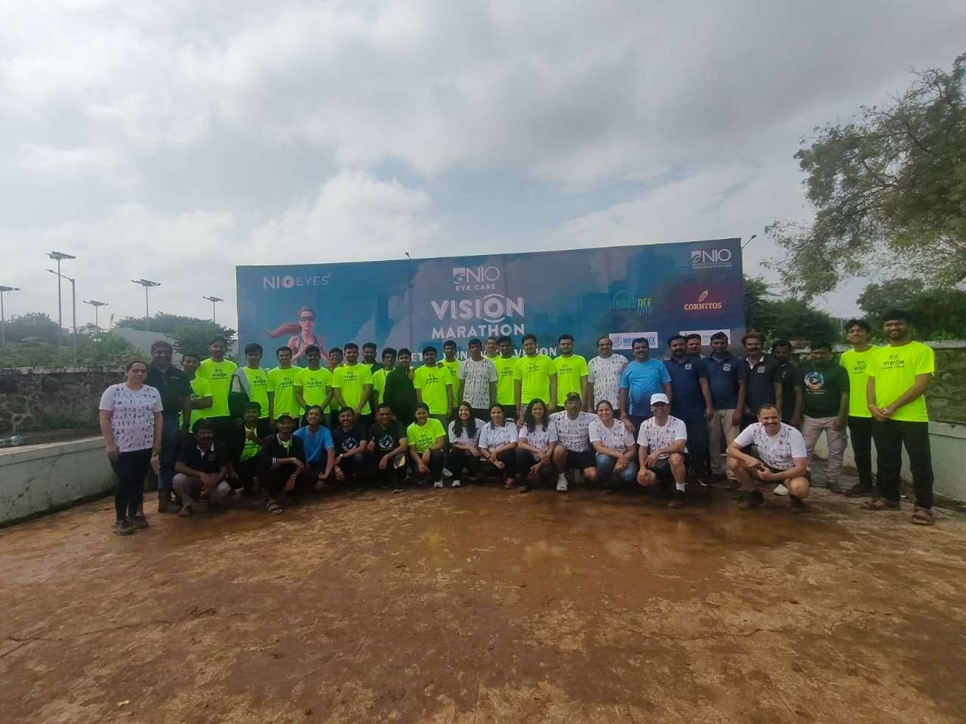

7. Swachhata Hi Seva Campaign – Swachhata Shapath (Cleanliness Pledge)
Date: 25th September 2025 (Pandit Deendayal Upadhyaya Jayanti)
Venue: Vice-Chancellor’s Lobby & all departments
Participants: 25–30 students per department
In alignment with the national “Swachhata Hi Seva” campaign, the NSS Unit organized the Swachhta Shapath across all departments. Students and faculty reaffirmed their commitment to cleanliness and the vision “My Department, My Responsibility”.
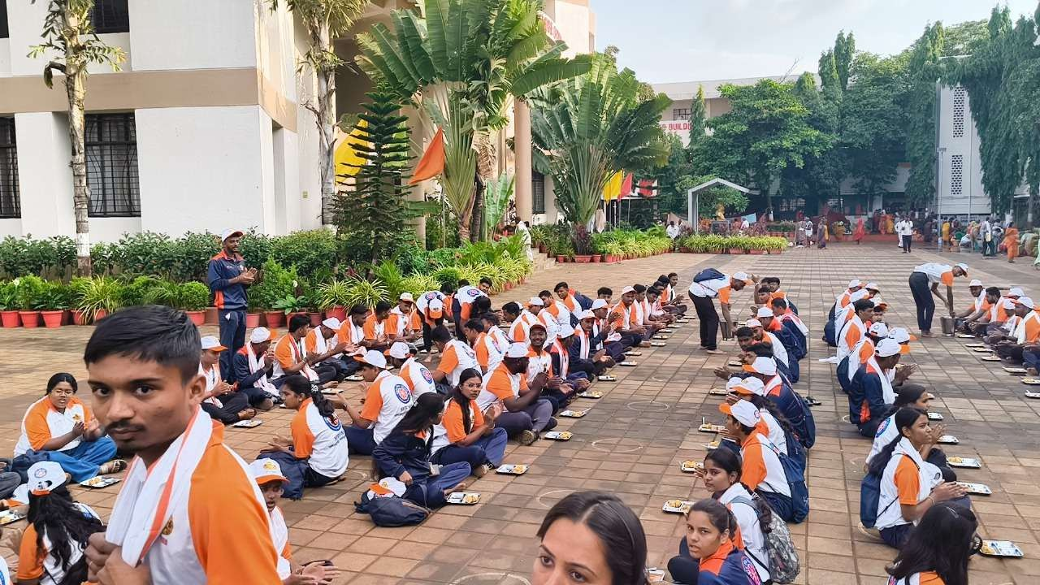

8. Department-wise Swachhata Shapath & Monthly Cleanliness Initiative
Ongoing throughout the year
Participants: All departments
Following the university-wide pledge, every department committed to conducting monthly cleanliness drives on the third Saturday of each month to maintain a clean and green campus.

9. NSS Cleanliness Drive in collaboration with Pune Municipal Corporation (PMC)
Date: Multiple drives during the year
Participants: NSS volunteers
Volunteers actively participated in city-wide cleanliness drives in collaboration with PMC, contributing to the Swachh Bharat Mission.
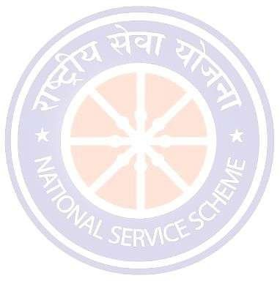
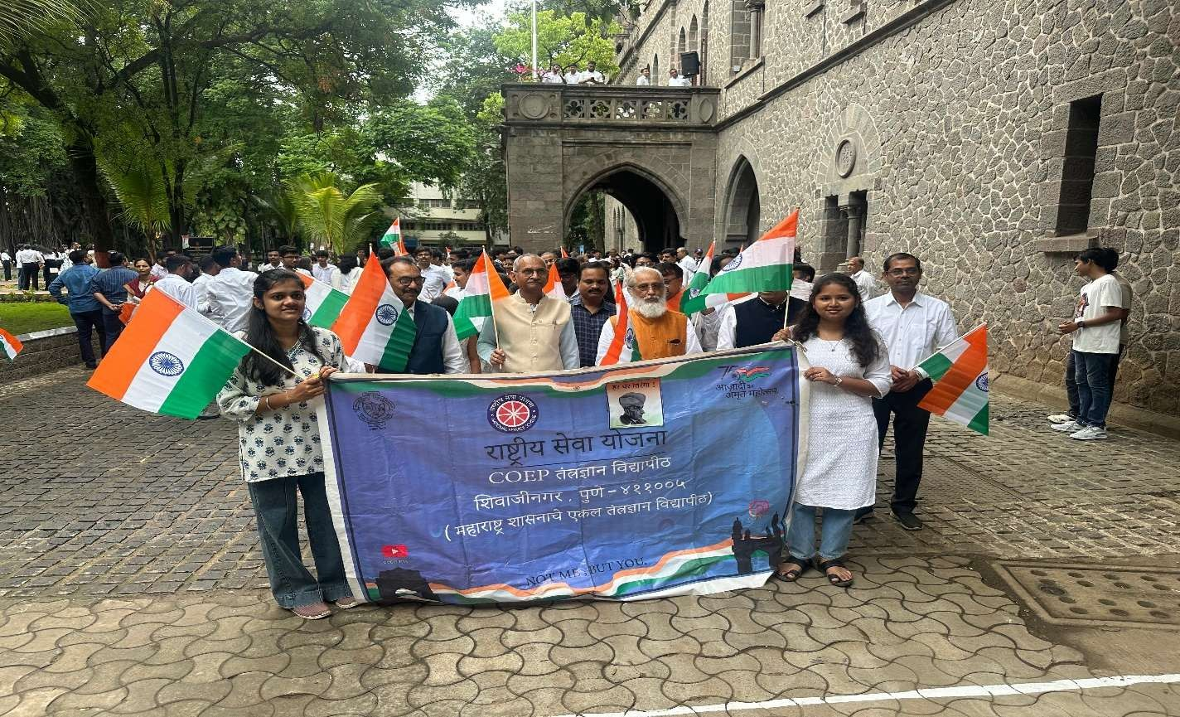

10. Fort Conservation Drive – Lohagad Fort
Date: During the year
Participants: NSS volunteers
Volunteers undertook conservation and cleanliness activities at Lohagad Fort to preserve historical heritage.

11. PRISM 2025 – Intercollegiate NSS Event (Participation & Award)
Date: During the year
Participants: COEP Tech NSS team
The unit participated in the intercollegiate NSS event PRISM 2025 and won awards for outstanding performance.
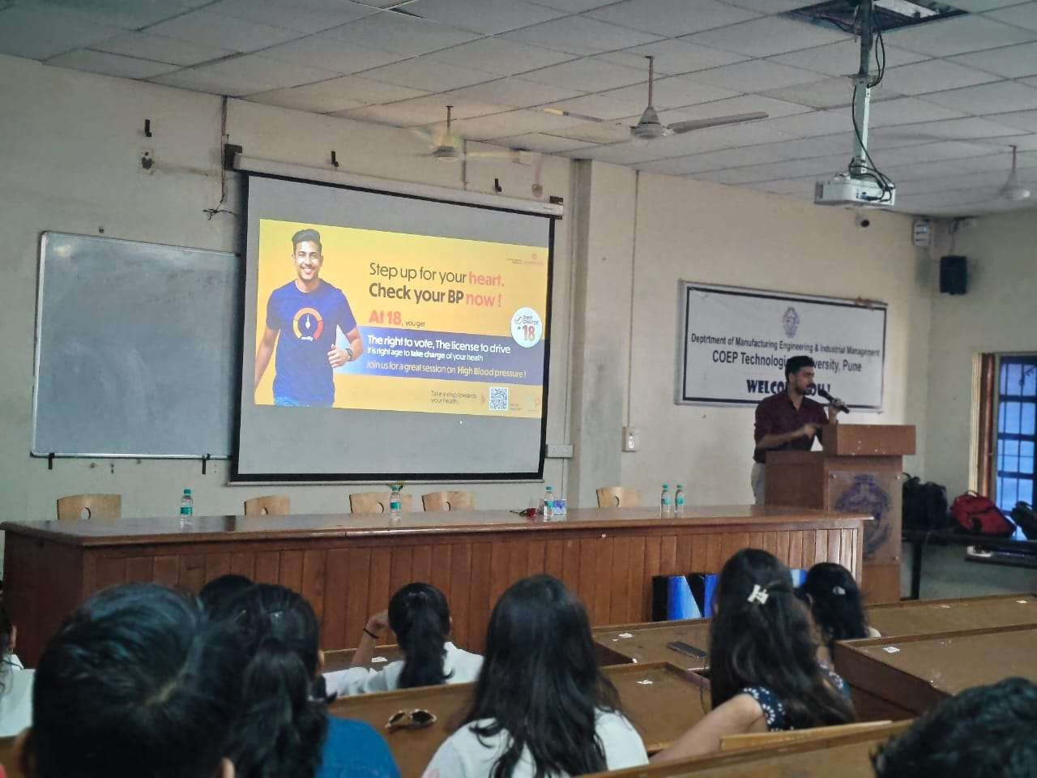
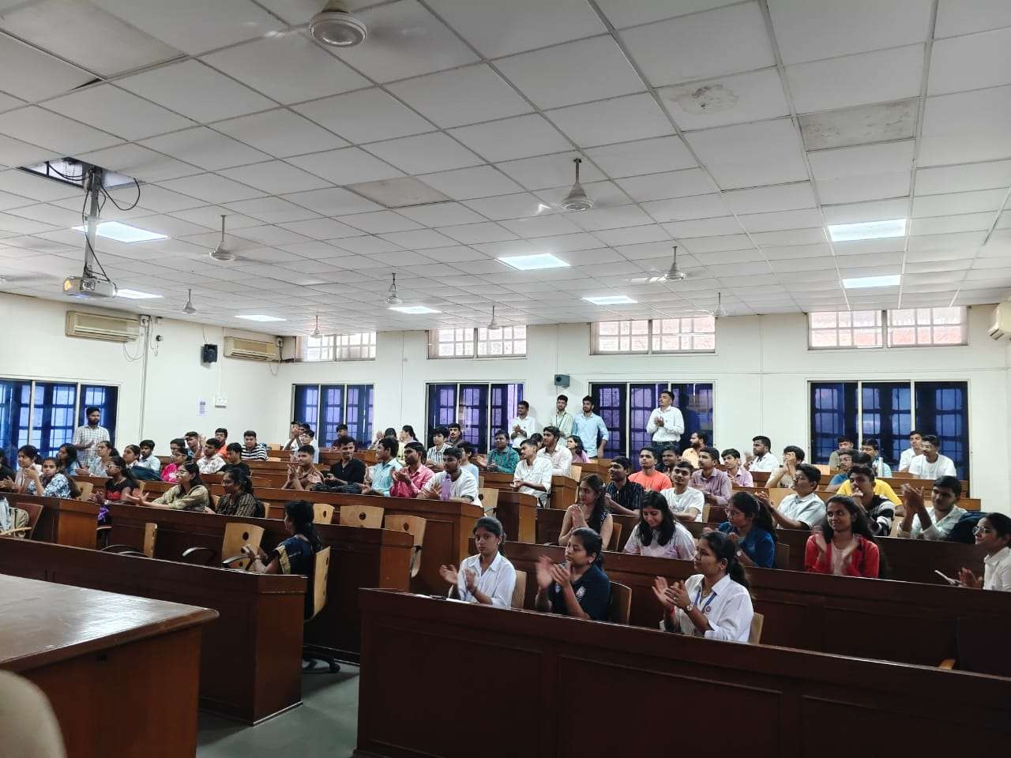

12. Unity March & Classroom to Cosmos Program
Date: During the year
Participants: NSS volunteers
The program promoted national unity and scientific temperament among students.

13. Walk for Unity – Sardar Vallabhbhai Patel Jayanti
Date: 31st October 2025
Participants: NSS volunteers
Volunteers participated in the Unity March to celebrate the birth anniversary of Sardar Vallabhbhai Patel.

14. AGRADOOT – Leadership Development for Social Change Program
Date: During the year
Participants: Selected NSS volunteers
The program focused on developing leadership skills for driving social change.

15. Sant Jagnade Maharaj Jayanti Celebration
Date: During the year
Participants: NSS volunteers
The unit celebrated the Jayanti with cultural programs and social awareness activities.

16. 8 Days Special Winter Camp – SPARSH (Village Adoption & Development Activities)
Date: During the winter break
Participants: NSS volunteers
The special camp adopted a village and carried out comprehensive development activities including cleanliness, health awareness, and infrastructure support.
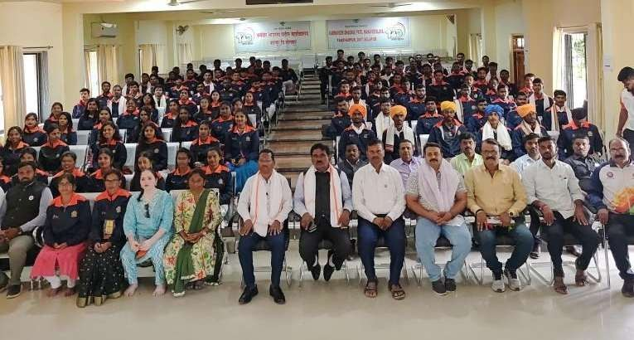
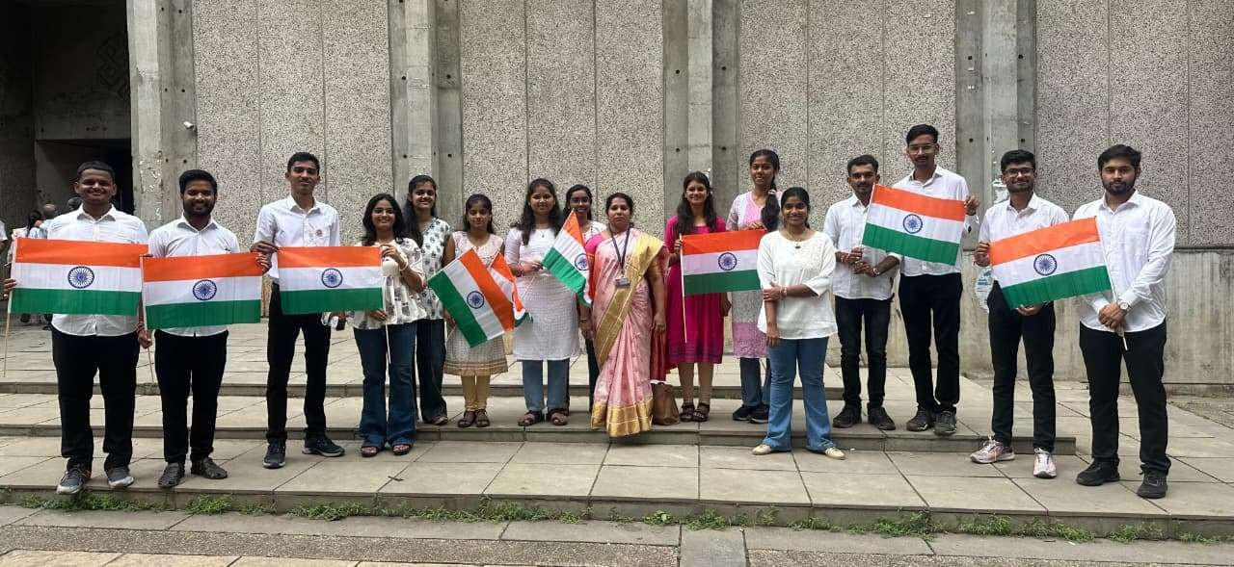

Outcomes and Impact
• Increased awareness about health, cleanliness, environment, and national unity among students.
• Active participation of over 500 students in various social service activities.
• Successful contribution to national campaigns like Swachhata Hi Seva and Ashadhi Wari.
• Development of leadership, empathy, teamwork, and civic responsibility.
• Strengthened institute-community bond through meaningful service projects.
• Recognition and awards at intercollegiate events like PRISM 2025.
• Creation of a sustained culture of monthly cleanliness and social responsibility on campus.

Core Team 2025-26
Program Officer: Prof. Rashmi Kulkarni
