NISARG – THE GREEN CLUB

About NISARG
NISARG – The Green Club is the environmental club of COEP Technological University, dedicated to promoting awareness about nature, biodiversity, and sustainable living among students. The club conducts nature visits, environmental monitoring, awareness programs, guest lectures, and field studies to encourage students to understand real-world environmental challenges and participate in conservation efforts.

Objectives 2025-26
- To create environmental awareness among students.
- To encourage participation in nature and conservation related activities.
- To provide practical exposure to environmental studies.
- To promote teamwork and leadership through club activities.
- To understand real-life environmental challenges in urban areas.
- To motivate students towards sustainable and responsible living.

Activities Conducted

1. Bird Watching Activity – ARAI Hills (Vetal Tekdi), Pune
Date: 3rd August 2025 (7:00 AM – 11:00 AM)
Participants: 50 Second Year students (two batches)
Guide: Professional birdwatcher Mr. Ajit Jere
The first activity of the academic year was a bird watching session at ARAI Hills (Vetal Tekdi), Pune. Students observed different species of birds and learned about their habitat, behavior, and ecological importance. The activity helped students understand biodiversity and the significance of nature conservation.

2. Coordinator Induction
During the induction program, new coordinators were introduced to the working and objectives of NISARG – The Green Club. Students were informed about upcoming environmental activities and encouraged to actively participate in club events. The induction helped form an active and dedicated team for the academic year.

3. Noise Monitoring during Ganesh Visarjan – Pune
Dates: 6th and 7th September 2025
Guided by: Dr. Shindikar Sir (conducting this activity for the last 25 years)
Noise monitoring was conducted during the Ganesh Visarjan procession. Sound levels of DJ systems and Dhol-Tasha groups were recorded at 10 different chowks on Laxmi Road, Pune. Monitoring was conducted across 6 time slots starting from 12:00 PM – 4:00 PM and continuing through the night till 8:00 AM – 12:00 PM the next day. Participating in this decades-long initiative under Dr. Shindikar Sir's guidance was a valuable learning experience for students.

4. Treasure Hunt for First Year Students
Date: 15th October 2025
Participants: ~50 students (8 teams of 6 members each)
A treasure hunt activity was conducted inside the college campus for first-year students. Clues were related to nature, environment, and general awareness. The event encouraged teamwork, observation skills, and active participation, making it an engaging introduction to environmental thinking for new students.

5. Tree Mapping Activity – Ganeshkhind Botanical Garden
Date: 7th February 2026
Members of NISARG participated in a Tree Mapping activity at Ganeshkhind Botanical Garden. Students observed and recorded different species of trees as part of the mapping process. The activity provided practical exposure to plant identification, biodiversity study, and the importance of maintaining green spaces in urban areas, helping students gain field experience in environmental documentation and conservation practices.
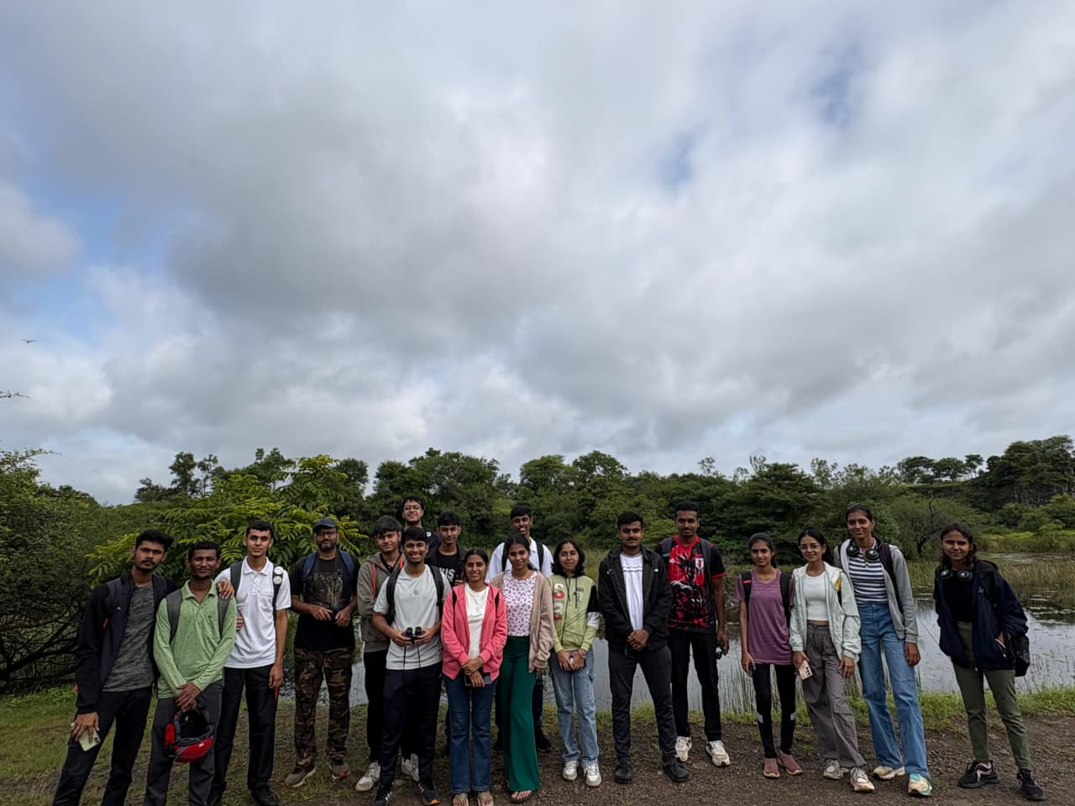

6. Guest Lecture – 'Pune's River: Challenges and Solutions'
Date: 13th February 2026
Speaker: Dr. Prajakta Ma'am
The guest lecture focused on the present condition of rivers in Pune, environmental issues caused by pollution and urbanization, and possible solutions for conservation. The session was informative and helped students understand real environmental problems faced by the city, connecting classroom knowledge to pressing local challenges.
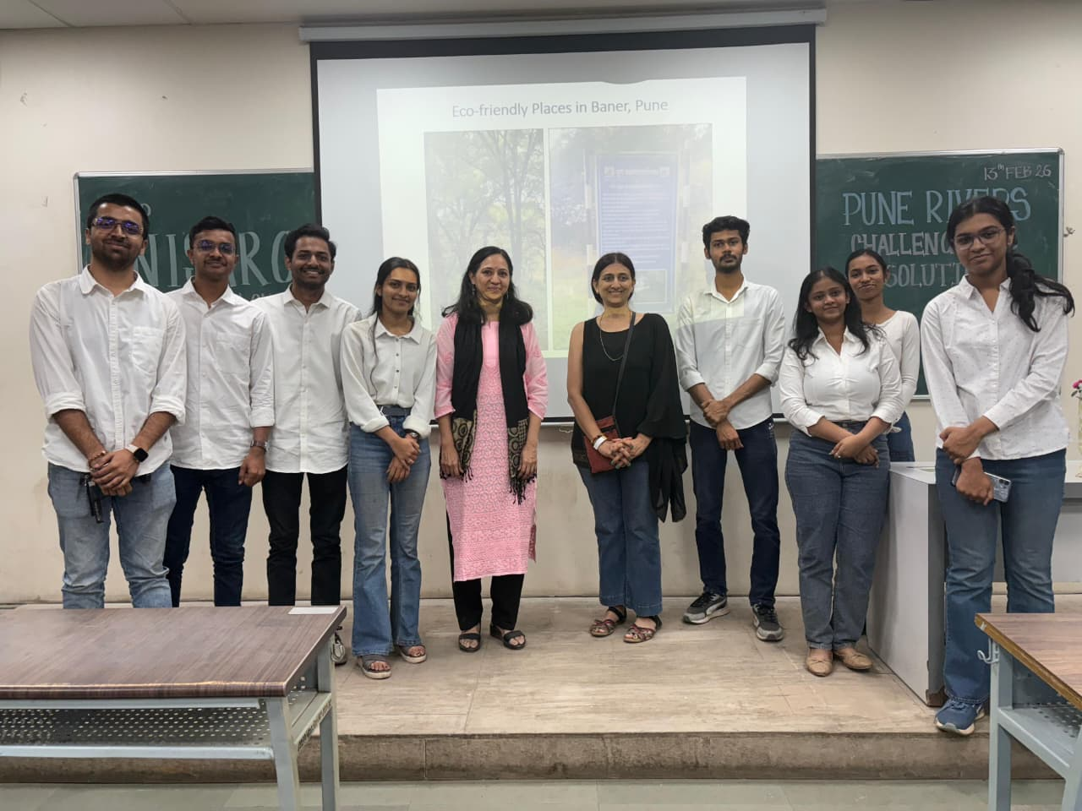

Outcomes and Impact
- Increased awareness about biodiversity and conservation among students.
- Practical understanding of environmental monitoring through the noise pollution activity.
- Improved teamwork and leadership skills through collaborative activities.
- Exposure to real environmental problems facing Pune and its rivers.
- Encouragement towards sustainable practices and responsible living.

Core Team 2025-26
President: Shreya Karande
Vice President: Mohit Kandalkar
Head of Documentation: Sumedh Brahmankar
Head of Events: Shantanu Kele, Shreya Shinde
Head of Public Relations: Mrunal Khutemate, Vedant Joshi
Head of Media and Design: Siddharth Shidid, Shravani Sutar

