MINDSPARK '23
Annual Technical Festival – COEP Technological University

Dates: 27th, 28th and 29th October 2023
Total Visitors / Participants: 25,000+
Competitions: 37

MindSpark is the annual Technical Festival of COEP Technological University. It comprises technical competitions, workshops, guest keynote sessions, technical and auto exhibitions. Through a meticulously curated blend of workshops, competitions, guest lectures, and exhibitions, MindSpark fosters a stimulating environment that empowers participants to translate their raw potential into tangible solutions for real-world challenges. Driven by the unwavering spirit of intellectual exploration and collaborative problem-solving, MindSpark aspires to be a launchpad for the next generation of tech pioneers, shaping the future with their ingenuity and dedication.

Distinguished Guests
Inauguration Chief Guest: Mr. Ashish Gaikwad (MD, Honeywell Automation)
Keynote Speaker: Mr. Sandeep Jain (CEO, GeeksForGeeks)
Valedictory Chief Guest: Mr. Anil Datar (Ex-Director, ARDE DRDO)

Inauguration
MindSpark '23 was inaugurated with Mr. Ashish Gaikwad, MD of Honeywell Automation, as the Chief Guest. His presence set a tone of industry engagement and innovation for the three-day festival.
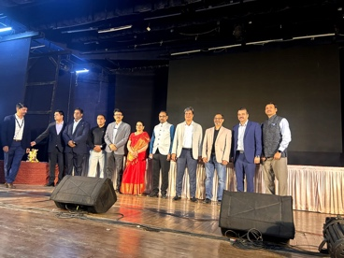
Keynote Session
Mr. Sandeep Jain, CEO of GeeksForGeeks, delivered a special keynote session on the topic 'Breaking into Product Based Companies', which captured widespread attention among the young and enthusiastic crowd — one of the most talked-about sessions of the fest.

Competitions
Students participated in 37 competitions across various technical domains, including the flagship 24-hour Hackathon and the Robotica Module events. Key competitions included:
- 24-Hour Hackathon — flagship programming and problem-solving marathon
- Robotica Module — diverse robotics competitions including Roboraces, Robowars, Bot Wrestling, and Virtual Robotics
- NeuroHack 2.0 — Data Science and AI Hackathon organized by DSAI Club
- RoboFalconry — drone racing event organized by ARSC
- 37 competitions in total spanning all major technical domains

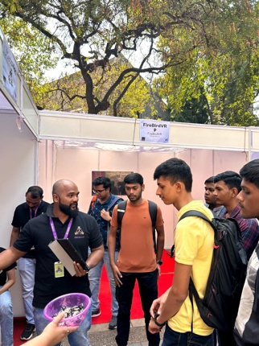
Technical and Auto Expo
The Technical and Auto Expo served as the breeding ground for excellence, innovation, and curiosity — showcasing projects, prototypes, and innovations developed by students from COEP and visiting institutions.

Social Initiative – Paakhi
MindSpark's own social initiative Paakhi, aimed at women empowerment, was held successfully before the fest. The initiative included activities to enlighten young girls about personal finances, savings, and financial independence, reflecting MindSpark's commitment to social responsibility alongside technical excellence.
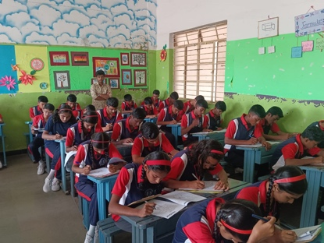

Genius Junior
Participants: 4,000+
Genius Junior, aimed at bringing out the best among school students, was conducted in and around Maharashtra. The competition saw 4,000+ school students participating, giving young talent a platform to showcase their academic and technical abilities.

Cultural Night
MindSpark's Cultural Night was performed by the COEP Cultural Club, featuring the Purushottam Karandak play 'Vilakha' — a suspense thriller — along with a musical performance, greatly appreciated by the audience.

Valedictory Ceremony
Mr. Anil Datar, Ex-Director of ARDE DRDO, graced the Valedictory Ceremony as Chief Guest, sharing his wisdom and experience with students and bringing the three-day festival to a successful and inspiring close.
