KHO-KHO CLUB
COEP Technological University's Kho-Kho Club is a dynamic student-led sports organisation dedicated to encouraging the traditional Indian game of Kho-Kho and developing physical fitness, teamwork, discipline, and sportsmanship in its members. The club focuses on enhancing athletic ability and leadership skills through competitive play, using speed, agility, strategy, and coordination.

Matches & Tournaments

1. MIT-ADT Tournament
Result: Lost in Quarter Finals
The team participated in the MIT-ADT tournament, reaching the quarter-final stage before being eliminated. The competitive exposure provided valuable insights into areas requiring further improvement.

2. Practice Match vs IISER
Result: Win
The Kho-Kho practice match against IISER ended in a thrilling victory, reflecting the true spirit of the game. Both teams displayed exceptional skill, agility, and determination throughout the match, making it a highly competitive and enjoyable contest. The COEP team showcased strong coordination, sharp defensive moves, and relentless chasing, proving the depth of preparation and team unity. Every player stepped up, supported one another, and gave their best on the field.
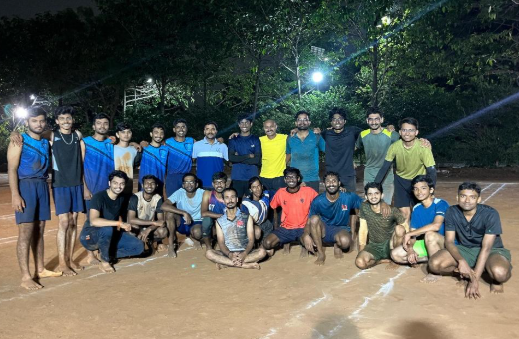

3. Daily Practice at Police Ground
Duration: 20 days
The team undertook an intensive 20-day training program at the Police Ground, focused on improving team coordination and match sense. Regular structured practice sessions significantly enhanced the team's tactical understanding and fitness levels.

4. COEP Zest '24 – Boys Team
Stage: Knockout Match
Result: Eliminated
The boys' Kho-Kho team competed in COEP Zest '24 in the knockout stage. The team put in a determined effort but faced a strong opponent early in the competition. Although the team could not progress further, the match provided valuable insights into areas requiring improvement, particularly in handling high-pressure knockout situations.

5. COEP Zest '25 – Girls Team
Stage: Knockout Match
Result: Eliminated
The girls' Kho-Kho team delivered an excellent performance, displaying strong coordination, discipline, and confidence. The team unfortunately lost the match and was eliminated, but their performance demonstrated significant growth in competitiveness and team spirit.

Focusing Areas

Training, Team Development & Performance Analysis
- Regular training sessions focusing on strength, endurance, and agility.
- Practice drills emphasising raiding techniques and defensive chains.
- Development of team coordination and match strategies.
- Exposure to high-intensity tournaments to improve mental resilience.
- Leadership development among senior players.
- Encouragement of fair play and sportsmanship.

Club Members

Role | Name
Secretary & Captain | Rohit Repal
Girls Captain | Suhani Nigam
Senior Player | Guru Kamble
Senior Player | Yogesh Patil
Senior Player | Abhinandan Jugale
Senior Player | Atharv Mahajan
