KABADDI CLUB
Kabaddi has always been one of the most competitive and disciplined sports at COEP Technological University. During the academic year 2024-25, the Kabaddi section actively focused on skill development, team bonding, and competitive exposure for both senior and junior players. Special emphasis was placed on grooming the junior team, ensuring continuity and long-term growth of the Kabaddi culture at COEP.

Practice Matches

1. Senior Team vs AISSMS
Date: 15th October 2024
Result: COEP Win
The COEP senior Kabaddi team played a practice match against AISSMS. The match helped players assess their physical preparedness and tactical awareness. COEP displayed strong raiding skills and effective defensive coordination, resulting in a confident victory. The match proved valuable in identifying key players and refining team combinations.
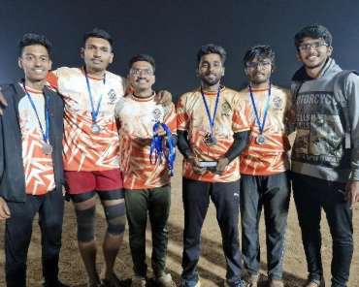

2. Junior Team vs AISSMS
Date: 22nd January 2025
Result: COEP Junior Team Win
The COEP Junior team played against AISSMS with great enthusiasm and discipline. The juniors showcased remarkable improvement in basic skills such as ankle holds, chain tackles, and bonus point strategies. The win significantly boosted confidence among junior players and motivated them to perform consistently in future competitions.

3. Junior Team vs IISER, Pune
Date: 12th January 2025
Result: COEP Junior Team Win
The junior team faced IISER, Pune in an away practice match. As many players were first-year students, this match played a vital role in introducing them to competitive Kabaddi. The team maintained composure under pressure and executed planned strategies effectively, contributing greatly to the overall development of the junior squad.

Tournament Performances

1. MIT Summit '25 – Boys Team
Date: 26th January 2025
Stage: League Stage
Result: Win
The boys team delivered a strong performance during the league stage of MIT Summit '25. Defensive strength and coordinated raids helped secure an important league-stage victory.

2. MIT Summit '25 – Girls Team
Date: 27th January 2025
Stage: League Stage
Position: 3rd Place
The girls Kabaddi team showed exceptional fighting spirit and consistency throughout the league matches. Their disciplined gameplay helped them secure third place, highlighting the growing strength of women's Kabaddi at COEP.
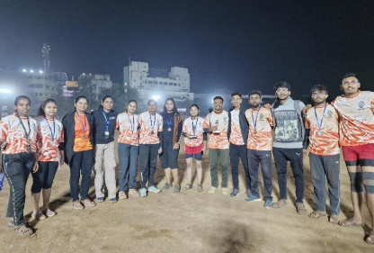

3. AISSMS Shivaji Trophy
Date: 1st February 2025
Stage: Quarter Final
The COEP boys team participated in the prestigious AISSMS Shivaji Trophy, advancing to the quarterfinal stage. Despite the loss, the tournament proved extremely valuable in strategic learning and mental toughness, particularly with ZEST approaching.
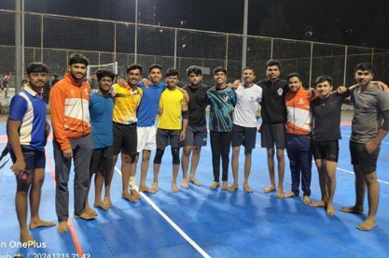

4. COEP ZEST '25 – Boys Team
Date: 9th February 2025
Position: Runner-Up
At COEP ZEST '25, the boys Kabaddi team delivered an outstanding performance throughout the tournament. With excellent teamwork, discipline, and resilience, the team reached the finals and secured the Runner-Up position. The final match was closely contested and decided by a very narrow margin, reflecting the high level of competition.

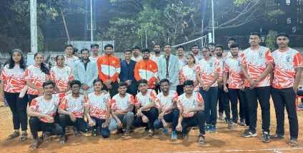
5. COEP ZEST '25 – Girls Team
Date: 9th February 2025
Position: Runner-Up
The girls Kabaddi team also performed remarkably well at ZEST '25. Their consistent performance, strong defense, and strategic raids helped them reach the finals where they secured the Runner-Up position. The team's dedication and teamwork were highly appreciated.

Training Focus Areas
- Regular practice sessions focused on fitness, stamina, and flexibility.
- Special drills for raiding techniques, defensive formations, and coordination.
- Grooming of junior players to prepare a strong future squad.
- Emphasis on discipline, leadership, and sportsmanship.
- Match analysis sessions to identify strengths and areas for improvement.

Core Team

Role | Name
Secretary | Dhanajay Gaikwad
Captain | Digvijay Patil
Girls Captain | Pritija Ghorpade
Senior Player | Sanjay Genji
Senior Player | Abhishek Mane
Senior Player | Shivraj Gaytidak
Senior Player | Atharv Shrikhande
Senior Player | Rishikesh Patil

