KABADDI CLUB
Kabaddi has been one of the most actively pursued sports at COEP Technological University, promoting physical fitness, discipline, teamwork, and leadership among students. During the academic year 2023–24, the Kabaddi section participated in multiple intercollegiate tournaments, including knockout and league formats, providing valuable competitive exposure to both senior and junior players.
The year was marked by strong performances, notable achievements, and important learning experiences that contributed significantly to the overall growth of the team.

Major Tournaments & Match Performances

1. AIT Intercollegiate Kabaddi Tournament
Format: Knockout Tournament
The COEP boys Kabaddi team participated in the AIT Intercollegiate Kabaddi Tournament, displaying excellent coordination, defensive strength, and confidence during the initial rounds.
- Knockout Match 1: Won
- Knockout Match 2: Won
After securing two consecutive victories, the team advanced to the Quarter Final stage. In the quarterfinal match, COEP faced a strong and experienced opponent. Despite a fighting performance, the team was eliminated at this stage. The tournament helped players gain high-pressure match experience and improve tactical decision-making.

2. COEP ZEST '24 – Boys Team
Achievement: Champions / Winners
The boys Kabaddi team delivered an outstanding performance at COEP ZEST '24, the university's flagship sports event. Throughout the tournament, the team maintained consistent form, strong defense, and well-planned raiding strategies. The players showcased excellent teamwork, discipline, and mental strength in crucial moments. Their dedication and hard work resulted in the team emerging as Champions of ZEST '24 — one of the most significant achievements of the year.

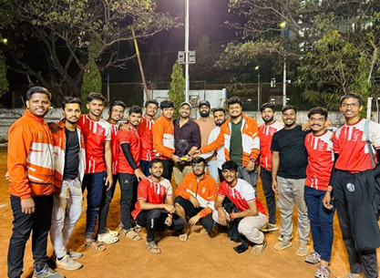

3. COEP ZEST '24 – Girls Team
Achievement: Runner-Up
The girls Kabaddi team performed commendably at ZEST '24, playing with great determination and confidence and successfully reaching the finals. The players exhibited strong defensive skills and effective raiding throughout the tournament. In the final match, the girls team fought valiantly but narrowly missed the title, securing the Runner-Up position. Their performance reflected the growing strength and competitiveness of women's Kabaddi at COEP.

4. AISSMS Intercollegiate Kabaddi Tournament (Junior Team)
Format: Knockout Tournament
Result: Eliminated in the First Match
The COEP Junior Kabaddi team participated in the AISSMS intercollegiate tournament. As many players were relatively new to competitive Kabaddi, this tournament served as an important learning opportunity. Despite the loss, the junior players gained valuable match exposure and learned to handle tournament pressure, contributing to their long-term development.

5. MIT Summit Kabaddi Tournament
Format: Knockout Matches
- First Knockout Match: Won
- Next Round: Eliminated
The team showed good coordination and fighting spirit in the opening match. In the subsequent round, the team was eliminated. This tournament helped players analyze their strengths and identify areas for improvement, particularly in high-intensity knockout scenarios.
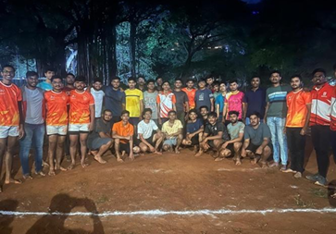

6. VJTI Kabaddi Tournament
Format: League Stage followed by Knockouts
COEP performed exceptionally well during the league stage, topping the league table and successfully qualifying for the Semi-Finals. Unfortunately, due to management and scheduling issues, the team could not participate further in the tournament. Topping the league stage nonetheless demonstrated the team's consistency, preparation, and competitive capability.

Core Team Members

Role | Name
Secretary | Sanjay Genji
Captain | Digvijay Patil
Girls Captain | Pritija Ghorpade
Senior Player | Tanmay Thakre
Senior Player | Shubham
Senior Player | Omkar Patil
Senior Player | Manas Jadhav
Senior Player | Rohan Deokar
Senior Player | Abhishek Mane
Senior Player | Shivraj Gaytidak

