IMPRESSIONS '24
Annual Cultural Festival – 9th Edition
Theme: Rangrez – The Artist Within

Pre-Fest Events

1. Under 25 Summit
A collaboration with youth organizations to connect students with professionals, providing networking opportunities and career-related insights for young college students.

2. Mr. and Ms. Impressions
Judge: Taneesha Joshi
A cultural talent competition designed for freshers, providing a platform for newcomers to showcase their personality, confidence, and creative abilities on stage.
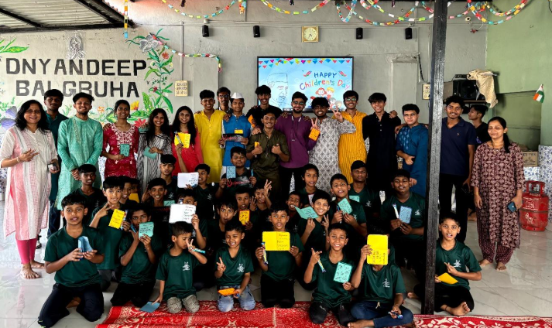

3. Children's Day at Dnyandeep Balgruh – Muskaan
As part of the social initiative Muskaan, members visited Dnyandeep Balgruh to organize sports and fun activities for children, spreading joy and creating meaningful connections with the community.

4. Raahi Hostel Sundowner
A soulful musical evening held at the hostel ground, featuring intimate performances that created a relaxed and celebratory pre-fest atmosphere on campus.

5. Ukulele Workshop
A hands-on music workshop introducing students to the ukulele, encouraging musical exploration in an accessible and fun format.

6. Kala Kumbh
A mental health and art therapy workshop integrating art, music, and movement therapy to promote well-being and mindfulness among students — reflecting Impressions' commitment to holistic artistic engagement.

Main Fest – 18th and 19th December 2024

Arts & Crafts Module
- Cirकला – Mandala art competition
- Game of Shades – Graphite sketching competition
- Colorsplash – Painting competition
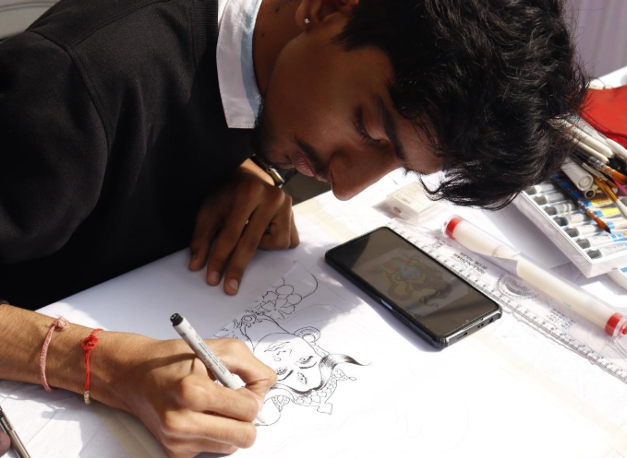
Music Module
- Saavani – Solo singing competition
- Stay Tuned – Musical instrument playing competition

Dance Module
- Nrityagana – Classical dance competition
- Step It Up – Solo dance competition
- Dance Dil Se – Group dance competition

Abhinay Module (Drama)
- Scenesational – Group acting competition

Camera Module
- LensArt – Photography competition
- Reelscape – Short video competition

Shoutout Module
- COEP Open Mic – Solo performances of poetry, stories, and monologues

Workshops & Interactive Sessions
- Drum Circle Workshop – Hands-on rhythmic experience
- Candle Making Workshop

Social Initiatives
- Muskaan Orphanage Day – Children's activities and games
- Rangrez Flea – A market showcasing handcrafted arts and crafts by local artisans and students

Performances & Proshows
- Performance by Ms. Ketakee Mateygaonkar at Inauguration
- Storytelling by Helly Shah – Inaugural event
- The Jogi Experience – Sufi music performance
- Maahi Mukherjee – Live concert with 2,700+ attendees

Key Milestones & Achievements
- 9th edition successfully conducted under the theme 'Rangrez: The Artist Within.'
- 250+ participants across 12 competitions; 2,000+ attendees over 2 days; 2,700+ attendees at Maahi Mukherjee's live concert.
- Distinguished performances by Ketakee Mateygaonkar, Helly Shah, The Jogi Experience, and Maahi Mukherjee.
- Impactful pre-fest and social initiatives — Under 25 Summit, Mr. & Ms. Impressions, Children's Day at Dnyandeep Balgruh (Muskaan).
- Promotion of creativity and local talent through Rangrez Flea market and workshops including Kala Kumbh, Drum Circle, Candle Making, and Ukulele Workshop.
- Reinforced cultural legacy — competitions judged by professionals; upheld the festival's tagline 'By the Artist, For the Artist.'

Core Team
- Chetan Patil – Secretary
- Dhiraj Murmude – Joint Secretary
- Megha Joshi, Rohan Langar – Accounts
- Sakshi Morge, Soham Laghate – Corporate Outreach
- Manali Joshi, Mansi Harshe – Decor
- Riya Vankani, Sanchit Shahare – Graphic Design
- Janvi Thul, Ishita Gaikwad – Documentation
- Madhura Godale, Parth Farkade, Arnav Bankar – Events & Proshows
- Adit Ghorpade, Atharv Dhoot – Finance & Sponsorships
- Diya Panchasara, Riya Shinde, Chinmay Mulmule – Marketing
- Smruti Chaudhari, Prithviraj Deshmukh – Media
- Tanvi Patil, Payal Latane, Amogh Kulkarni – Publicity & Registration
- Yash Parekh, Idris Adeep – Production
- Purva Hingane, Shubham Dadge, Devesh Pande – Print and Purchase
- Ritesh Patil, Chinmay Kathekaye – VFX
- Dhruva Totala, Paras Dhole – Web

