IMPRESSIONS’25

Major activities and events conducted
Pre fest Events
• Various Activations & Campus Engagements
Multiple pre-fest activations such as Tic Tac Musical Activation, LaLiga Penalty Shootout Challenge, and PlayMax Campus League created a dynamic campus atmosphere by blending music, sports, and esports. These initiatives significantly boosted student participation, campus footfall, and brand engagement.
• Ganpati Idol Making Workshop
Conducted during Ganeshotsav under the guidance of sculptor Mittiwala, the workshop encouraged students to create eco-friendly Ganpati idols using traditional techniques. It successfully combined cultural devotion with sustainability and artistic learning.
• Garba Workshop
Held during Navratri and conducted by Urvashi Palandurkar, the Garba Workshop introduced students to traditional garba steps, rhythm, and formations. The event fostered cultural appreciation and transformed the campus into a festive, energetic space.
• Cultural Workshop
A two-day multidisciplinary workshop covering acting, scriptwriting, set design, dance, and art & craft promoted hands-on learning and creative collaboration. It enhanced students’ artistic skills, teamwork, and confidence in preparation for fest performances.
• Mr. & Miss Impressions
Mr. & Miss Impressions was a flagship competition exclusively for first-year students, focusing on personality development, confidence, and self-expression. Judged by Sanika Renuke and Vinayak Mishra, the event evaluated participants across multiple rounds assessing talent, creativity, and poise.
• Under25 Summit
In collaboration with Under 25, Impressions 2025 hosted a large-scale youth-centric programme featuring talks and performances by creators like Ahsaas Channa and Tejas Patil. The event inspired students through exposure to content creation, storytelling, and creative career pathways.
• Raahi
Raahi was a collaborative cultural initiative with the band Cult Esthete, featuring live performances, a campus flashmob, and interactive stalls. The event offered an immersive and informal musical experience, reinforcing Impressions’ inclusive and evolving cultural identity.
Main Fest (11th-14th December)
1.Dance Module
- Swa(g)desi- Group Dance Competition
- So Duet- Solo and Duet Dance Competition
- Nrityangana- Classical Dance Competition
- Heat the Beat- Street Dance Competition
2.Music Module
- Stay Tuned- Musical Instrument playing competition
- Savaani- Solo Singing competition
- Poona-5- Rap Singing Competition
- Boots n Cats- Beatboxing Competition
- Bomb a Drop- DJ Competiton
- High Current- Battle of Bands
3.ANC Module
- Cosplay Competition
- Game of Shades- Sketching Competition
- Coloursplash- Painting Competition
- Doodlydoo- Doodling Competition
- Graphix- Digital Art Competition
- Cirkala- Mandala Art Competition
4.Shoutout Module
- Ancedote- Creative Writing Competition
- Versatile- Poetry Competition
- Andaz-e-Bayan- Shayari Competition
- Taletaler- Storytelling Competiton
- Comiking- Standup Comedy Competiton
5.Abhinay Module
- Artiskit- Group Acting Competition
- Limelight- Solo Acting Competition
6.Camera Module
- Reelscape- Reel Making Competition
- Lensart- Photography Competition

Social Initiatives / Community Events
- Muskaan Orphanage Day at Sparsh Shelter Home – Children’s activities and games
- Kalanagri Flea – Market showcasing handcrafted arts and crafts
- कलाCrew is a vibrant cultural community of Impressions where creativity, collaboration, and artistic expression come together to form the emotional heartbeat of the fest.
Performances
1.Sukhada Khankekar graced the inauguration of Impressions 2025 as the chief guest, formally commencing the fest.
2.Psycho Shayar engaged the audience with a powerful shayari session centered on emotion and storytelling.
3.Ziyarat presented a soulful Sufi musical performance, creating an immersive and spiritual experience.
4.Marathi Legends entertained the audience with a comedy-based performance celebrating Marathi culture and humor.
5.The Anand Bhaskar Collective delivered an electrifying live concert.
Key Milestones & Achievements – 10th Edition
- The 10th edition of Impressions was successfully conducted under the theme “Miraas – Woven by Time,” celebrating heritage, continuity, and evolving cultural expression.
- The fest recorded significant participation and reach, with around 700 participants across 25 competitions and an overall footfall of approximately 10,000 attendees.
- The proshows featured renowned artists and performers such as Sukhada Khankekar, Psycho Shayar, Ziyarat, and The Anand Bhaskar Collective, enhancing the festival’s cultural impact.
- Major student engagement initiatives including the Under 25 Summit, Mr. & Miss Impressions, and Muskaan at Sparsh Shelter Home strengthened youth participation and social responsibility.
- Cultural creativity was actively promoted through KalaCrew, KalaNagri Flea, and traditional workshops such as Ganpati Idol Making, Garba, and the Cultural Workshop.
- The edition successfully reinforced Impressions’ legacy as a holistic cultural platform, blending tradition, contemporary art forms, community engagement, and student-led creativity.

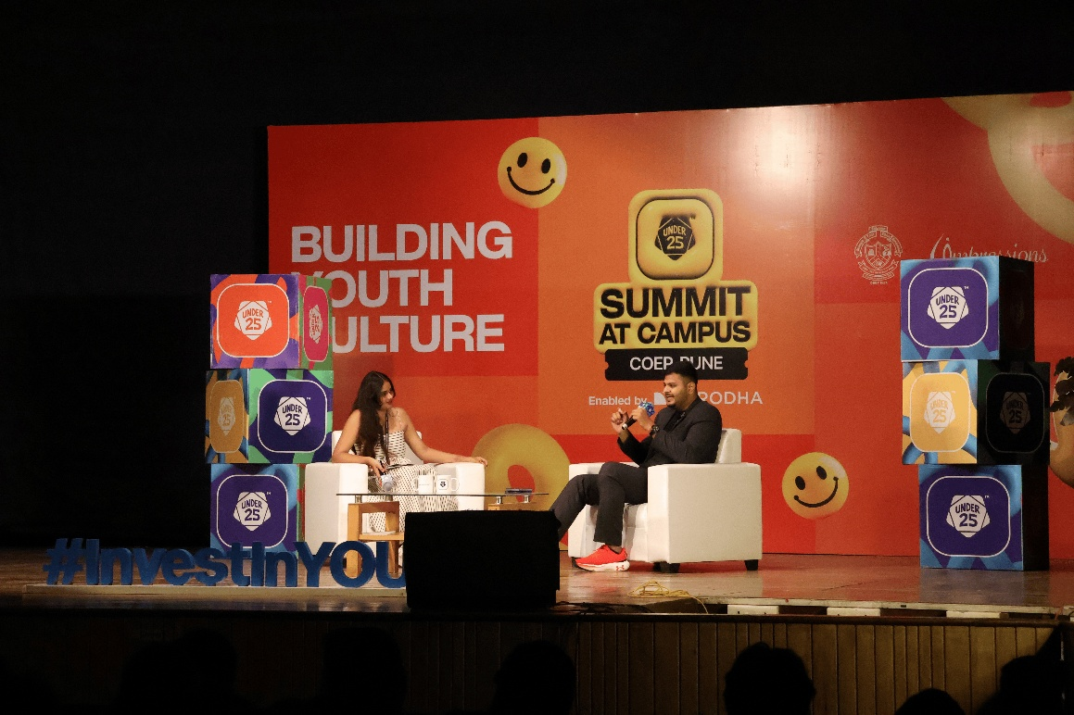

CORE TEAM MEMBERS-
- Secretary- Soham Laghate
- Joint Secretary- Ishita Gaikwad
- Accounts- Anway Joshi, Ishita Dalvi
- Corporate Outreach Group- Anushka Tanpure, Partha Shinde
- Decor- Harshada Shelar, Yash Shrivastava
- Graphic Design- Aashutosh Gudnawar, Chetan Wagh, Ruhi Pednekar
- Documentation- Kshitij More, Vrutika More
- Events & Proshows- Gargi Supe, Yash Patil
- Finance & Sponsorships- Prajakta Patkari, Udayan Indalkar
- Marketing- Annsh Shah, Jyotika Sharan
- Media- Anushka Palwe, Aarohi Komalkar
- Publicity & Registrations- Aditi Navghare, A.R.Sivapriya
- Production- Dikshant Wakade, Yashwardhan Abhale
- Print and Purchase- Arnav Gupta
- VFX- Aditya Khadse, Siddhant Shete
- Web- Tanishq Motghare, Yashwant Bhosale

