History Club

MAJOR ACTIVITIES

Rangoli Competition:
The term began with a Rangoli Competition held on 14th August 2025 as part of the Independence Day celebrations. Students created patriotic rangoli designs inspired by the colours of freedom. The entries were evaluated on 15th August by Prof. Anil Sahasrabudhe, Former Director of COEP Technological University and Former Chairman of AICTE, Delhi. The event encouraged creativity and celebrated national spirit in a vibrant atmosphere.

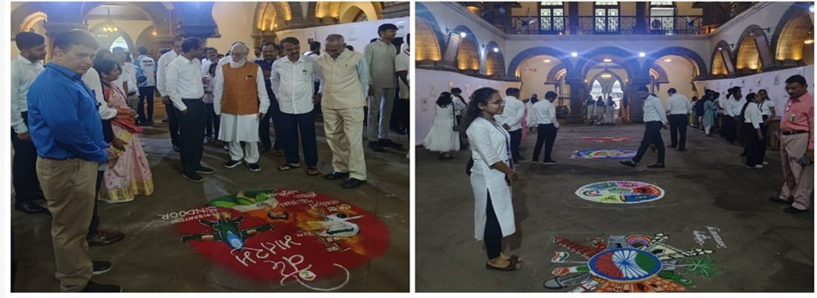

Shivsrushti Historical Theme Park Visit:
On 27th September 2025, the club, in collaboration with NSS, organized an educational visit to the Shivsrushti Historical Theme Park, Ambegaon. Twenty-three students participated in this immersive tour focusing on the life and legacy of Chhatrapati Shivaji Maharaj. Through audiovisual shows, museum exhibits, and interactive installations, students gained valuable insights into Maratha history and Swarajya.

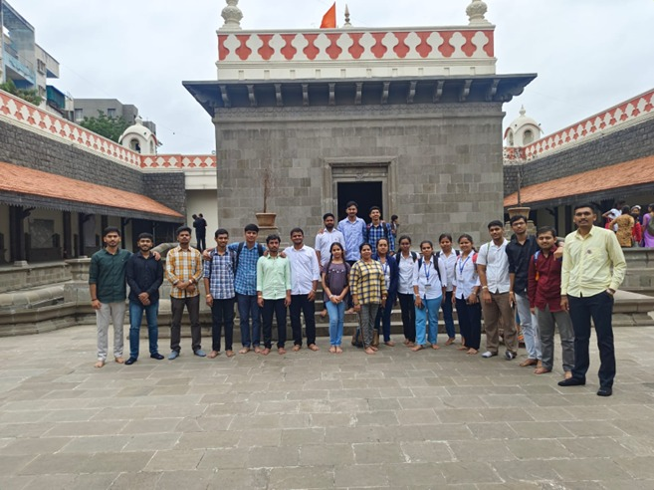

Maharshi Valmiki Jayanti:
The club celebrated Maharshi Valmiki Jayanti on 7th October 2025 at the VC Hallway. A special address highlighted the life, teachings, and literary contributions of Maharshi Valmiki, the Adi Kavi of Sanskrit literature. The event enriched participants’ understanding of Indian cultural and literary heritage.

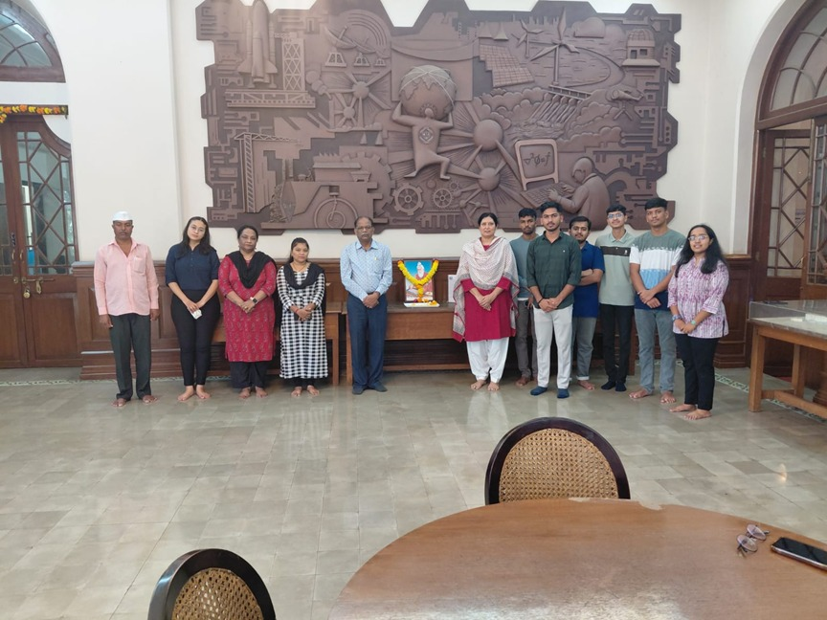

150th Anniversary of Vande Mataram:
To commemorate the 150th anniversary of “Vande Mataram”, a Vande Mataram Singing Competition was organized on 3rd November 2025 in collaboration with the Cultural Club. The programme included musical performances and informative segments on the history and significance of the national song. Winners were felicitated, and the event successfully instilled patriotic feeling among the audience.

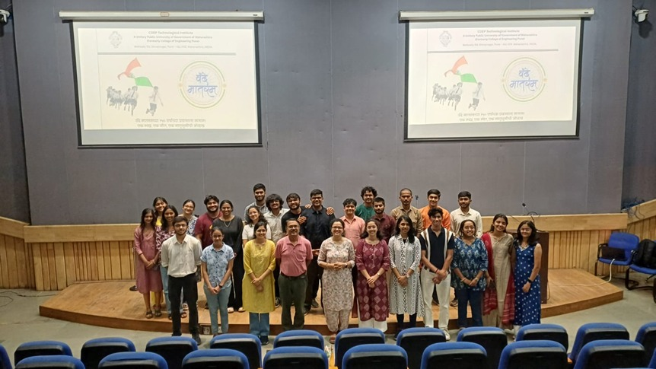

Campus Visit for Foreign Students:
On 6th November 2025, the History Club facilitated a Campus Visit for Foreign Students as part of a cultural exchange programme. A delegation from Stuttgart, Germany, interacted with Indian students and faculty, gaining insights into India’s educational system and campus life. The visit strengthened international understanding and cultural exchange.

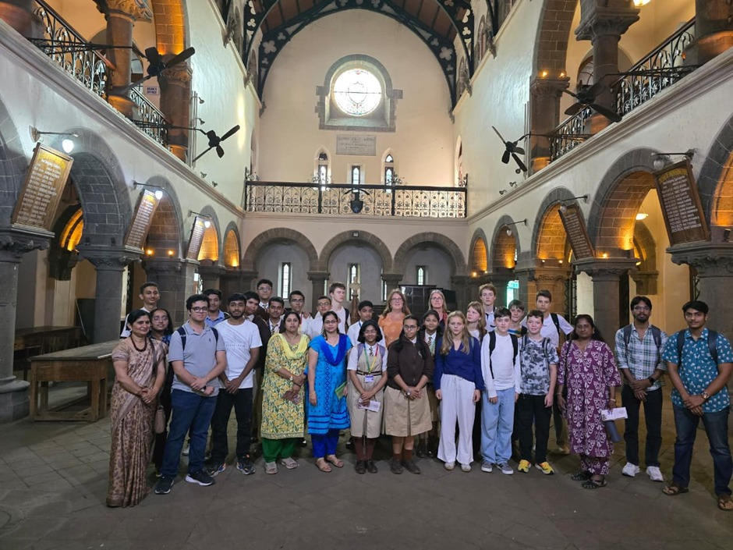

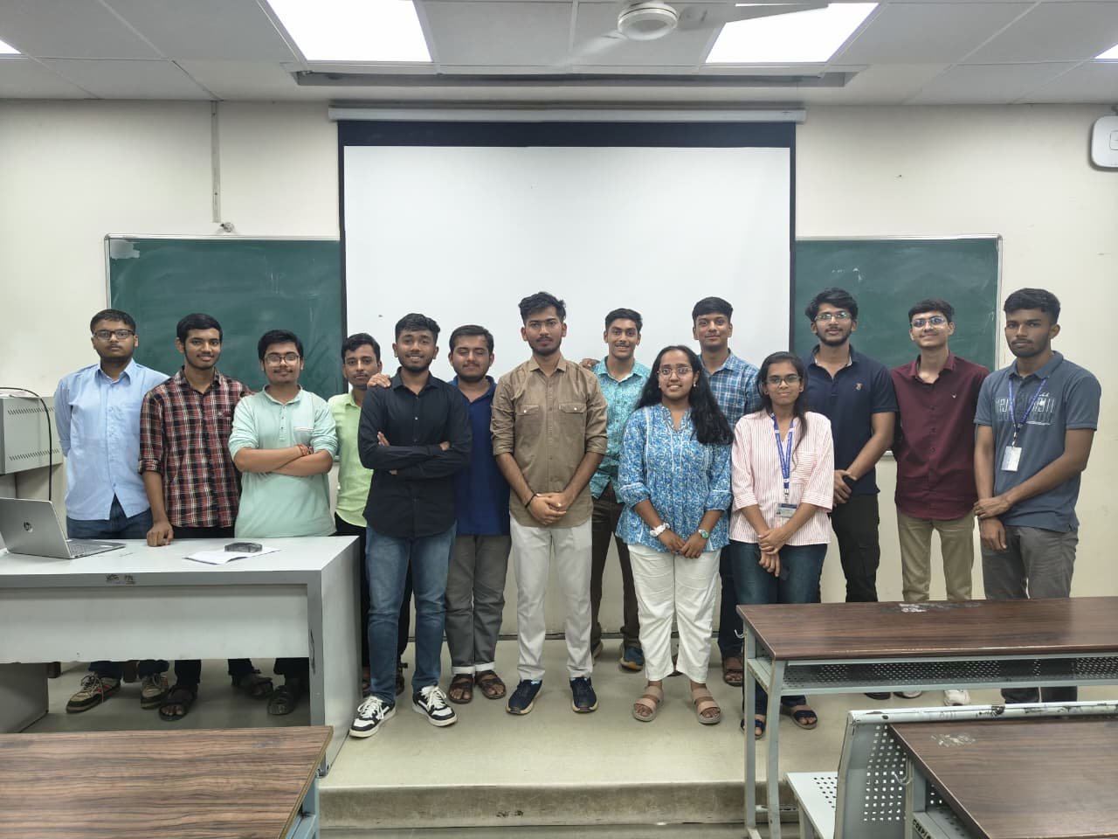

CORE TEAM MEMBERS

Name of Post | Name | Branch
Secretary | Sachin Pawar | E&TC
Joint Secretary | Aayush Suryawanshi | E&TC
Auditor | Hariprasad Jadhav | E&TC
Auditor | Pavan Satale | Mechanical
Documentation Head | Dhanraj Kondar | E&TC
Research Head | Onkar Thosar | Planning
Research Head | Vighnesh Hurpade | Instrumentation
Media Head | Harshal Khaire | E&TC
Media Head | Sarthak Bokil | Metallurgy
Design Head | Aayush Suryawanshi | E&TC
Events Head | Digvijay Saste | E&TC
Purchasing Head | Pinak Yeole | E&TC
Purchasing Head | Arnav Apangire | E&TC

