COEP HISTORY CLUB
The COEP History Club is dedicated to making history accessible, engaging, and relevant for the student community. Through guest lectures, cultural celebrations, film screenings, and collaborative events, the club empowers students to explore India's rich heritage and draw lessons from the past for the present.

Events and Activities

1. Guest Lecture – 'Chhatrapati Shivaji Maharaj: Pioneering Law and Leadership for a Modern Era'
Dates: 2nd and 3rd September 2024 (4:30 PM – 6:30 PM each day)
Venue: AC 204
Audience: 60–70 students over 2 days
Conducted in collaboration with: National Service Scheme (NSS)
Speakers:
- Prof. Ganesh Raut – HV Desai College
- Shivshri Baburao More

The event was aimed at sharing the inspiring stories of various brave warriors from Indian history, while drawing valuable lessons from the great values embodied by Chhatrapati Shivaji Maharaj and their relevance for the youth of India.
Prof. Ganesh Raut emphasized the strategic brilliance of Shivaji Maharaj — his innovative military tactics and his ability to unite the Marathas against foreign invaders. He narrated several stories and anecdotes of ancient kings with his characteristic witty and engaging delivery, making the lecture thoroughly enjoyable. He recounted the famous defeat of Afzal Khan by Shivaji Maharaj as a landmark moment that pioneered psychological warfare in India, and encouraged students to undertake visits to historical sites and organize heritage walks.
Shivshri Baburao More shed light on Shivaji Maharaj's administrative acumen and his commitment to justice and equality, which laid the foundation for a prosperous and inclusive Swarajya. He drew parallels between the swift justice system of Shivaji's era and the current national context, offering thought-provoking perspectives on law and order.
Both speakers were felicitated by the History Club and NSS. The session concluded with a keynote address by Dr. M.P. Khond Sir, who highlighted the importance of revisiting India's past and understanding its legacy to build a better future, encouraging students to imbibe the courage, leadership, and moral values of Shivaji Maharaj.

2. Guest Lecture – 'Walong Saga: Guts and Glory'
Date: 25th October 2024
Venue: Mini Auditorium
Audience: 200+ students
Speaker: Col. Sumit Sharma – 71st Infantry Division
Conducted in collaboration with: Urja and NSS

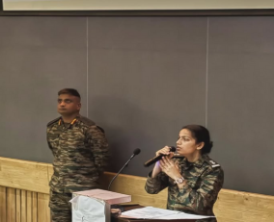

The event was organized to honor the 62nd anniversary of the Battle of Walong — a tale of courage and sacrifice from the 1962 Indo-China War. Col. Sumit Sharma delivered an engaging and deeply moving presentation on the battle, bringing to life the bravery and strategic resolve of Indian soldiers who fought against overwhelming odds.
A question-and-answer segment allowed the audience to interact directly with Col. Sharma, delving deeper into the historical and strategic significance of the Battle of Walong. The event concluded with a formal vote of thanks, and the organizing clubs were felicitated for their collaborative efforts. The session served as a poignant reminder of the sacrifices made by India's armed forces and inspired the audience to honor their legacy of dedication and patriotism.

3. Shiv Jayanti Celebrations 2025
Date: 19th February 2025
Venue: COEP Hostel Ground
Audience: 300+
Conducted in collaboration with: Student Welfare Forum (SWF) and Youth Empowering Centre (YEC)
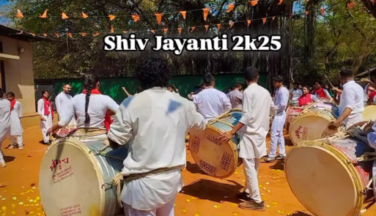

The COEP History Club, in collaboration with the Student Welfare Forum and Youth Empowering Centre, organized a grand Shiv Jayanti Celebration to honor the extraordinary legacy of Chhatrapati Shivaji Maharaj — one of India's greatest leaders.
The event commenced with a powerful and inspiring speech on the life and achievements of Shivaji Maharaj, highlighting his courage, strategic brilliance, and unwavering commitment to Swarajya. His statue was then ceremoniously garlanded, accompanied by resounding chants of 'Har Har Mahadev!', filling the atmosphere with devotion and pride.
A Dhol-Tasha Pathak performed a mesmerizing and high-energy musical tribute, playing the traditional beats that have been an integral part of Pune's cultural heritage for centuries. The thundering rhythms stirred a deep sense of patriotism among the 300+ students present. Moved by the electrifying performance, the audience enthusiastically joined in, showering flowers on the performers as a mark of respect and devotion. The atmosphere was charged with excitement, unity, and a deep connection to history.
The Shiv Jayanti Celebrations were not just an event but a profound homage to a leader whose ideals continue to inspire generations. As the celebration concluded, it left an indelible mark on everyone present, reinforcing the values of courage, leadership, and justice that Shivaji Maharaj stood for.

Core Team
Secretary: Anand Panajkar

Heads:
- Tanaya Govardhan
- Anish Gokhale
- Atharva Khadloya
- Ajit Patil
- Chaitanya
- Mohit Urkunde
- Sachin Pawar

