HISTORY CLUB
The COEP History Club is dedicated to making history accessible, engaging, and relevant for the student community. Through treks, film screenings, quiz competitions, cultural celebrations, and awareness events, the club serves as a catalyst for exploration, dialogue, and discovery — empowering students to become stewards of history and agents of positive change.

Events and Activities

1. Purandar Fort Trek
Date: 29th October 2023
Participants: 70+
Conducted in association with: Ek Bharat Shreshtha Bharat Club
The Purandar Fort trek was not merely an excursion but a journey through history itself. Organized under the 'Meri Maati Mera Desh' initiative launched by the Central Government, the trek took students and faculty into the Sahyadri range. Guided by experienced trek leaders and historians, participants traversed rugged terrain, ascending the fort's ancient ramparts and exploring its time-worn chambers. The trek offered both a physical challenge and a spiritual journey, allowing students to connect with the rich heritage of their homeland, witness the fort's strategic significance, and appreciate its architectural splendor.

2. National Youth Day Celebration
Date: 12th January 2024
Venue: COEP Tech Ground
Participants: 60
The History Club celebrated National Youth Day to commemorate the birth anniversary of Swami Vivekananda and highlight the pivotal role of youth in nation building. The event commenced with an inaugural ceremony graced by esteemed speaker Mr. Prashant S Lele, who shared insights on youth empowerment and leadership. Through interactive sessions and engaging activities, students explored themes of social responsibility, innovation, and community engagement. Discussions ranged from challenges facing today's youth to strategies for harnessing their potential for positive change.
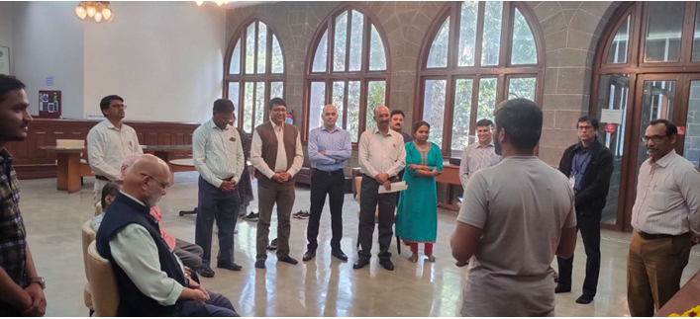

3. Screening of 'Tashkent Files'
Date: 16th January 2024
Venue: Mini Auditorium
Participants: 90
Organized on the occasion of Sh. Lal Bahadur Shastri's death anniversary, the club screened 'Tashkent Files' — a gripping exploration of the mysteries surrounding the Tashkent Agreement and Shastri Ji's sudden demise. The film sparked thought-provoking discussions among students, ranging from debates on historical narratives to reflections on political intrigue. The event served as a poignant reminder of the importance of questioning history and seeking truth in the face of ambiguity.

4. History Quiz Competition 1
Date: 31st January 2024
Venue: Electrical Department
Participants: 42
History came alive as the History Club hosted its monthly quiz competition. From ancient civilizations to modern revolutions, participants tested their historical acumen through a series of challenging questions and interactive rounds. The quiz not only stimulated intellectual curiosity but also fostered camaraderie and healthy competition, reinforcing the club's mission to make everyone fall in love with history.

5. Shivjayanti Celebration
Dates: 18th – 19th February 2024
The Shivjayanti program witnessed an electrifying performance by Raj Mali and his team, who enthralled the audience with a captivating Powada rendition in the Main Auditorium. The auditorium was packed to capacity, resonating with cheers and applause throughout the performance. On 19th February 2024, the celebrations continued with a vibrant Dhol Pathak performance at the COEP hostel ground, adding to the festive fervor of Shivjayanti. Both events were met with great enthusiasm, fostering cultural pride and community spirit.
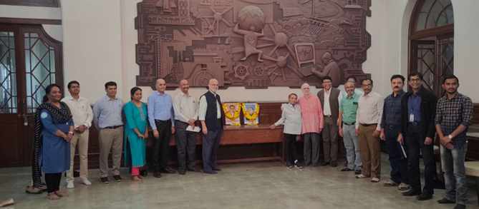

6. National Science Day Screening — 'Rocketry: The Nambi Effect'
Date: 28th February 2024
Venue: Mini Auditorium
Participants: 90+
On National Science Day, the History Club screened 'Rocketry: The Nambi Effect', a biographical drama based on the life of aerospace engineer Nambi Narayanan. The film captivated audiences with its tale of perseverance and triumph in the face of adversity. The screening paid homage to the spirit of scientific inquiry and honoured the contributions of India's scientific luminaries, inspiring students to embrace the wonders of science and pursue their dreams with passion.

7. History Quiz Competition 2
Date: 29th February 2024
Venue: Electrical Department
Participants: 38
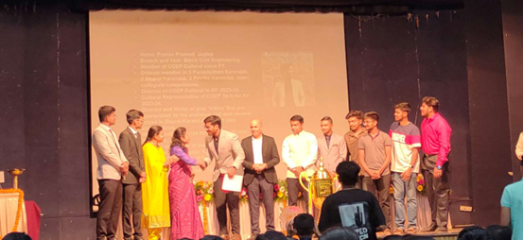
The second quiz competition of the year once again brought history enthusiasts together in friendly competition. From iconic figures to pivotal events, participants engaged in collaborative teamwork, vying for the title of history champion. The quiz encouraged students to expand their historical horizons and reinforced the club's ethos of mutual support and shared achievement.

