COEP HAM CLUB

About COEP HAM CLUB
The COEP Ham Club (Callsign: VU2COE) is the oldest technical club of COEP Technological University. During this reporting period, the club organized multiple technical events and workshops aimed at bridging the gap between theoretical knowledge and real-world implementation in communication systems and electronics.

Objectives 2025-26
• To provide practical exposure to antenna design, fabrication, and field operations.
• To organize competitions and workshops in amateur radio direction finding.
• To develop skills in RF circuit design and low-cost communication systems.
• To promote self-learning and innovation in wireless communication technologies.
• To strengthen the campus culture of amateur radio and technical collaboration.

Activities Conducted

1. Antenna Making Workshop
Date: 21st September 2025
Students designed and fabricated a 3-element Tape 2m Yagi antenna. Participants tested their antennas using HAM radios to understand directionality and its effect on communication. The workshop was organized under the guidance of Pune Hams and Amateur Radio Club (VU2PHQ).
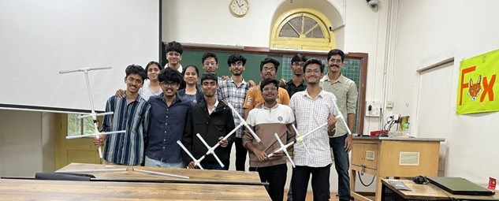

2. MindSpark Foxhunt Competition
As part of the MindSpark technical festival, the club organized an Amateur Radio Direction Finding (ARDF) competition. Teams used self-made Yagi-Uda antennas to locate a hidden radio transmitter (fox) built with a Baofeng UV-5R transceiver and ESP8266 microcontroller using triangulation techniques.

3. Hill-Top Field Operation
Date: 17th January 2026
Participants engaged in a real-time field session to set up and study Dipole and Vertical antennas using an antenna switcher module. The activity included laying horizontal radial wires for better grounding and live communication attempts with other HAM operators.
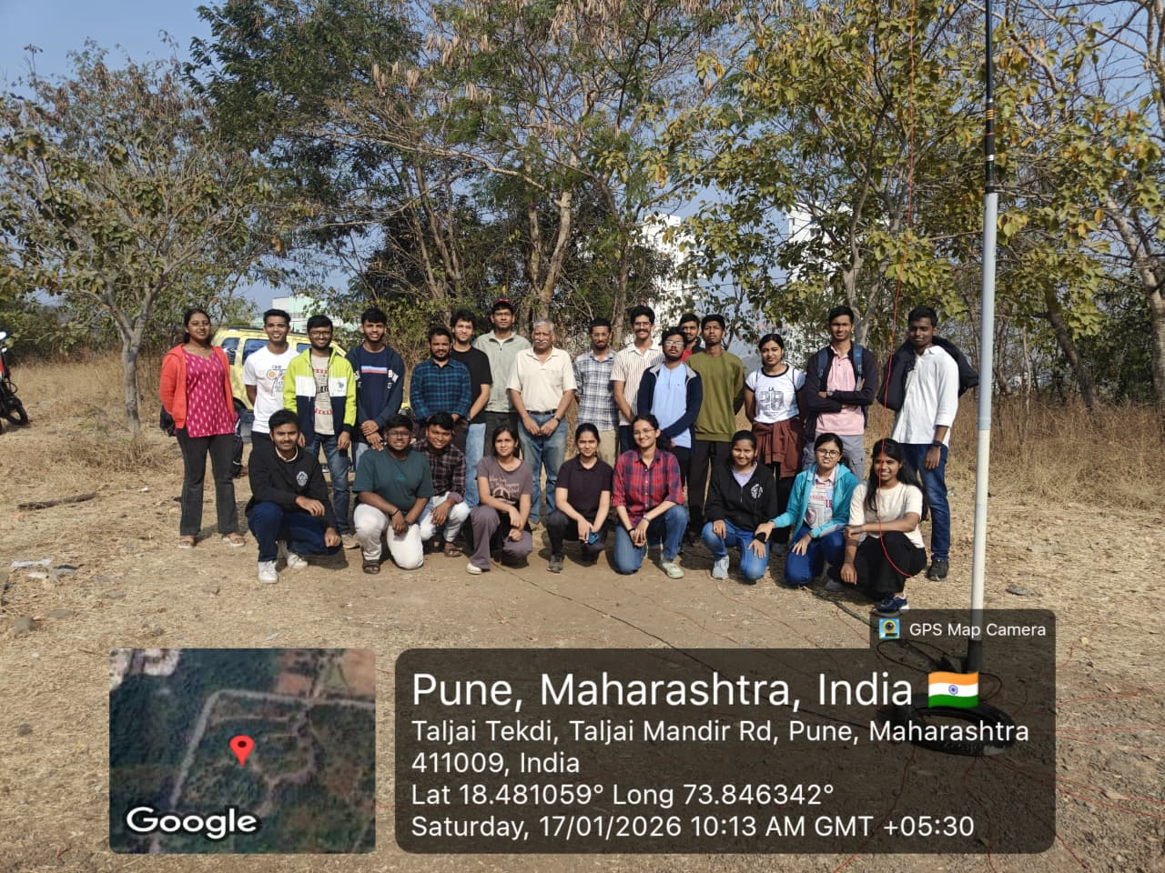

4. LARCSet Workshop
Date: 18th January 2026
Students assembled and soldered Low-cost Amateur Radio Communication Sets (LARCSet). The workshop provided practical experience in RF circuit design, component identification, and stage-wise testing of Local Oscillator, Receiver, and Transmitter. 8 out of 10 kits were successfully built.
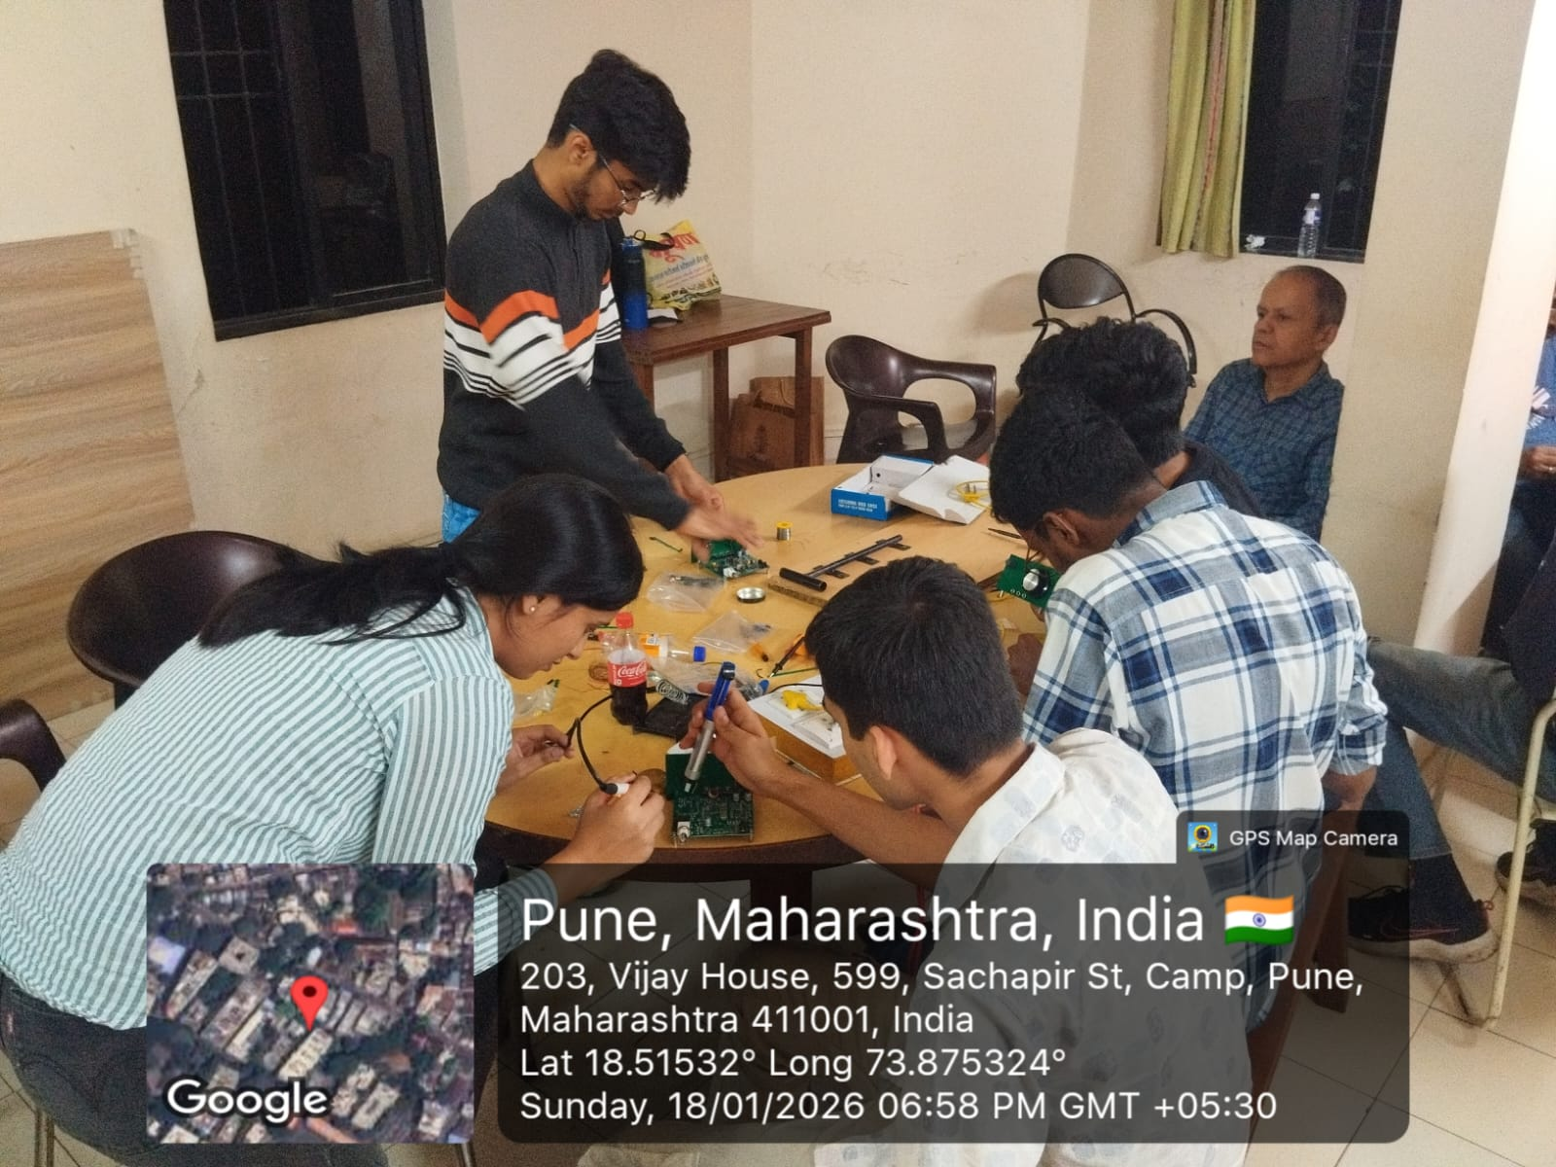

Outcomes and Impact
• Students gained strong practical skills in antenna fabrication, testing, and field deployment.
• Successful organization of technical competitions and hands-on workshops.
• Enhanced understanding of RF circuit design and low-cost communication systems.
• Increased interest and participation in amateur radio activities on campus.
• Strengthened collaboration with external HAM communities and industry exper

