FOOTBALL CLUB
The COEP Football Club represents COEP Technological University at various intercollegiate football tournaments across Pune and Maharashtra. The club fosters teamwork, physical fitness, competitive spirit, and sportsmanship among its members, participating in both standard and short-format football competitions throughout the academic year.

Tournaments Participated

1. FLAME Kurukshetra 2024
The COEP Football team participated in the FLAME Kurukshetra 2024 intercollegiate tournament, representing COEP Technological University against teams from colleges across Pune.

2. COEP Zest 2024
The team competed in COEP Zest 2024, the university's flagship sports event, showcasing their skills against fellow college teams in a competitive internal tournament format.

3. MIT Summit 2024
COEP Football participated in MIT Summit 2024, gaining valuable competitive match exposure against strong intercollegiate opposition at the MIT-WPU campus.

4. AIT Pace
The team participated in the AIT Pace football tournament — a standard format intercollegiate event organized at Army Institute of Technology, Pune.

5. AIT Pace (6-a-side)
The team also competed in the 6-a-side format of AIT Pace, a shorter and faster-paced variant of the game that tests agility, quick decision-making, and small-group coordination.

6. MIT Vishwanath
COEP Football represented the university at the MIT Vishwanath football tournament, participating against intercollegiate teams from across the region.

7. Cummins Pentacle
The team participated in the Cummins Pentacle football tournament, gaining further competitive experience across diverse intercollegiate competition.

Achievement
Runner-Up at AIT Pace
The Football Club's standout achievement of the year was finishing as Runner-Up at the AIT Pace tournament. The team's performance demonstrated strong technical skill, team coordination, and competitive resolve, making it the most notable result of the 2023-24 season.
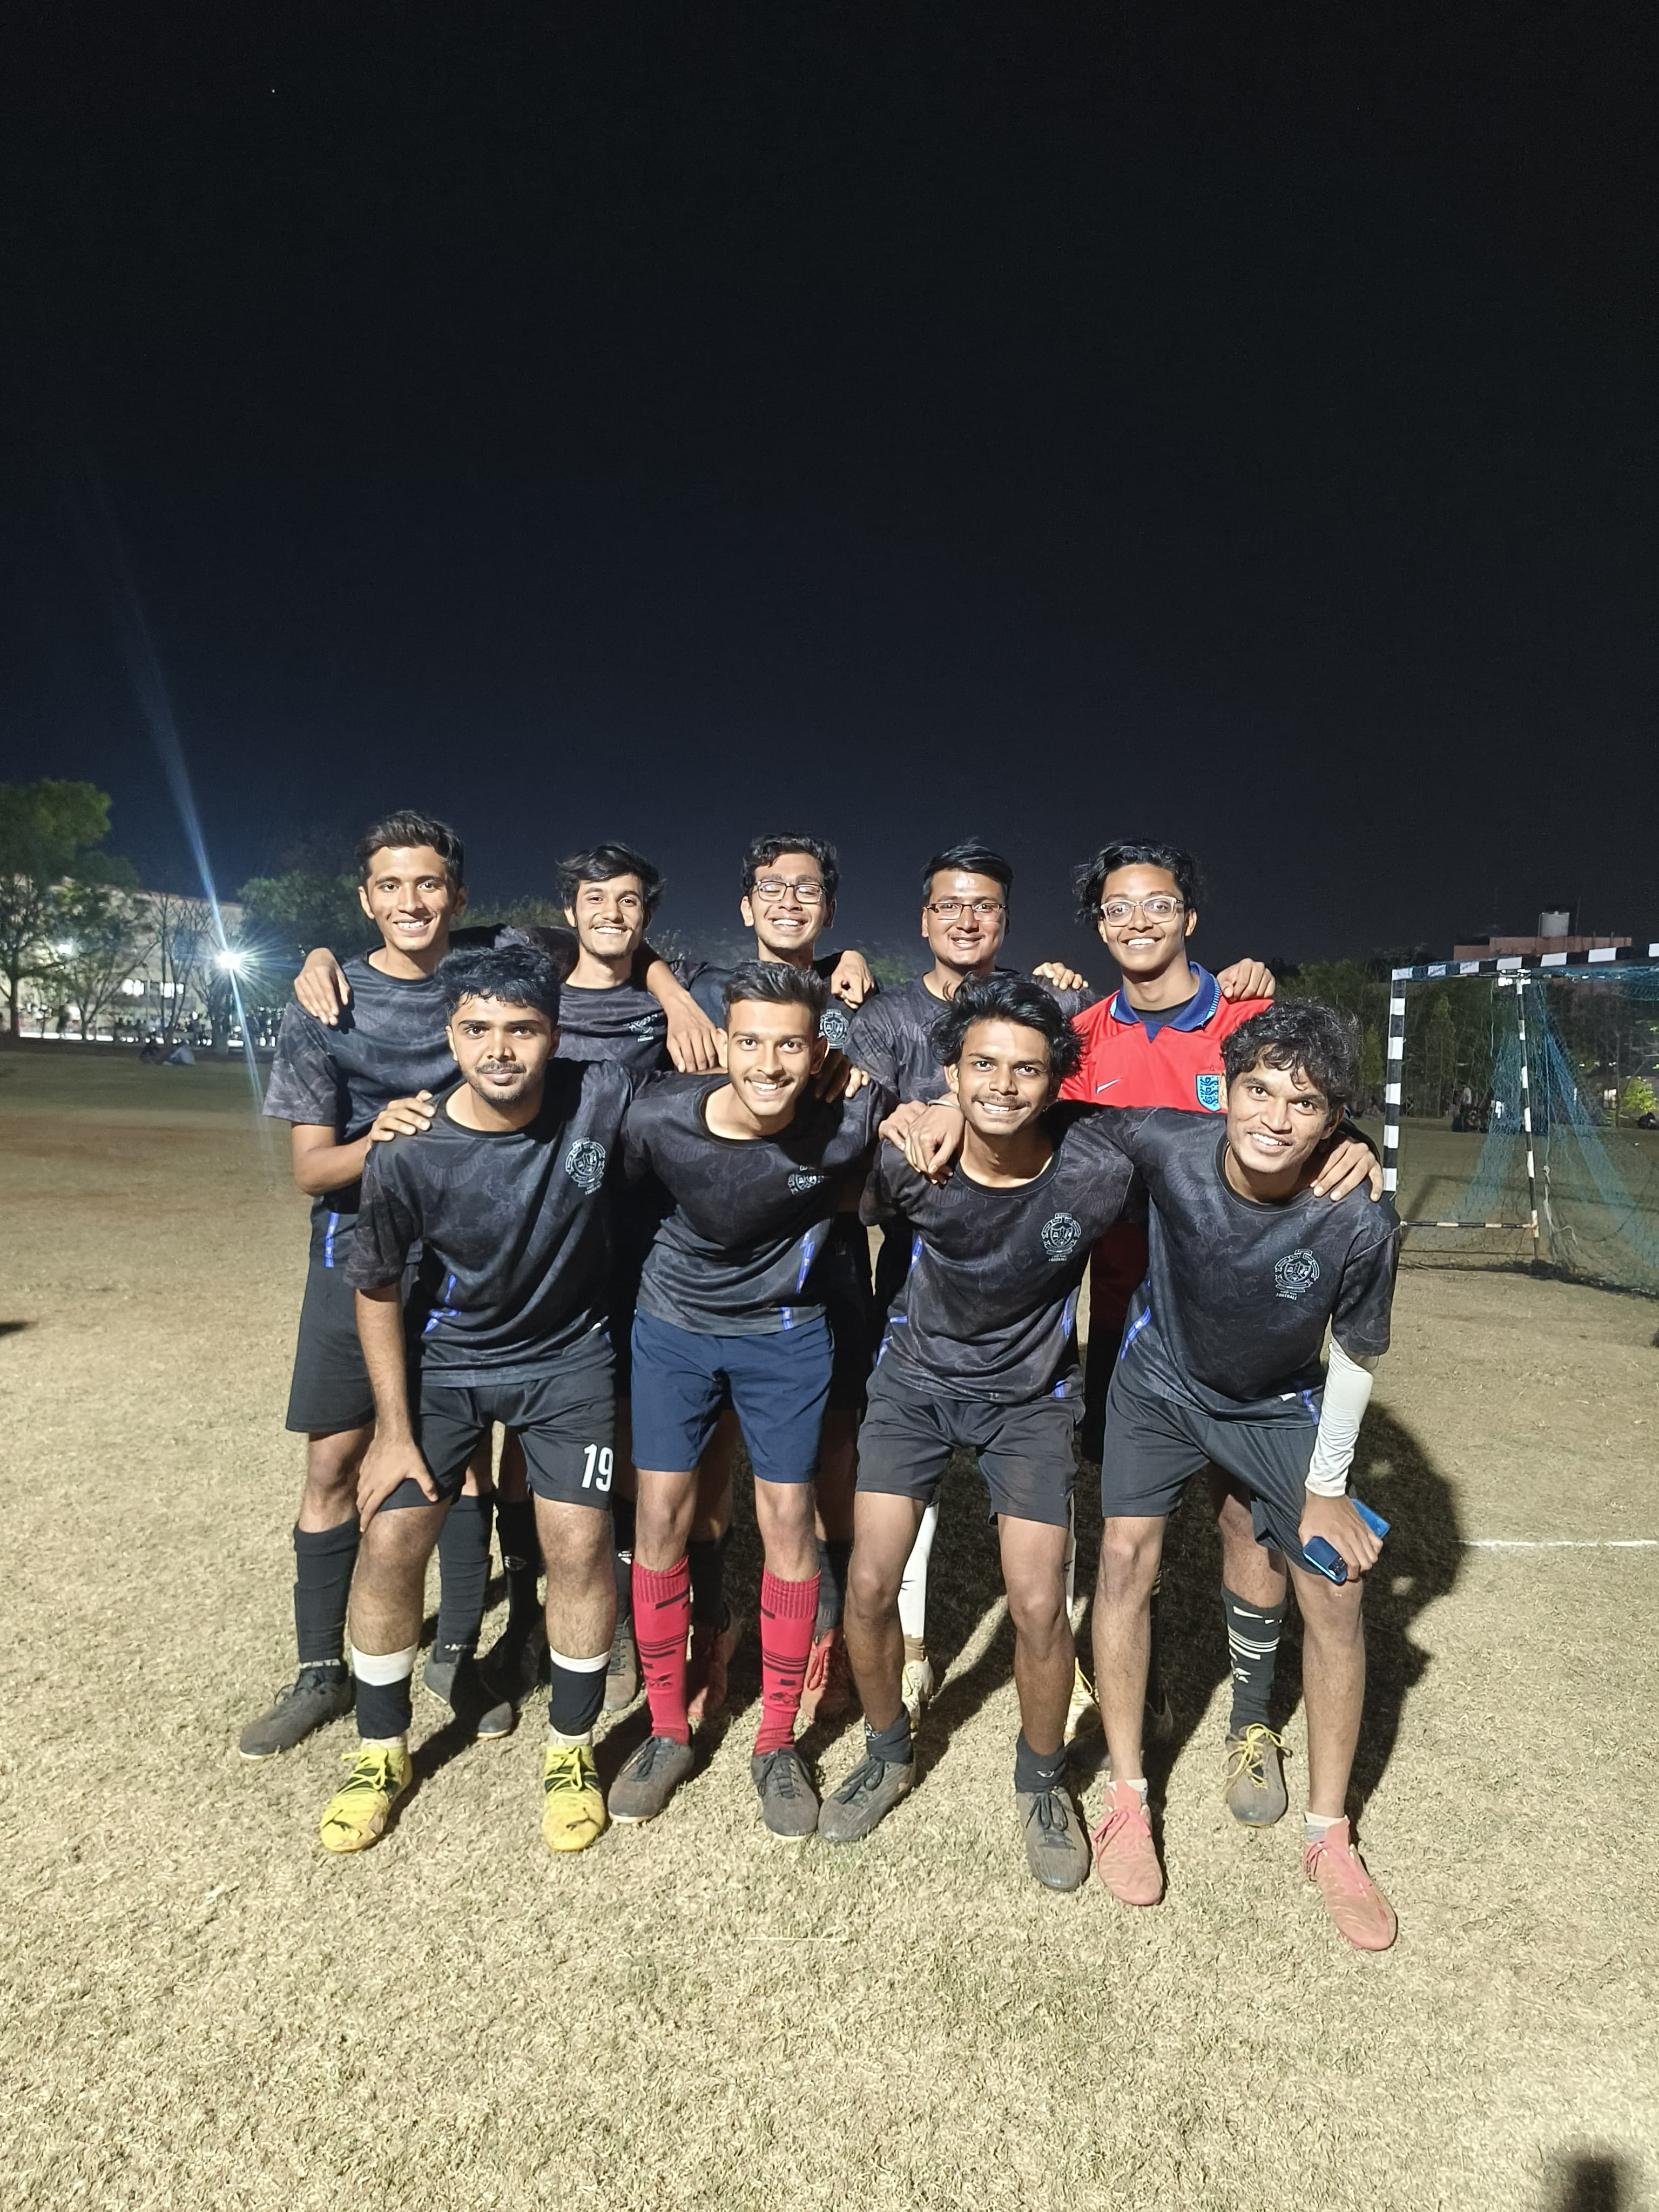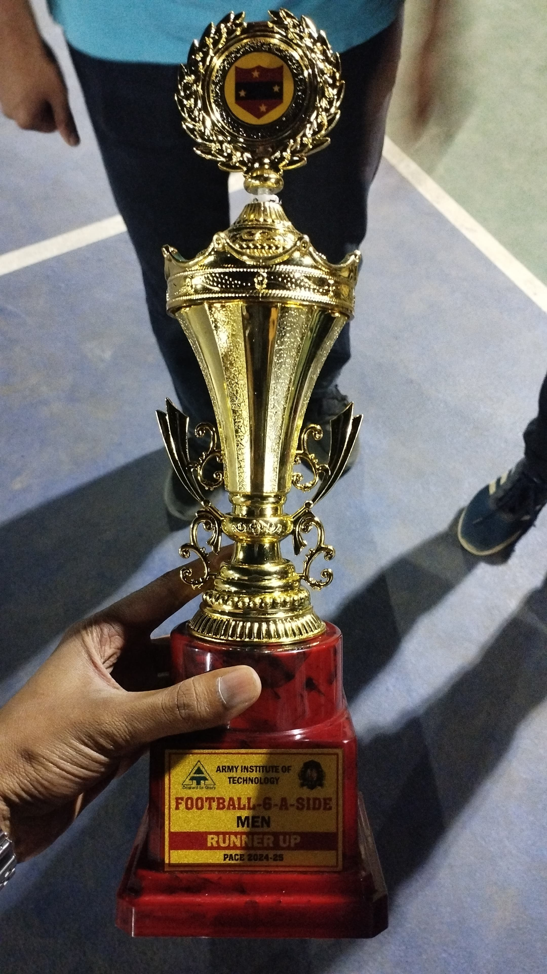

Core Team

Role | Name
Secretary | Aditya Joshi
Captain | Durvesh Rasane
Captain | Siddharth Hedaoo
Media | Shirshak Tiple

