DRAMA AND FILMS CLUB (DnFC)
The Drama and Films Club (DnFC) at COEP Technological University continued to expand its creative footprint during the academic year 2024-25 through film productions, theatre performances, workshops, and interactive initiatives. The club focused on strengthening technical proficiency and storytelling skills among members while maintaining strong engagement with the student community.

Major Activities & Productions

Skill-Development Workshops
The club conducted multiple immersive workshops in acting, scriptwriting, cinematography, editing, and set design, offering hands-on learning opportunities for members interested in different domains of filmmaking and theatre. These workshops strengthened the club's internal capacity and equipped members with professional-level skills.

Short Film – Cocoon (Flagship Production)
The flagship film project of 2024-25 was the short film Cocoon, screened at the grand inauguration of Impressions 2024. The film received widespread appreciation for its storytelling and production quality, going on to achieve significant national recognition:
1st Prize — Frame by Frame Competition, YCCE Nagpur
2nd Prize — Nagpur Film Festival
Best Editor Award — Nagpur Film Festival
Best Production Award — National Student Film Festival
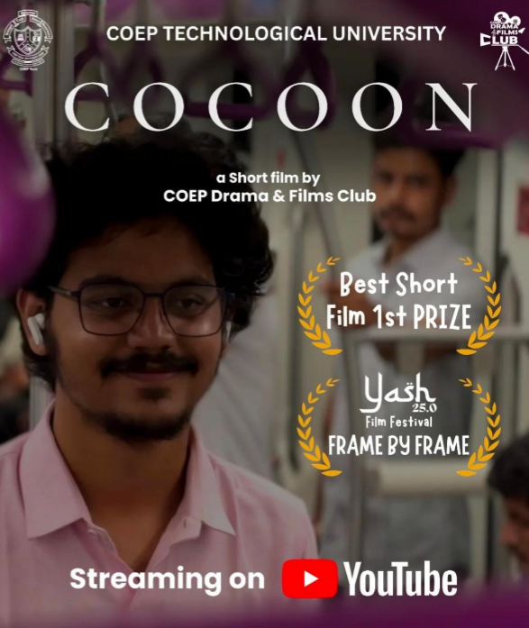
The film was also nominated at several other prestigious film festivals, further strengthening DnFC's reputation as a leading student filmmaking club.

Continued Recognition for Earlier Productions
- Aabhas (short film, 2023-24) — nominated at the Videotape Short Film Festival.
- Tasveer (music video, 2023-24) — nominated at the Spotlight Foundation Film Festival.

Theatre – Two-Act Play 'Kaul'
In theatre, the club staged its largest production yet — the two-act play Kaul — during the Annual Social Gathering 2025. The performance received overwhelming audience appreciation, and due to popular demand, was staged for a third show, a rare achievement for student productions at COEP and a testament to the quality and impact of the production.
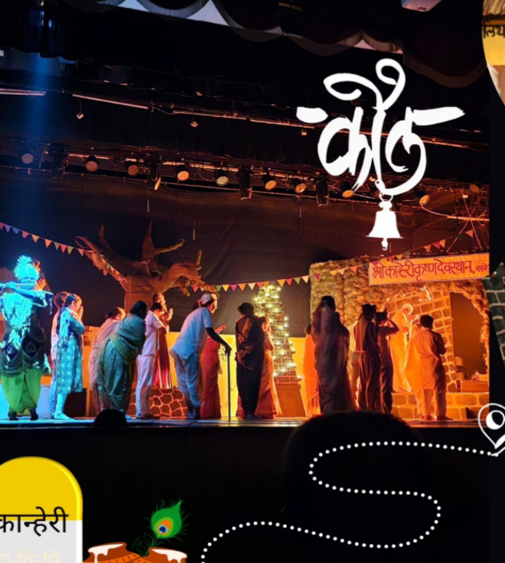

'Lights, Camera, Teesri Ghanta' – Interactive Initiative
The club introduced an interactive engagement initiative titled 'Lights, Camera, Teesri Ghanta', encouraging open discussions and Q&A sessions among film and theatre enthusiasts from across the campus. The initiative fostered a creative community and helped build deeper interest in the cinematic arts.
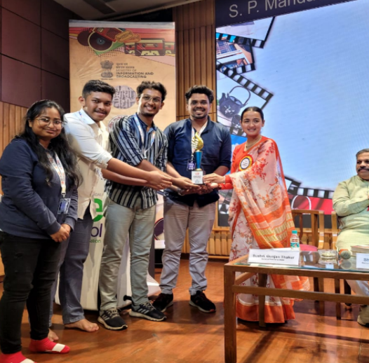

Social Media Presence
The club maintained an active and engaging social media presence throughout the year, sharing behind-the-scenes content, creative reels, and film-based discussions. This strengthened the club's connection with the wider student community and helped showcase DnFC's creative output beyond the campus.
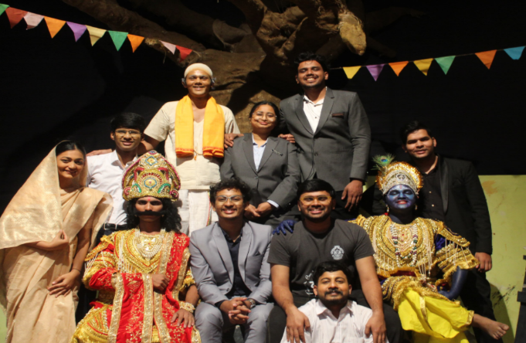

Key Milestones & Achievements
- Award-winning short film Cocoon screened at Impressions inauguration and recognized at multiple national platforms.
- 1st Prize at Frame by Frame (YCCE, Nagpur), 2nd Prize and two individual awards at Nagpur Film Festival, Best Production Award at National Student Film Festival.
- Continued national-level nominations for earlier productions — Aabhas (Videotape Short Film Festival) and Tasveer (Spotlight Foundation Film Festival).
- Successful execution of large-scale theatre production Kaul — staged for a third show due to popular demand.
- Conducted structured skill-development workshops across acting, cinematography, editing, scriptwriting, and set design.
- Launched 'Lights, Camera, Teesri Ghanta' — an interactive campus engagement initiative for film and theatre enthusiasts.
- Established the club as a consistent cultural and creative contributor to university life with national-level recognition.

Core Team
- Secretary: Aniket Dhait
- Overall Heads: Om Pendam, Anurag Lokhande
- Prathamesh Kale – Head of Cinematography
- Prathamesh Domse – Head of Cinematography
- Harshavardhan Diwate – Head of Cinematography
- Khushali Borikar – Head of Set Design & Documentation
- Parth Khedekar – Head of Set Design
- Yash Lohi – Head of Scriptwriting and Direction
- Harshavardhan Nikam – Head of Scriptwriting and Direction
- Aryan Karewar – Head of Acting
- Vaishnavi Pagar – Head of Acting
- Tanishque Jain – Head of Music

