DRAMA AND FILMS CLUB (DnFC)
The Drama and Films Club (DnFC) at COEP Technological University was formally established during the academic year 2023-24, marking the beginning of a new creative chapter for the institution. In its very first year, the club produced an impressive body of work spanning short films, a documentary, a music video, and a full-length Marathi stage play — earning national-level recognition and establishing a strong foundation for creative excellence at COEP.

Major Activities & Productions

Short Films

One Last Time
COEP's first-ever student-made short film, premiered at the Farewell Ceremony of the Batch of 2023. Shot entirely on campus, it crossed over 7,000 views within 24 hours of being uploaded to YouTube — a landmark achievement for student filmmaking at COEP.

Abhay
A horror short film shot over three nights in the hostel premises, pushing the club's technical and storytelling capabilities into new genre territory.

PopUp
A one-minute social message film exploring short-format storytelling as a medium for impactful communication.

Aabhas (Flagship Production)
The flagship production of the year, Aabhas premiered at the inauguration of COEP Impressions 2023. It crossed 10,000 views within one week of release and was selected for screening at the National Students Film Festival 2024 held at Mumbai University — marking the first time a COEP student film was screened at a national platform outside campus. 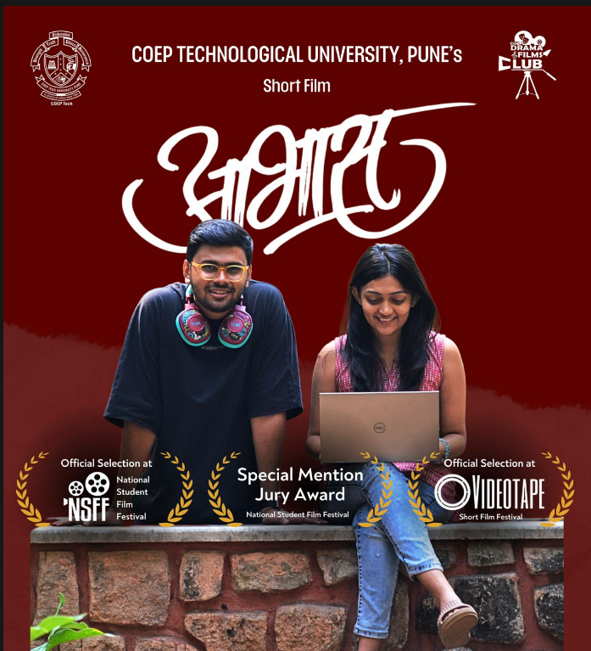

Documentary
Stepping Beyond Excellence
COEP's first official documentary, produced under the guidance of then Vice Chancellor Prof. Sudhir Agashe. The documentary focused on the academic and infrastructural development of COEP Technological University, serving as a lasting institutional record.

Music Video
Tasveer
An original music video produced in collaboration with The Audio Culture Studio — marking COEP's first student-composed and student-produced music video. 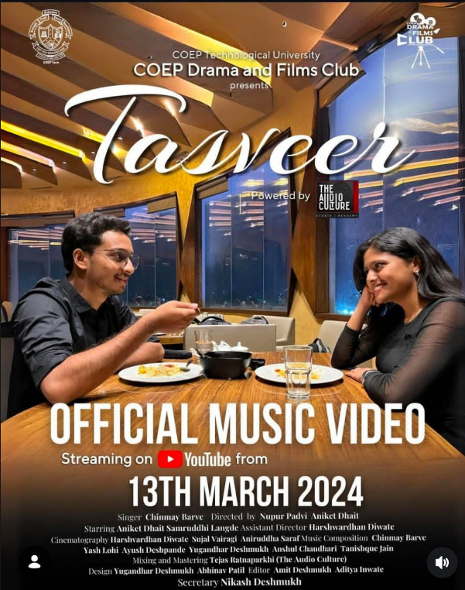

Theatre
Dasva (Two-Act Marathi Play)
A two-act Marathi play staged during the university's Annual Social Gathering (Antarang). The production introduced Box Set stage design for the first time in COEP drama — a professional theatre technique that elevates the visual storytelling of stage performances. The play received an overwhelming audience response, including a standing ovation and popular demand for an additional show.
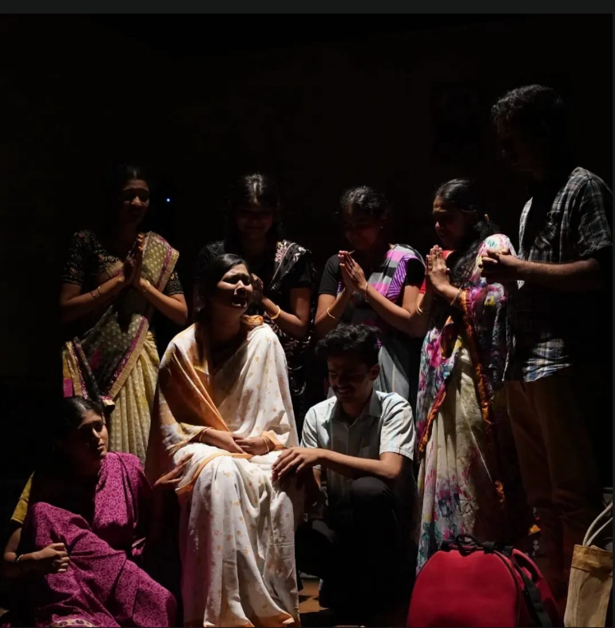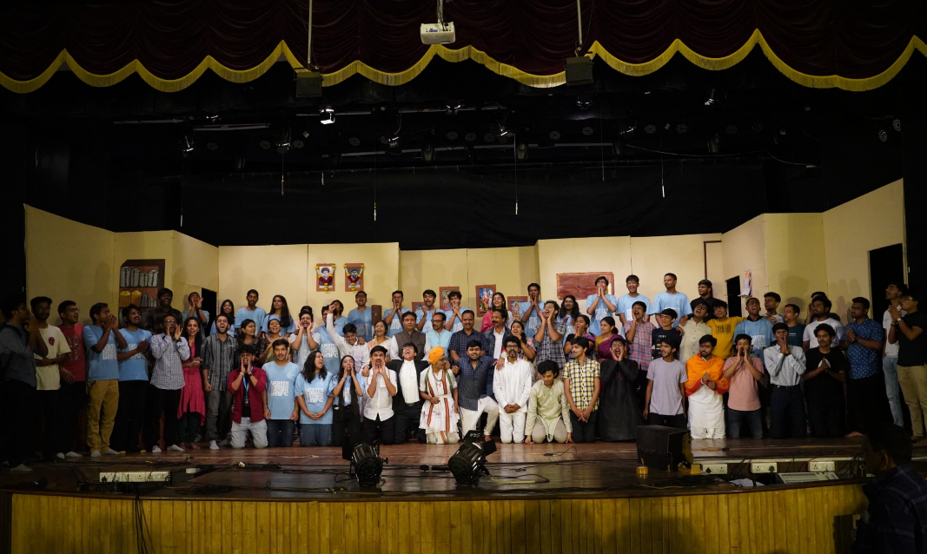

Key Milestones & Achievements
- Formal establishment and structuring of COEP Drama and Films Club (DnFC).
- Production of 4 short films, 1 documentary, 1 music video, and 1 two-act stage play in the first year.
- First national-level recognition for COEP in student filmmaking.
- Aabhas selected for screening at National Students Film Festival 2024 at Mumbai University.
- Winner of Special Mention Jury Award at national level.
- Introduction of professional theatre practices — Box Set stage design — first time in COEP drama history.
- First COEP student film to be screened outside campus at a national platform.
- One Last Time crossed 7,000 YouTube views within 24 hours.
- Aabhas crossed 10,000 YouTube views within one week.

Core Team Members
- Secretary: Nikash Deshmukh
- Vice Secretary: Nupur Padvi
- Shivanjali Shinde – Advertising & Design
- Aniket Dhait – Cinematography & Finance
- Anurag Lokhande – Production & Scriptwriting
- Om Pendam – Editing
