CHESS CLUB

Tournaments Participated & Achievements

1. India Collegiate Chess Championship (ICCC)
A team round-robin tournament following Blitz format (5+2), consisting of teams from across the nation.
Team A — Third Place – Division 5
Team B — First Place – Division 11
Team C — First Place – Division 15

2. Collegiate Chess League (CCL)
A team round-robin tournament following Blitz format (5+2), consisting of teams from across the world.
Team A — First Place – Division 5

3. Kurukshetra – FLAME University
Format: One-day Rapid event (15+5)
Result: 1st Runner-Up
An intense rapid tournament against many strong teams from across the country. The team performed excellently in a competitive setting.
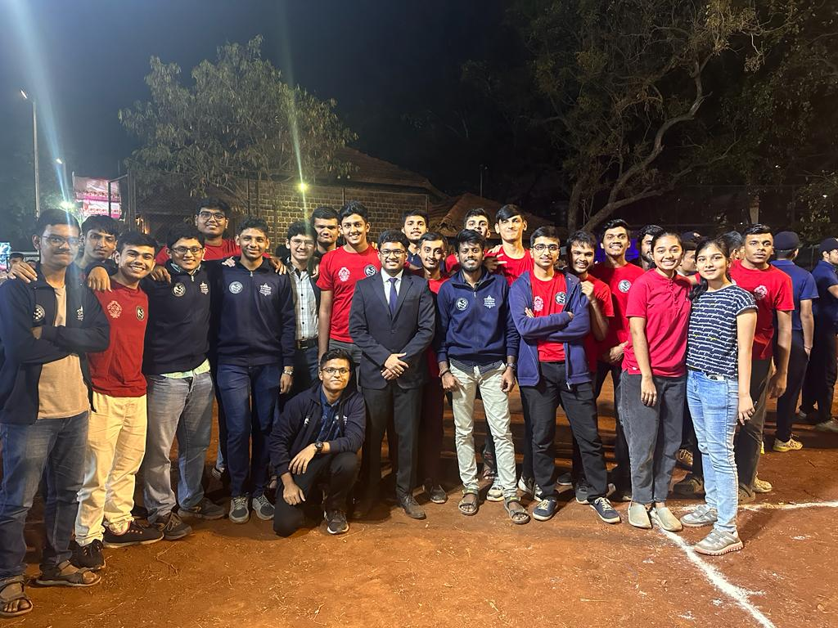
4. PACE '25 – Army Institute of Technology
Format: Two-day Rapid event (15+5)
Result: 1st Runner-Up
A two-day rapid tournament against strong intercollegiate competition. The COEP chess team stood tall and secured the Runner-Up position.

5. All India Chess League 6.0 (AICL) – Tier 1
Organized in collaboration with: MIT-WPU
Result: 2nd Runner-Up (Third Prize)
A remarkable milestone secured by the COEP Chess Team in the highly competitive AICL 6.0 Tier-1 event — one of the most prestigious national chess leagues featuring top college teams.

6. Zest '25 – Classical
Format: Team Classical Chess Tournament
Result: 2nd Runner-Up

7. Zest '25 – Rapid, Boys
Format: Team Rapid Chess Tournament
Result: 2nd Runner-Up

8. Zest '25 – Rapid, Girls
Format: Team Rapid Girls Event
Result: First Place – Winners
A dominating victory by the COEP Chess Girls Team, claiming the top position in the Rapid Girls event at Zest '25.

9. Zest '25 – Relay
Format: Team Relay Event
Result: 1st Runner-Up
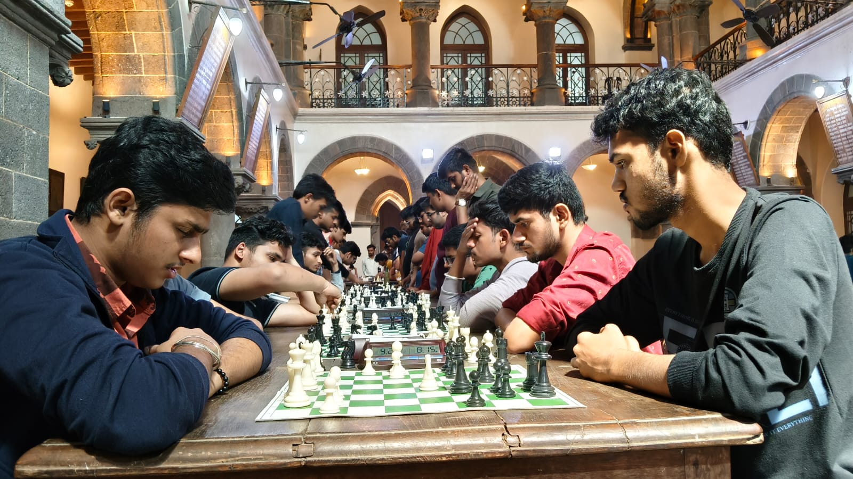
10. Zest '25 – Blitz, Team
Format: Team Blitz Event
Result: 1st Runner-Up

11. Zest '25 – Solo Blitz
Alumni Anvay Parwekar — 2nd Place
Parth Lahoti (FY ENTC) — 2nd Place

12. St. Mira's College Chess Tournament
Format: Solo Rapid Tournament
Nitesh Rasekar — 3rd Place – along with 3 COEP players finishing in the top 10

Event Organised
The Chess Club organized all chess events at Zest '25, including Team Classical, Team Rapid, Rapid Team Relay, Blitz Team, and Blitz Solo — all executed with meticulous planning and coordination within the span of 3 days.
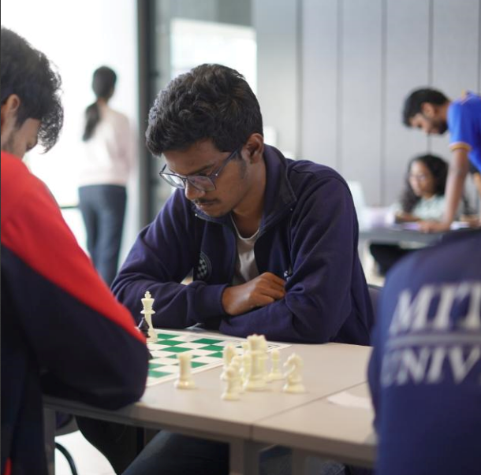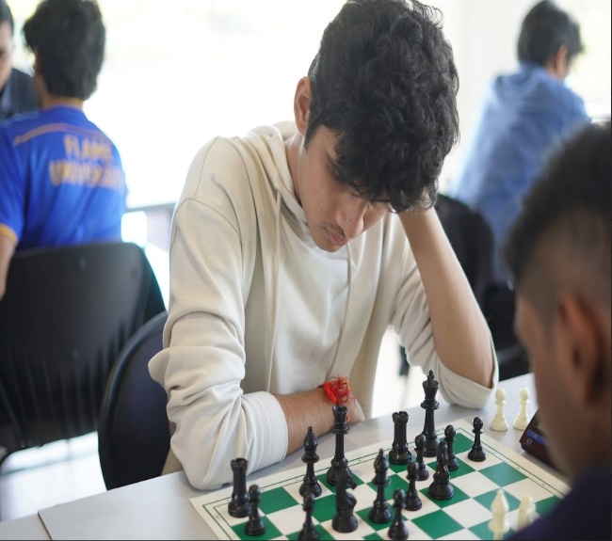

Key Highlights
- ICCC – Three teams competed; Team B (1st, Division 11) and Team C (1st, Division 15) won their divisions.
- CCL – Team A secured 1st Place globally in Division 5.
- AICL 6.0 Tier-1 – Third Prize in one of India's most competitive national chess leagues.
- 1st Runner-Up at both Kurukshetra (FLAME) and PACE '25 (AIT).
- Girls Rapid Team – Winners at Zest '25.
- Multiple Runner-Up finishes at Zest '25 across Classical, Rapid (Boys), Relay, and Blitz events.
