CHESS CLUB
COEP Tech Chess Club shines brightly within our college, boasting a rich legacy of triumphs and achievements. We are a community of passionate chess enthusiasts dedicated to honing our skills, fostering sportsmanship, and achieving remarkable feats both on and off the board.

Achievements & Tournament Results

AFMC – 1st Runner Up — Team Rapid event (Men) organized in May–June.
AFMC – 2nd Runner Up — Solo Blitz event won by Aditya Singh in open category.
AICL 3.0 – 2nd Runner Up — Blitz and Bullet arenas, organized by IIT Bombay — one of the largest national level chess events, featuring top colleges and clubs from across the country.
University '24 – 1st Runner Up (Girls) — Classical 3-day event, where colleges under SPPU compete amongst themselves.
Revels Cup '24 – 1st Runner Up — Team Rapid chess tournament organized at MIT, Manipal. Time format: 25+10.
Pace '24 – 1st Runner Up — Team Rapid chess event organized at AIT, Pune. Time format: 15+5.
Zest '24 – 1st Runner Up — Team Rapid Chess Tournament. Time format: 10+5.
Zest '24 – 1st Runner Up — Team Rapid Relay Chess Tournament. Time format: 10+5.
Zest '24 – 2nd Runner Up — Team Classical Chess Tournament.
Zest '24 – 2nd Runner Up — Team Blitz Chess Tournament. Time format: 3+2.
Zest '24 – Winner (Girls) — Team Rapid event. Time format: 10+5.
Zest '24 – 2nd Runner Up — Blitz Solo event. Time format: 5+0. Arya Gorhe bagged third place.
Aarambh '23 – 1st Runner Up — Organized by MIT WPU. Solo Blitz event — Vivek Khandelwal bagged third place.
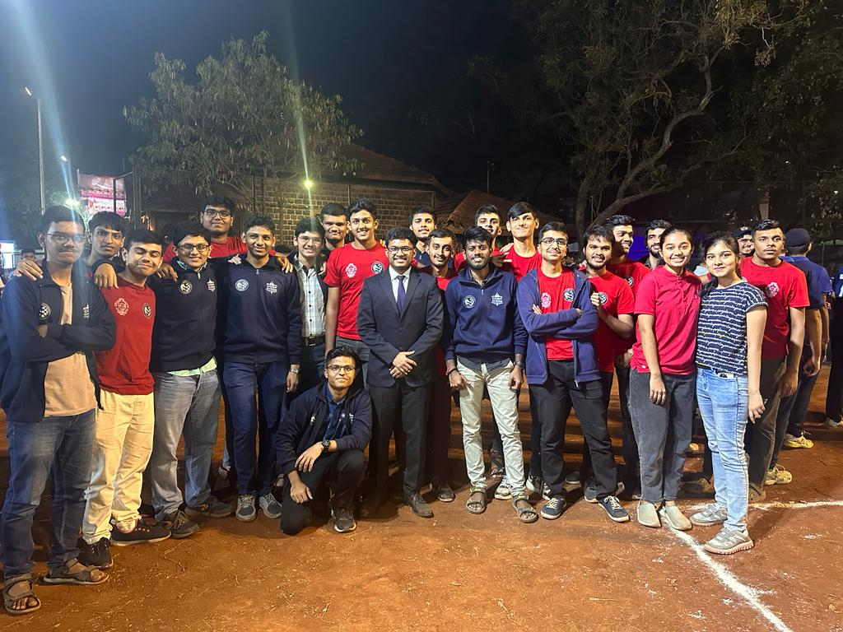

Other Tournaments Participated
- Summit '24 at MIT WPU
- CMPL '24 organized by IIT Kanpur – Team reached the Semi-Finals

Events Organized
The Chess Club organized all chess events at Zest '24, including Team Classical, Team Rapid, Rapid Team Relay, Blitz Team, and Blitz Solo events — all executed with meticulous planning and coordination within the span of 3 days.

Secretary: Abhinav Kurule
Faculty Advisor: Dr. Kavita Suranje

