COEP FOOTBALL TEAM

Events Participated: -
Mens Team
Flame Kurukshetra 2026
COEP Zest 2026
AISSMS 2026 (Commencing 2nd Feb)

Womens Team
COEP Zest 2026
Symbiosis Sprint (Commencing 4th Feb)

Achievements : -
Mens Team
Quarter Finalist at Zest 2026
Quarter Finalist at Flame Kurukshetra 2026 - The only team to record victories in every group-stage match.

Womens Team
Winners of the Zest 2026

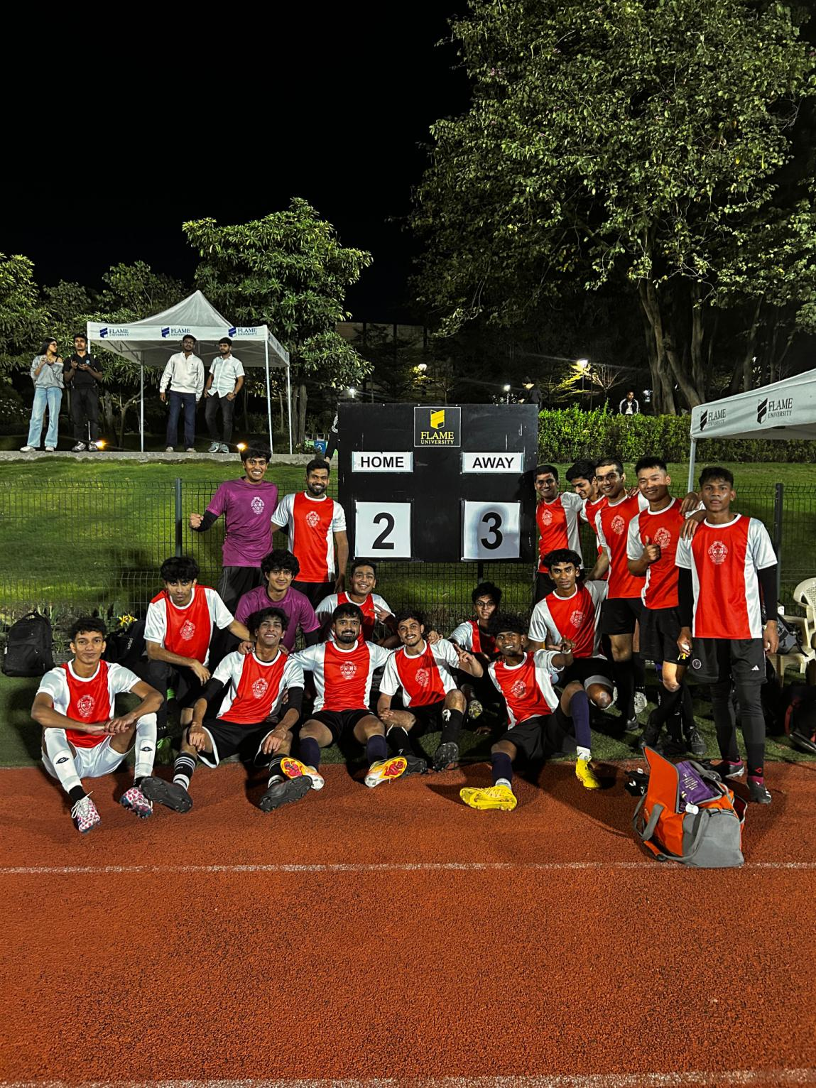

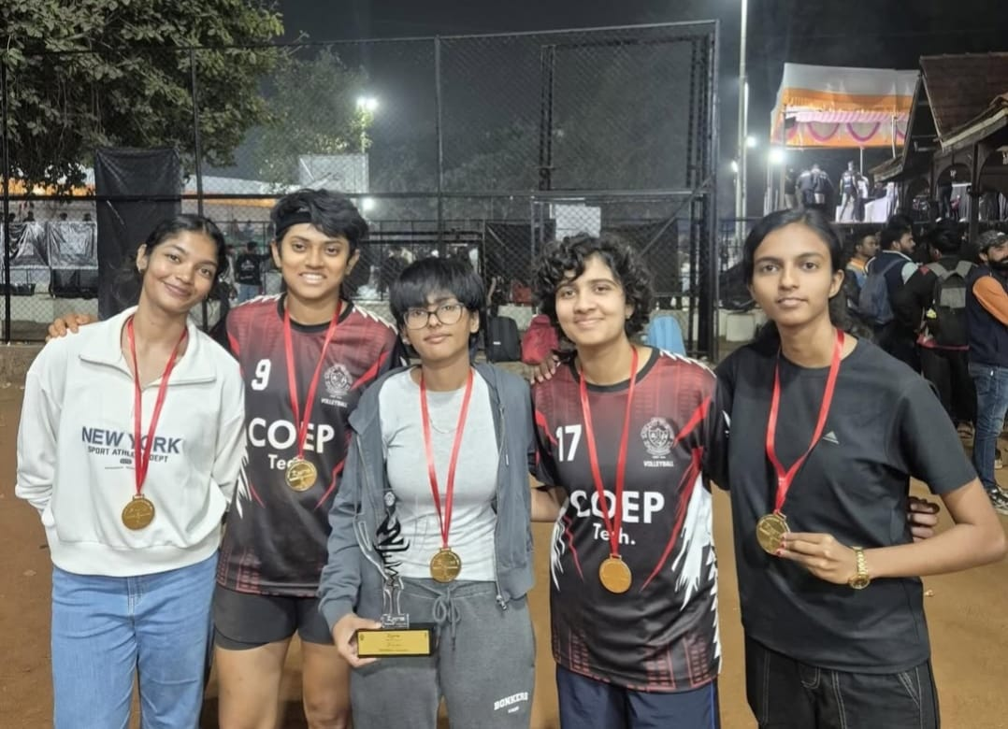

Secretary: -Mandar Khond

Captain: -Viraj Patel

Media: - Atharva Patil

