BIS STUDENT CHAPTER

About the BIS Student Chapter
The BIS Student Chapter at COEP Technological University is a student-led initiative affiliated with the Bureau of Indian Standards (BIS), India's national standards body. The chapter is dedicated to promoting awareness of standardization, quality, and product safety among engineering students. Through technical events, paper presentations, quizzes, debates, and industry interactions, the chapter bridges the gap between academic learning and the standards-driven requirements of modern engineering practice. The chapter operates under the guidance of the Faculty Advisor and aims to produce graduates who are equipped with a strong understanding of national and international standards frameworks.

Objectives 2025-26
- To promote awareness of standardization, quality assurance, and BIS certification among students.
- To conduct technical events that encourage engagement with national and international standards.
- To connect students with BIS-supported activities including research, internships, and quizzes.
- To foster a culture of responsible and quality-driven technological innovation within the institute.
- To develop students' understanding of emerging standards in areas such as AI, cybersecurity, and manufacturing.
- To provide a platform for technical communication through paper presentations, debates, and competitive events.

Activities Conducted
1. Inauguration Ceremony of BIS Student Chapter (2025–26)
Date: 14th October 2025
Venue: COEP Mini Auditorium
Participants: ~60 students
Guest / Faculty Advisor: Dr. Yogita Vaidya, Mr. S. D. Rane (Head, BIS Pune Branch), Dr. M. P. Khond (Director, Student Development)
The inauguration ceremony of the BIS Student Chapter for the academic year 2025–26 was held at the COEP Mini Auditorium. The event was coordinated and executed by club members under the guidance of Dr. Yogita Vaidya. The program commenced with a warm welcome to the dignitaries, followed by Saraswati Poojan invoking blessings for knowledge and wisdom. The club's anthem, the 'Manak Geet of BIS,' was played to provide a traditional and respectful opening to the event. Dignitaries were felicitated with bouquets as a gesture of appreciation.
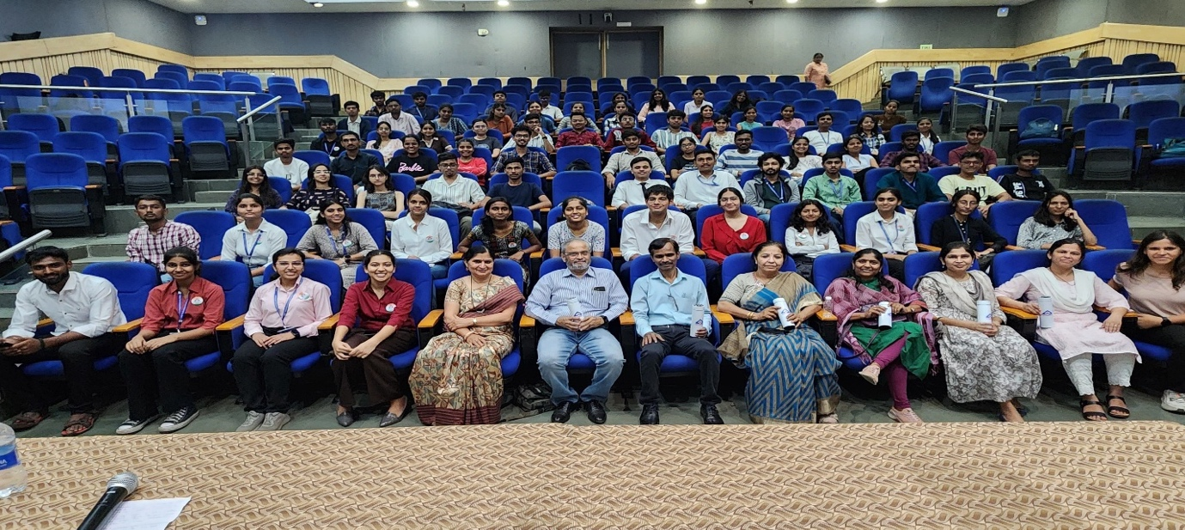
In her keynote address, Dr. Yogita Vaidya highlighted the growing importance of standardization in modern engineering education. She emphasized that understanding national and international standards is essential for engineers involved in design, manufacturing, testing, certification, and quality assurance. She elaborated on how BIS certification serves as a backbone of consumer protection and explained the various BIS-supported activities available to chapter members, including case studies, pre-standardization research, exposure visits to BIS laboratories, national-level quizzes, and internship opportunities.
2. Shaping AI Through Standards – STANDARDIZE
Date: 28th November 2025
Venue: COEP Mini Auditorium
Participants: ~90 students
Guests / Judges: Mr. S. D. Rane (Head, BIS Pune Branch), Dr. M. P. Khond (Director, Student Development), Dr. Yogita Vaidya (Faculty Advisor), Invited Faculty and Industry Experts
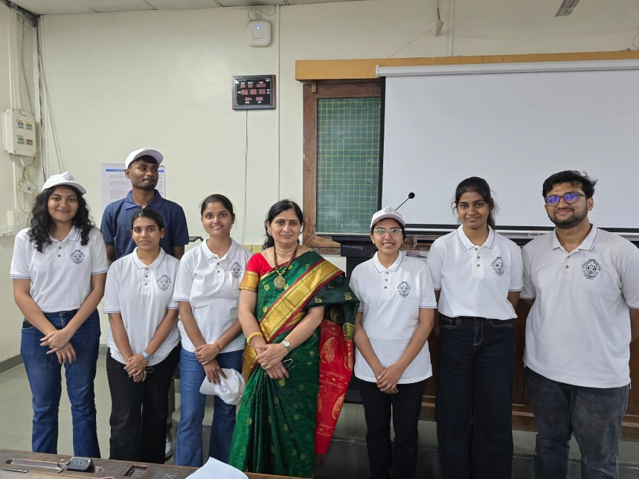
The BIS Student Chapter organized the technical event 'Shaping AI Through Standards – STANDARDIZE' on 28th November 2025. The event aimed to highlight the increasing role of standards in the development, deployment, and governance of Artificial Intelligence technologies, and to sensitize students about BIS initiatives, AI-related standardization frameworks, and the importance of responsible technological innovation.
The program commenced with a formal welcome address and an orientation on the event's theme — the intersection of Artificial Intelligence and standardization. Dr. Vaidya addressed the audience on the significance of standardization in AI-driven engineering, highlighting how BIS along with international bodies such as ISO/IEC JTC 1/SC 42 is actively developing standards related to AI ethics, model transparency, dataset quality, cybersecurity, human oversight, and operational safety.
The event featured three competitive segments:
A. Paper Presentation Competition
Students presented research papers on topics including AI governance frameworks, ethical AI and risk mitigation, technical standards for machine learning, and AI safety and compliance mechanisms. Presentations were evaluated on technical depth, adherence to the theme, structure, and relevance to standardization.
B. Quiz Competition
A multi-round technical quiz tested students' understanding of BIS standards and certification processes, Artificial Intelligence fundamentals, international standardization bodies, and real-world applications of AI in regulated sectors.
C. Debate Competition
Participants debated on topics such as the necessity of strict standards for AI, the potential of AI to remain unbiased, and the role of human intervention in automated decision-making. Judges assessed participants based on argument clarity, factual accuracy, reasoning, and professional presentation.
The event concluded with prize distribution and a formal vote of thanks. The dignitaries appreciated the initiative and encouraged the BIS Student Chapter to continue conducting programs that promote awareness of standards among engineering students.

Outcomes and Impact
- Formally launched the BIS Student Chapter for 2025–26 with a well-attended inauguration ceremony.
- Enhanced student understanding of how standards shape innovation in emerging technologies such as AI.
- Increased awareness of BIS initiatives, quality frameworks, and the significance of certification.
- Improved technical communication and analytical skills through Paper Presentation, Quiz, and Debate competitions.
- Strengthened student engagement with national standardization activities and BIS-affiliated opportunities.
- Created a vibrant platform for interdisciplinary discussions on AI governance, ethics, and compliance.

Faculty Advisor
Faculty Advisor: Dr. Yogita Vaidya

Core Team 2025-26
Finance & Marketing: Mrunmayee, Sakshi Shingde
Web: Apurva, Chandrashekhar
Refreshments & Hospitality: Vaibhavi Raut, Yogita Thigale
Accounts: Rupali, Suraj
Documentation: Pratiksha Hasbe, Purva
Design & Media: Arya S, Ashlesha Patil
Public Relations & Outreach: Shravani Sutar
Events & Operations: Bhumika, Gopal Masulkar

