COEP ASTRONOMY CLUB

About the COEP Astronomy Club
The COEP Astronomy Club is the astronomy and astrophysics club of COEP Technological University, dedicated to fostering a passion for space, science, and observational astronomy among students. The club conducts stargazing events, expert lectures, telescope-building projects, and public outreach programs to connect students with the wonders of the universe. Through collaborations with premier institutions like IUCAA and partnerships with other astronomy clubs across India, the club creates a rich ecosystem for learning, exploration, and community engagement in astronomy.

Objectives 2025-26
- To promote interest in astronomy, astrophysics, and observational science among students.
- To organize expert lectures, workshops, and outreach events for students and the public.
- To develop advanced telescope and radio astronomy projects through hands-on engineering.
- To strengthen collaborations with IUCAA and expand the club's national network through ISAAC.
- To reach rural students and underserved communities through sustained NGO outreach partnerships.
- To represent COEP at inter-collegiate competitions and contribute to national astronomy discourse.

Activities Conducted
1. Lecture on Precise Measurement and Quantum Clocks
Speaker: Prof. Subhadeep De, IUCAA (Ultra-Precise Measurement Lab)
Attendees: ~100 students
The club organized a lecture by Prof. Subhadeep De from IUCAA, covering the development of quantum clocks and the fundamental parameters of timekeeping — accuracy, stability, repeatability, and precision. Prof. De explained the engineering applications and scientific significance of quantum clocks in astronomical observations. The session was attended by around 100 students and was followed by an interactive session where Prof. De discussed how engineers contribute to astronomy research and outlined opportunities for students to engage with his lab.
2. MindSpark 2025 – Annual Astronomy Competitions
Event: MindSpark 2025 – Annual Technical Festival
The club conducted its annual astronomy competitions at MindSpark 2025. The competitions included Torquest, an astronomy-based quiz; TakeOff, a rocket launching competition; and The Wright Turn, a glider flying competition preceded by a hands-on glider making workshop. These events continued the tradition of fostering competitive and practical engagement with aerospace and astronomy concepts.
3. Full-Day Signal and Image Processing Workshop
Speaker: Mr. Jameer Manur, IUCAA
Attendees: ~70 students from various colleges
A full-day workshop on signal and image processing was organized in collaboration with other astronomy clubs, conducted by Mr. Jameer Manur from IUCAA. The session covered the processing of astronomical images across the electromagnetic spectrum, providing participants with practical knowledge of techniques widely used in observational astronomy. The workshop drew around 70 students from multiple institutions.
4. Lecture on Gravity and Gravitational Waves – Chandra Public Lectures Series
Speaker: Prof. Shasvath Kapadia, IUCAA
Attendees: ~80 students
The club hosted a lecture by Prof. Shasvath Kapadia, a researcher at IUCAA, under the 'Chandra Public Lectures' series. The lecture covered gravity, gravitational waves, and their engineering applications. It also served as the introductory lecture for students enrolled in the LLC/CCA-01 Astronomy course and was attended by around 80 students, marking a significant intersection between the club and formal academic learning.
5. From Classrooms to Cosmos (C2C) – Project Exhibition
Chief Guests: Group Captain Prasanth B. Nair (ISRO Astronaut) and Mr. Aditya Pittie, Pittie Enterprises
Attendees: ~1000
The club organized a large-scale project exhibition as part of the Classroom to Cosmos event, held on the occasion of ISRO Astronaut Group Captain Prasanth B. Nair and Mr. Aditya Pittie visiting COEP for a talk and interview in the Main Auditorium. The exhibition displayed the club's ongoing projects including the Horn Antenna Radio Telescope and the Dobsonian Telescope. The event saw an audience of approximately 1000 attendees, making it one of the largest events organized by the club.
6. Club Star Party
The club organized an overnight stargazing event for club members and faculty. The event provided junior members with an introduction to the club's equipment, telescopes, and night sky observation techniques, building practical observational skills and deepening their connection with astronomy.
7. NGO Visit – Godavari Bidkar Foundation, Rajgurunagar
Outreach Reach: ~150 students across 2 schools and an orphanage; 250+ first-time telescope viewers
The club was invited by the Godavari Bidkar Foundation to deliver introductory astronomy sessions to students from rural schools. The visits were followed by rooftop stargazing activities, enabling over 250 people to observe celestial objects through a telescope for the first time. This outreach effort reached approximately 150 students across two schools and an orphanage, making a meaningful impact on young learners in underserved communities.
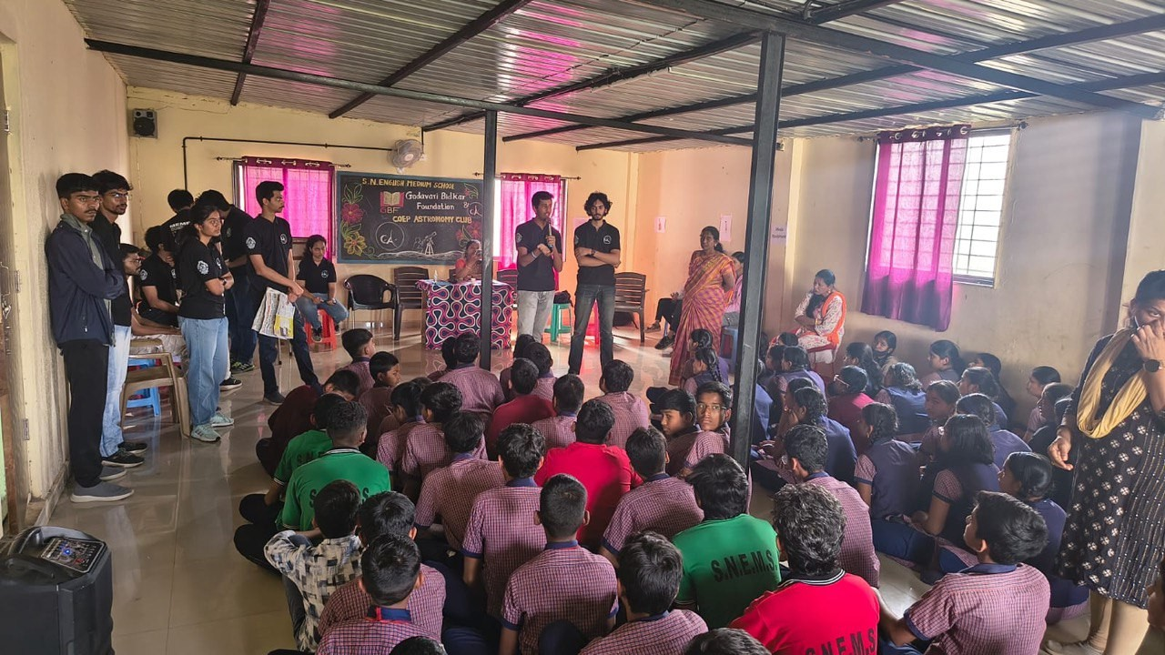
8. Full-Day Astrophotography Workshop
Conducted by: Amogh Bhosekar (Projects Head) and Mr. Jameer Manur, IUCAA
Attendees: ~60 students including participants from other colleges
A full-day hands-on astrophotography workshop was organized, covering the fundamentals of astrophotography, a live image processing demonstration, and a display of professional astrophotography equipment capturing photos in real-time. The workshop was conducted by the club's Projects Head and Mr. Jameer Manur from IUCAA, and drew an audience of around 60 participants from COEP and other colleges.
9. IEEE APS COEP Tech Student Branch Inauguration
The club set up a special exhibition at the inaugural event of the IEEE Antennas and Propagation Society (APS) COEP Tech Student Branch, displaying the in-progress Horn Antenna Radio Telescope project. The exhibition showcased the technical depth of the club's projects and highlighted the interdisciplinary nature of radio astronomy engineering.
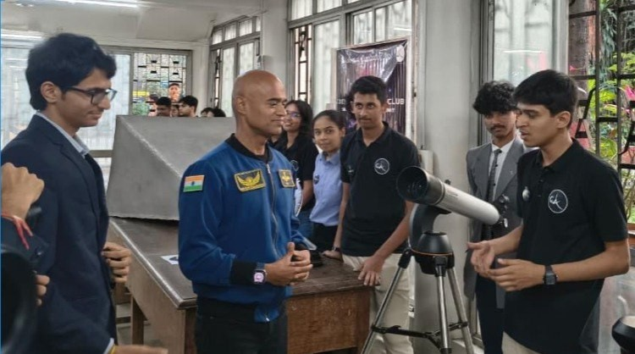
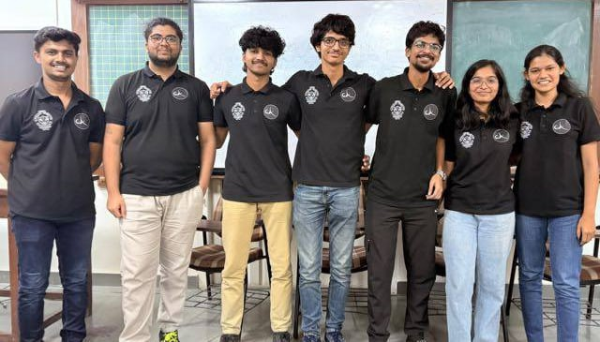
10. Public Star Party
The club organized an overnight public stargazing event open to all COEP students and faculty. The event sparked widespread interest in astronomy across the campus, providing an accessible and engaging first experience with telescopic observation and the night sky for students beyond the club's regular membership.

Projects
1. Horn Antenna Radio Telescope – 21 cm H I Line Observer
The club is constructing a Horn Antenna Radio Telescope to observe the 21 cm neutral hydrogen (H I) line, associated with the spin-flip transition in neutral hydrogen that traces the structure of the Milky Way galaxy. By measuring the Doppler shift of the incoming 21 cm radiation, the club aims to calculate the velocities of different regions of neutral hydrogen, and by plotting these against distance from the galactic centre, generate a rotation curve from which the presence and distribution of dark matter can be inferred.
Key milestones achieved this year include: framing the problem statement and conducting a thorough literature review; constructing a trapezoidal horn antenna with a waveguide from aluminium sheets; building a stable two-axis rotating mount for precise targeting; procuring and testing electronic data acquisition components at the IUCAA Measurement Lab; and developing a novel Python-based post-processing pipeline tested on live measurements at IUCAA.
2. 6-Inch Reflector Dobsonian Telescope
The club is developing a low-cost, portable, tabletop Dobsonian telescope using a 6-inch primary mirror with a focal length of 600mm (f/4), balancing light collection and field of view. A 6-inch concave mirror was successfully ground and polished this year. Design of the telescope tube, mount, and cost analysis are currently in progress.

Collaborations and Outreach
- Maintained and strengthened collaborative relations with astronomy clubs in Pune through jointly organized events.
- Joined ISAAC (Indian Synergy of Astronomy & Astrophysics Clubs), a national initiative enabling collaboration and knowledge sharing between college-level astronomy clubs across India.
- Established liaison with Prof. Subhadeep De, IUCAA, for student research opportunities in quantum clocks and ultra-precise measurement devices.
- Ongoing collaboration with Mr. Samir Dhurde, IUCAA SciPOP, to bring established speakers under the 'Chandra Public Lectures' series.
- Received assurance from Mr. Manoj Bidkar, Godavari Bidkar Foundation, for continued and expanded outreach to rural schools in future years.
- Received financial support from Prof. Mandar Bhatavdekar (Professor of Practice, EnTC Department) for club academic activities.

Outcomes and Impact
- Organized 10 major events including lectures, workshops, competitions, and outreach visits.
- Reached over 250 people through the NGO outreach program, many experiencing telescopic observation for the first time.
- Hosted a landmark 1000-attendee event during the From Classrooms to Cosmos visit by ISRO Astronaut.
- Advanced the Horn Antenna Radio Telescope project to full antenna construction and pipeline testing at IUCAA.
- Joined the national ISAAC astronomy collaboration network, extending the club's reach across India.
- Strengthened ties with IUCAA through multiple collaborations, lectures, and workshop co-organizations.

Core Team 2025-26
Secretary: Yash Kavishwar
Astroreach Heads: Ritesh Chittora, Yash Zilmar
Events Heads: Anway Joshi, Bhumi Dave
Projects Heads: Amogh Bhosekar, Sneha Barudwale
