ARTS AND CRAFTS CLUB (ANC)
The Arts and Crafts Club (ANC) of COEP is a vibrant student-driven platform that encourages creativity, artistic exploration, and cultural expression on campus. The club provides students with opportunities to learn, create, and showcase diverse art forms while preserving traditional Indian art practices alongside contemporary styles. Through workshops, competitions, exhibitions, and interactive events, ANC actively contributes to the cultural and creative life of the institute.

Major Activities Conducted

1. Annual Gathering Art Exhibition
The Arts and Crafts Club organized a comprehensive art exhibition during COEP's Annual Gathering, serving as a platform for students to showcase their creativity across a wide range of art forms. The exhibition featured traditional and contemporary artworks, highlighting lesser-known Indian art styles alongside modern techniques. It attracted significant footfall from students, faculty, and visitors, contributing meaningfully to the cultural vibrancy of the campus.

2. Club Inductions
The club conducted structured induction activities at the beginning of the academic year to introduce new members to the objectives, functioning, and creative ethos of the Arts and Crafts Club. These inductions provided students with an overview of upcoming events, skill-building opportunities, and avenues for participation, helping foster an inclusive and enthusiastic artistic community within the institute.

3. Face Painting Event
As part of COEP's festive celebrations, the Arts and Crafts Club successfully organized its annual Face Painting event. The activity witnessed enthusiastic participation from students and faculty members, creating a lively and interactive environment on campus. The event encouraged spontaneous creativity while promoting artistic expression in a fun and engaging format.
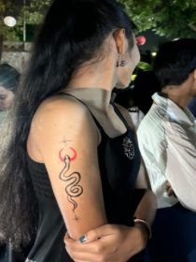

4. Art Exhibition during Annual Regatta
During the Annual Regatta, the club curated a dedicated art exhibition to complement the sporting and cultural spirit of the event. Student artworks were displayed in an accessible and engaging manner, allowing a wider audience to appreciate diverse art forms. The exhibition added a creative dimension to the Regatta celebrations and increased visibility for student artists.
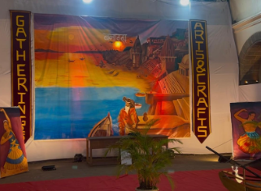

5. Poster Painting Competition – Shivaji Maharaj and Mahatma Gandhi
The club organized a poster painting competition centred on the themes of Chhatrapati Shivaji Maharaj and Mahatma Gandhi, combining artistic expression with historical and social awareness. Participants creatively depicted the values, leadership, and legacy of these iconic figures through visual storytelling, engaging students with India's heritage while expressing their perspectives through art.

Major Achievements
- Successfully established a strong creative presence on campus by curating multiple large-scale art exhibitions during flagship institute events such as the Annual Gathering and Annual Regatta, providing sustained visibility to student artists and promoting diverse art forms.
- Strengthened student engagement and membership growth through well-structured club inductions, building an active and inclusive artistic community while increasing awareness about art-related opportunities at COEP.
- Encouraged participative and interactive art practices by organizing high-footfall events such as Face Painting, fostering spontaneous creativity and enhancing cultural engagement among students and faculty.
- Promoted art as a medium for cultural and historical awareness through the thematic poster painting competition on Chhatrapati Shivaji Maharaj and Mahatma Gandhi, enabling students to creatively interpret national values, leadership, and heritage.
- Reinforced the club's role as a key contributor to campus cultural life by consistently integrating art into major institutional celebrations, positioning the Arts and Crafts Club as a central platform for creative expression at COEP.

Core Team
- Tejas Parsawat (Secretary)
- Sanket Lohar
- Tejas Chopda
- Anjali Pandey
- Bhumika Yadav
- Deep Vaidya
- Vedika Bansode
- Vaishnavi Pradhan
- Ved Madke

