ARTS AND CRAFTS CLUB (ANC)
The Arts and Crafts Club (ANC) of COEP is a vibrant student-driven platform that encourages creativity, artistic exploration, and cultural expression on campus. The club provides students with opportunities to learn, create, and showcase diverse art forms while preserving traditional Indian art practices alongside contemporary styles. Through workshops, competitions, exhibitions, and interactive events, ANC actively contributes to the cultural and creative life of the institute.

Major Events 2023-24

1. Masquerade Workshop
Date: 4th September 2023
Participants: 80+
The Masquerade Workshop (Mask Making Workshop) served as the inaugural event of the Arts and Crafts Club. All craft materials such as paints, glitters, foam, feathers, etc., were provided by the club. Students created a wide variety of creative and beautiful masks, which were later displayed at the club's exhibition. The event was a huge success and set an enthusiastic tone for the rest of the year.

2. Sketching Workshop
Date: 13th October 2023
The Arts and Crafts Club consistently highlights contemporary, underappreciated art and craft genres while never losing touch of their fundamentals. The Sketching Workshop was planned to provide all COEPians with structured learning in both basic and advanced levels of sketching techniques.
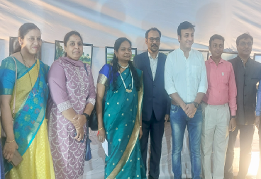

3. Face Painting Event
Date: 28th March 2024
Participants: 100+
Face painting is one of the most popular and fun events conducted by the club every year during the Gathering days. This year the event saw participation from over 100 students and faculty members. All materials were provided by the club. The event was judged by Dr. M.P. Khond Sir (Director of Student Affairs) and Neelima Patil Ma'am (Faculty Advisor, Arts and Crafts Club).

4. Gathering Exhibition
Dates: 29th, 30th and 31st March 2023
During COEP's annual social gathering, the Arts and Crafts Club organized a diverse art exhibition in the main building, showcasing over 130 artworks representing underrated art forms from across India. The exhibition featured traditional Madhubani, Lippan, and Mandala art, along with knife, watercolour, acrylic, oil paintings, pen art, calligraphy, and portrait sketches.
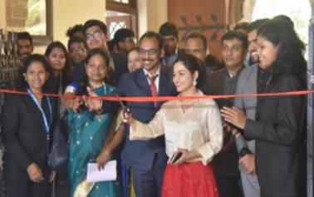
Two standout centrepieces included an AI-generated illustration of Ram Mandir Ayodhya with Shree Ram and a human-sized colourful Gopuram from a South Indian heritage temple. The exhibition highlighted India's rich cultural and heritage diversity through a vibrant display of artistic expressions.
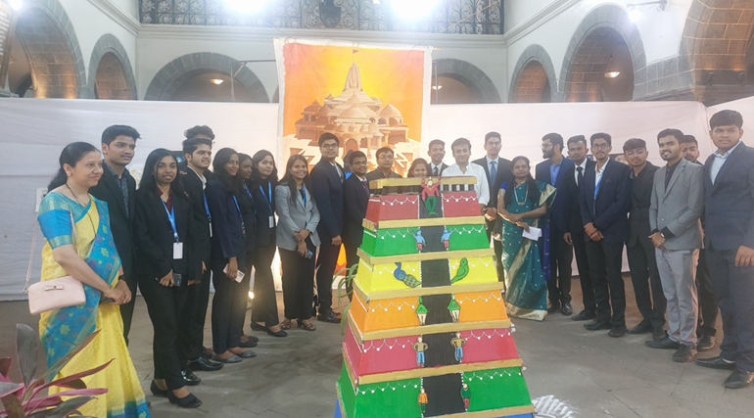

Major Achievements
- Launched the Arts and Crafts Club with a Masquerade (Mask Making) Workshop on 4th September 2023, engaging 80+ students and producing creative mask artworks later displayed in the club exhibition.
- Conducted a Sketching Workshop on 13th October 2023, focusing on both basic and advanced techniques to strengthen students' artistic foundations.
- Successfully organized the annual Face Painting Event during Gathering on 28th March 2024, with 100+ student and faculty participants, evaluated by the Director of Student Affairs and the club's Faculty Advisor.
- Curated a large-scale Art Exhibition during COEP's Annual Gathering (29th-31st March 2023), showcasing 130+ artworks across traditional and contemporary Indian art forms, including standout installations such as an AI-generated Ram Mandir artwork and a life-sized South Indian Gopuram.

Core Team
- Neha Samarth (Secretary)
- Sanket Lohar
- Deep Vaidya
- Bhumika Yadav
- Anjali Pandey
- Avinash
- Sharayu Deshkar
- Priyanka
- Pooja

