ARCHERY CLUB
The Archery Club at COEP Technological University promotes the sport of archery among students, focusing on discipline, precision, concentration, and sportsmanship. The academic year 2025-26 saw active participation from students across years, with the club conducting regular inductions, practice sessions, cultural observances, and competitive events.

Activities and Events

1. Induction Activity
Date: 8th September 2025
Venue: COEP Main Ground
The induction session introduced new students to the fundamentals of archery, including rules, safety protocols, and basic techniques. The session included an introduction to archery, equipment demonstration, and guided practice of essential skills such as stance and aiming. Participants tried shooting under expert supervision, with a strong focus on safety awareness. The induction helped build a strong foundation for new members and sparked enthusiasm for the sport.

2. Regular Practice Sessions
Regular practice sessions were conducted throughout the academic year to develop and refine skills among club members. Beginners learned fundamental skills including posture, grip, and aiming, while all students practiced target shooting regularly. The supervised sessions ensured steady improvement in accuracy and confidence among participants across all experience levels.

3. Shastra Puja
Date: 2nd October 2025
Venue: COEP Main Ground
Members of the Archery Club performed Shastra Puja, a traditional ritual honouring their bows and arrows, on the auspicious occasion of Navratri. The ceremony highlighted the cultural values of respect for one's equipment and discipline in practice. The ritual fostered a sense of unity within the club and connected members to the rich traditions associated with archery.
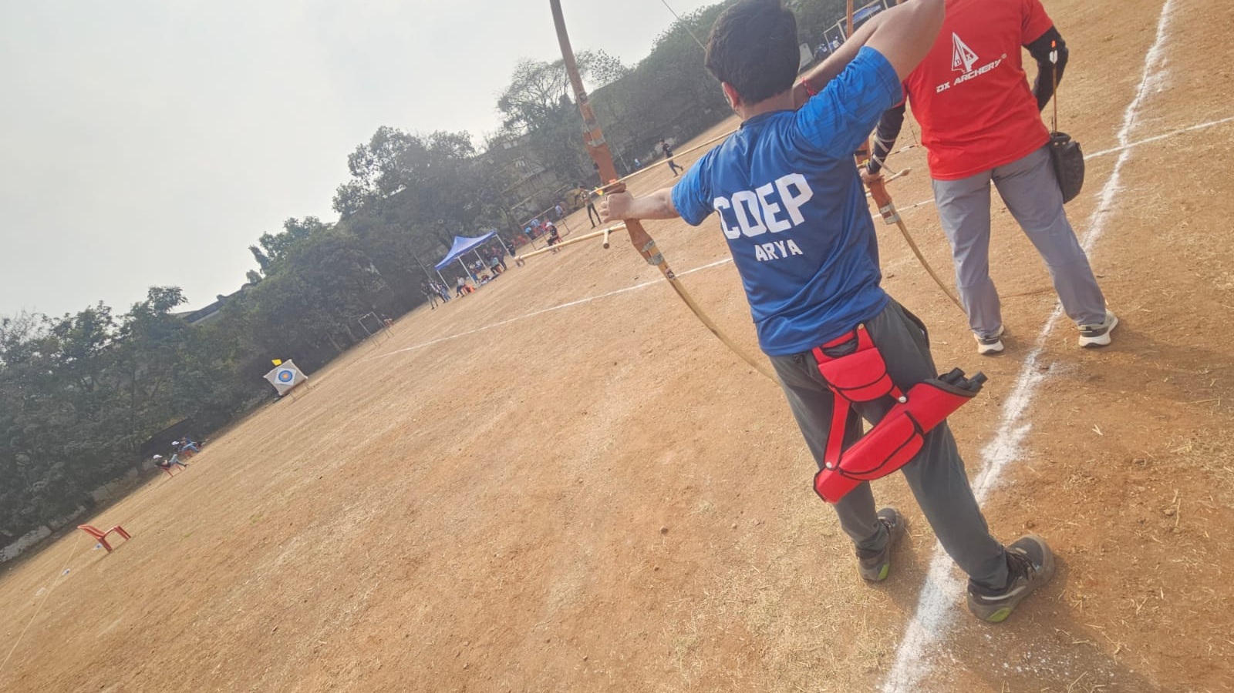

4. Zest '26
Date: 25th January 2026
Venue: COEP Main Ground
Format: Pool format — multiple matches per participant
At Zest '26, the COEP Archery Club's participants showcased excellent performance, securing multiple medals in competition. The pool format allowed players to compete in multiple matches, improving both skills and competitive experience. A majority of participants were from the first year, providing them with invaluable early exposure to competitive archery.

Achievements:
2 Gold Medals — Won
1 Silver Medal — Won

Gold Medalists:
- Prachiti Bhople – T.Y. Electrical Engineering
- Arya Kulkarni – T.Y. Computer Science

Silver Medalist:
- Roshni Naikwade – S.Y. Manufacturing Engineering

