Arts and Crafts Club (ANC)
The Arts and Crafts Club (ANC) of COEP is a vibrant student-driven platform that encourages creativity, artistic exploration, and cultural expression on campus. The club provides students with opportunities to learn, create, and showcase diverse art forms while preserving traditional Indian art practices alongside contemporary styles. Through workshops, competitions, exhibitions, and interactive events, ANC actively contributes to the cultural and creative life of the institute.

Events Organised
- ANC commenced the academic year with club inductions in October, introducing new members to the basics of visual art through a live acrylic painting demonstration. The session explained concepts such as light, shadow, colour hues, and gradients in an interactive and engaging manner, helping new entrants understand artistic fundamentals while building interest and confidence.
- In November, the club organised a painting competition to commemorate 150 years of Vande Mataram. Students were encouraged to depict themes of national pride, cultural heritage, and progress, resulting in a wide range of artistic interpretations and enthusiastic participation.
- On 22nd December, ANC conducted a Madhubani Painting Workshop under the LLC framework, attended by approximately 50 participants. The workshop familiarised students with the historical and cultural significance of Madhubani art, followed by a guided hands-on session that allowed participants to apply traditional techniques creatively.
- During COEP’s Annual Gathering, ANC organised its first Harry Potter–themed art exhibition. The exhibition included a large-scale 20×20 ft painting, interactive craft installations, themed photo booths, and immersive dark rooms with 3D elements. The club also conducted face painting sessions during the musical nights, contributing actively to the festive atmosphere.
Milestones Achieved
- ANC achieved a major milestone in December by performing live on stage for the first time during the Annual Alumni Association Meet. The performance featured live watercolor and digital art creation, offering the audience a rare opportunity to witness art being created in real time.
- The live artworks, depicting the Mechanical Engineering Department tower and the main building interior, received strong appreciation from alumni and guests, marking a significant step in expanding the club’s presence beyond exhibitions into live artistic performances.
- The successful execution of large-scale, theme-based exhibitions and workshops during this period reflected substantial growth in the club’s creative scope, participation levels, and organisational capability, further strengthening ANC’s contribution to COEP’s cultural ecosystem. Top three artworks from
- The Arts and Crafts Club organized an election awareness poster competition with the aim of promoting civic responsibility and encouraging informed participation among students. The competition invited participants to visually communicate the importance of voting, democratic values, and electoral awareness through creative posters. Students presented thoughtful and impactful artworks highlighting themes such as voter participation, ethical leadership, and the power of individual choice. The event successfully used art as a medium to spark dialogue on democratic engagement while fostering socially conscious creativity on campus.

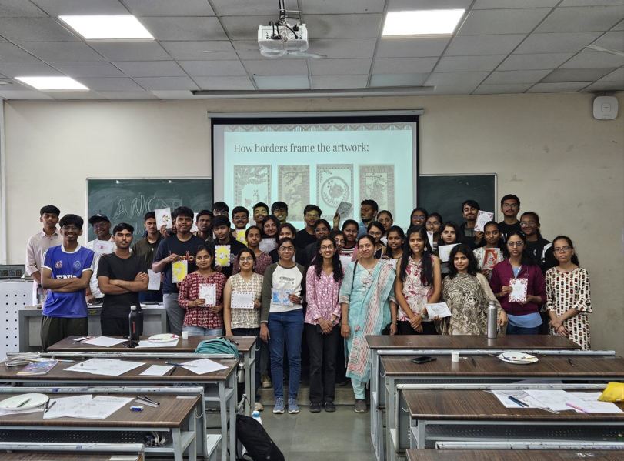

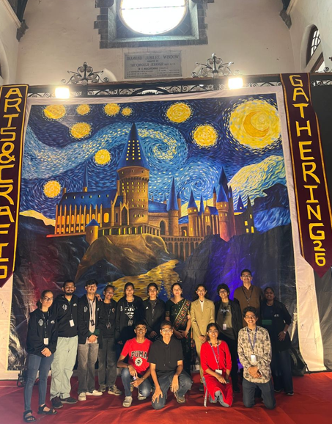
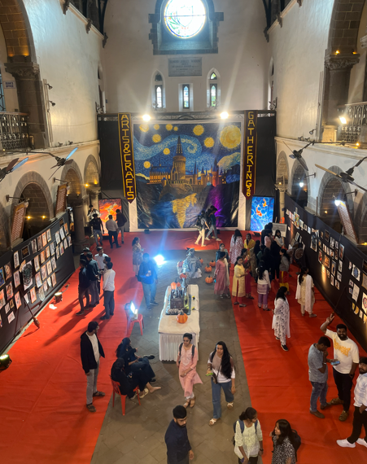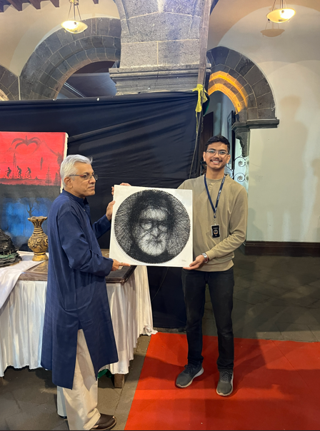
Core Team:
- Manali Joshi (Secretary)
- Shantanu Deo
- Prasanjeet Wadmare
- Anjali Pandey
- Bhumika Yadav
- Deep Vaidya
- Vedika Bansode
- Vaishnavi Pradhan
- Ishwari Patil
- Samruddhi Taware
- Arnav Padhye
- Shourya Tadwale
- Supriya Madne
- Unmesh Ambi
- Ved Madke
- Abhishek Mahanur
- Pravin Wadekar

