ATHLETICS & SWIMMING CLUB

About ATHLETICS & SWIMMING CLUB
The Athletics & Swimming Club of COEP Technological University is dedicated to promoting physical fitness, sportsmanship, and the overall well-being of students. The club provides a structured platform that encourages students to actively participate in sports while maintaining a balance with their academic commitments. Through regular training sessions, events, and competitions, the club fosters discipline, teamwork, and a healthy lifestyle across the campus.

Objectives 2025-26
• To promote physical fitness, sportsmanship, and overall well-being among students.
• To encourage active participation in athletics, swimming, and competitive sports.
• To provide practical training and exposure to inter-collegiate competitions.
• To organize special events introducing non-conventional fitness disciplines.
• To foster teamwork, discipline, leadership, and mental resilience through sports.
• To motivate students towards a healthy, active, and balanced lifestyle.

Activities Conducted

1. Regular Training and Conditioning Sessions
Date: Throughout the academic year 2025–2026
Participants: Students from all departments and fitness levels
The club conducted regular athletics and conditioning sessions focused on endurance and stamina building, strength and muscular development, flexibility and mobility, and injury prevention. These inclusive training programs helped students develop physical strength, mental resilience, and a disciplined routine, contributing to a strong fitness culture within the institute.
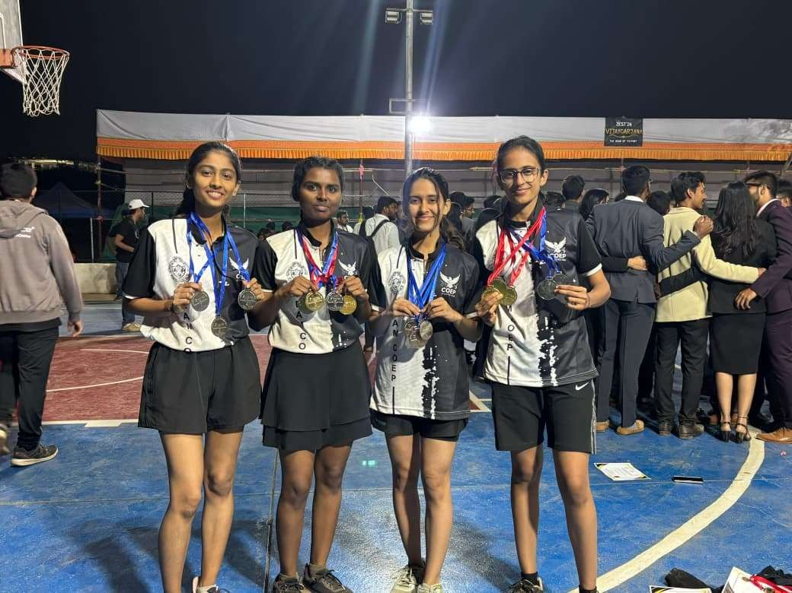

2. Calisthenics & Parkour Demonstration – “The Urban Rift”
Date: 7th January 2026
Time: 12:00 PM
Venue: AC Ground Floor, COEP Technological University, Pune
Participants: Students across multiple academic years (significant participation from First Year students)
Guide: Professional trainers from MYOW Fitness Parkour
A major highlight was the Calisthenics and Parkour Demonstration titled “The Urban Rift” organized in collaboration with MYOW Fitness Parkour. The live session introduced students to functional bodyweight training, agility, balance, coordination, and safe progressive exercises. Professional trainers demonstrated movements for beginners to advanced levels and explained progression, safety, and injury prevention. The event created awareness about alternative fitness methods and provided a constructive, stress-relieving activity post-examinations.

3. Athletics Achievements – LAWSKETS 2026
Date: 3rd February 2026
Host: Deccan Education Society’s Shri Navalmal Firodia Law College
Participants: Selected athletes representing COEP Tech
The club participated in LAWSKETS 2026 with outstanding performances. Boys 4 × 100 m Relay secured First Position (Jatin Mukhade, Jaywant Kolekar, Prathamesh Awale, Anirudh Chandra). Girls 4 × 100 m Relay also secured First Position (Tanishka Shelke, Siddhi Deshmukh, Heer, Aditi Bhandarkar). In the 100 m Girls sprint, Heer secured First Position and Siddhi Deshmukh secured Second Position. The athletes brought significant recognition to the institute through their discipline and competitive spirit.

4. Athletics and Swimming Achievements – ZEST 2026
Date: During ZEST 2026
Participants: Athletics and Swimming team members
Total Medals: 29
The club delivered a stellar performance at ZEST 2026, winning a total of 29 medals. Highlights included Boys Relay – First Position (Tanmay Bhandwalkar, Jaywant Kolekar, Jatin Mukhade, Prathamesh Awale) and Girls Relay – Second Position. Multiple track and field medals were won in events such as 1600 m, 400 m, 200 m, 100 m, Javelin Throw, Discus Throw, and Shot Put. Swimming events also contributed with medals in 50 m Butterfly and both 4 × 50 m Freestyle and Medley Relays.
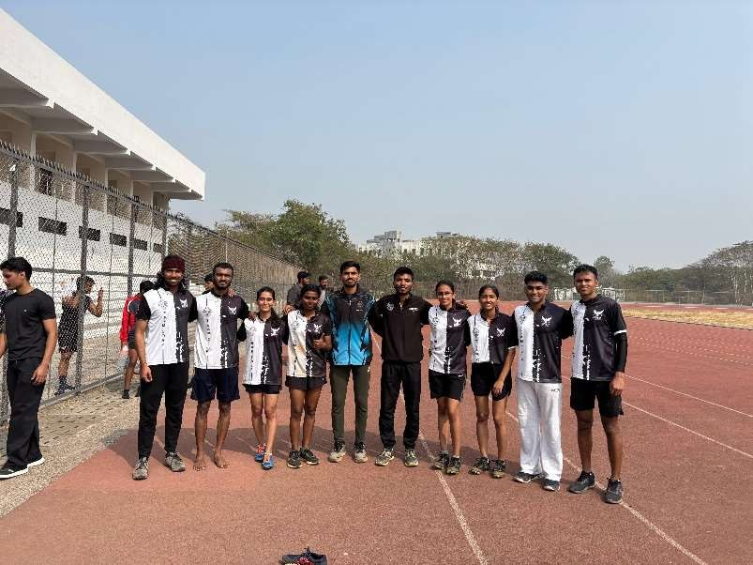

5. Vishwanath Sports Meet 2026 – MIT ADT University
Date: 24th January 2026
Participants: Swimming team members
The club participated in the Vishwanath Sports Meet 2026. Individual achievements included Pari More Patil securing First in 50 m Butterfly and Third in 100 m Freestyle, and Shruti Lonkar securing Third in 50 m Freestyle. Girls 4 × 50 m Freestyle Relay and 4 × 50 m Medley Relay both secured Third Position. The team demonstrated strong coordination and competitive excellence.
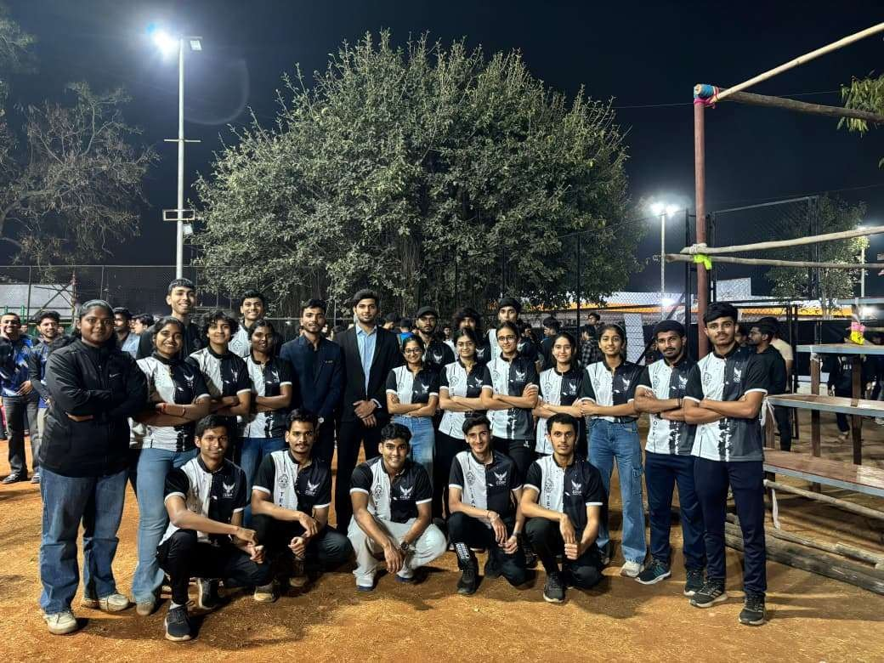
6. Swimming Meet – MIT World Peace University
Date: 4th February 2026
Participants: Swimming team members
Total Medals: 24
The club achieved remarkable success at the MIT-WPU Swimming Meet with 24 medals. Pari More Patil won First in 100 m Breaststroke and multiple Second positions. Rupak Ambekar, Bhavik Kalra, and Shirishkumar Shinde dominated Boys events with several First and Second positions. Both Girls Relay (Second Position) and Boys Relay (First Position) delivered excellent results. Overall, the athletes showcased outstanding skill and dedication.

Outcomes and Impact
• Significant increase in participation in sports and fitness activities across departments.
• Enhanced physical fitness, mental well-being, and awareness of healthy lifestyle practices.
• Exposure to diverse sporting disciplines including non-conventional fitness methods such as calisthenics and parkour.
• Development of essential life skills – teamwork, leadership, discipline, and time management.
• Boosted confidence and competitive spirit through inter-collegiate participation.
• Winning a total of 74 medals across all competitions, strengthening the institute’s sports reputation.
• Encouragement of long-term fitness habits and holistic personality development among students.

Core Team 2025-26
Secretary: Shivdas Bankar
Faculty Advisor: Prof. Archana Patil
