AERIAL ROBOT STUDY CIRCLE (ARSC)

Executive Summary
This report details the engineering, operational, and competitive milestones achieved by the Aerial Robot Study Circle (ARSC) during the 2025-26 academic cycle. The team successfully transitioned from conceptual hardware design to fully autonomous, edge-AI integrated deployments operating under strict regulatory constraints. Key achievements include securing a Silver Medal at NIDAR 2025, executing autonomous swarm flights within a DGCA Red Zone, and deploying RTK-precision logistics proofs-of-concept.

Activities & Projects

1. SAEINDIA AeroTHON 2025
Date: June 2025
Location: Global Academy of Technology (GAT), Bengaluru
Mission: Phase I Design Presentation for a Micro UAS capable of precision payload delivery and autonomous object classification

Technical Specifications:
- Airframe: Symmetrical X-shape quadcopter (469mm wheelbase) using 20mm square carbon fiber arms — MTOW engineered to 1.975 kg.
- Propulsion: Four Tarot TL2955 4008MT (320KV) motors with 10x5.5 3K Carbon Fiber propellers — Thrust-to-Weight Ratio (TWR) of 2.43:1.
- Avionics: Pixhawk Cube Orange+ (PX4 firmware) for flight control; NVIDIA Jetson Orin Nano (67 TOPS) for real-time edge processing.
- Autonomy Stack: MAVLink v2 protocol with ROS 2 (Humble) middleware; YOLOv8 for disaster indicator detection; Multi-View CNN (ResNet-18) for discrete object classification.
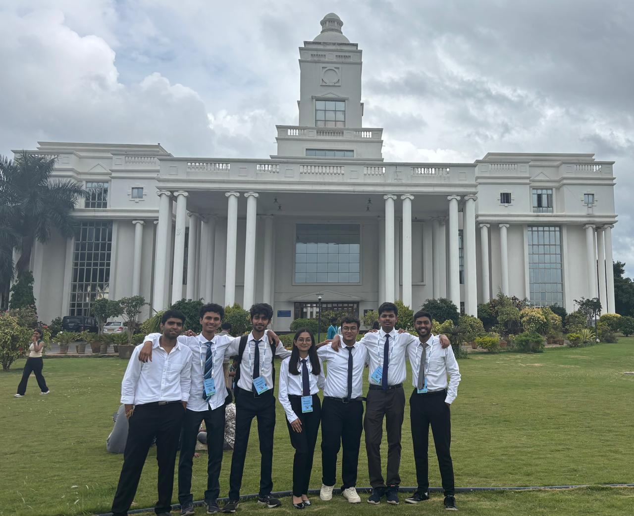
2. Independence Day Autonomous Drone Show
Date: 15th August 2025
Location: COEP Main Building (DGCA Red Zone – 10 km airport radius)
Mission: Fully autonomous, coordinated multi-UAV deployment requiring zero Ground Control Station (GCS) dependency to meet airspace regulations
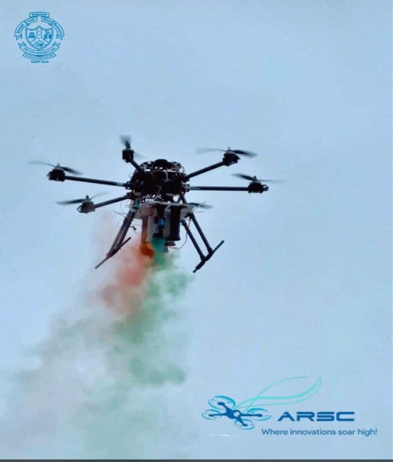
Technical Highlights:
- Fleet: 1 Quadcopter + 1 Hexacopter, both equipped with Pixhawk flight controllers and Raspberry Pi 4B companion computers.
- Custom Python/pymavlink script (MavlinkAutoConnector) developed for auto-scanning serial ports and ensuring reliable HEARTBEAT locks.
- Custom ESP32-based UDP communication layer (AP + STA topology) on a dedicated 2.4 GHz network — achieved sub-10 ms trigger latency with 0% packet loss.
- Synchronized payload releases: flower shower and tricolor smoke.

3. Autonomous Campus Delivery Deployment
Date: November 2025
Location: COEP Hostel Grounds (Cafeteria to Girls Hostel Block)
Validated by: Hostel Chief Rector Dr. B.G. Birajdar and Faculty Advisor Dr. M.D. Jaybhaye
Proof-of-concept autonomous logistics operation validating point-to-point delivery in a high-interference urban canyon environment. Key upgrades included transitioning from standard GNSS (~1.5m CEP) to RTK GPS architecture achieving centimeter-level precision, and replacing servo-actuated mechanisms with a binary magnetic gripper system, eliminating mechanical binding risks and ensuring instantaneous payload handoff. The end-to-end autonomous demonstration was successfully completed.
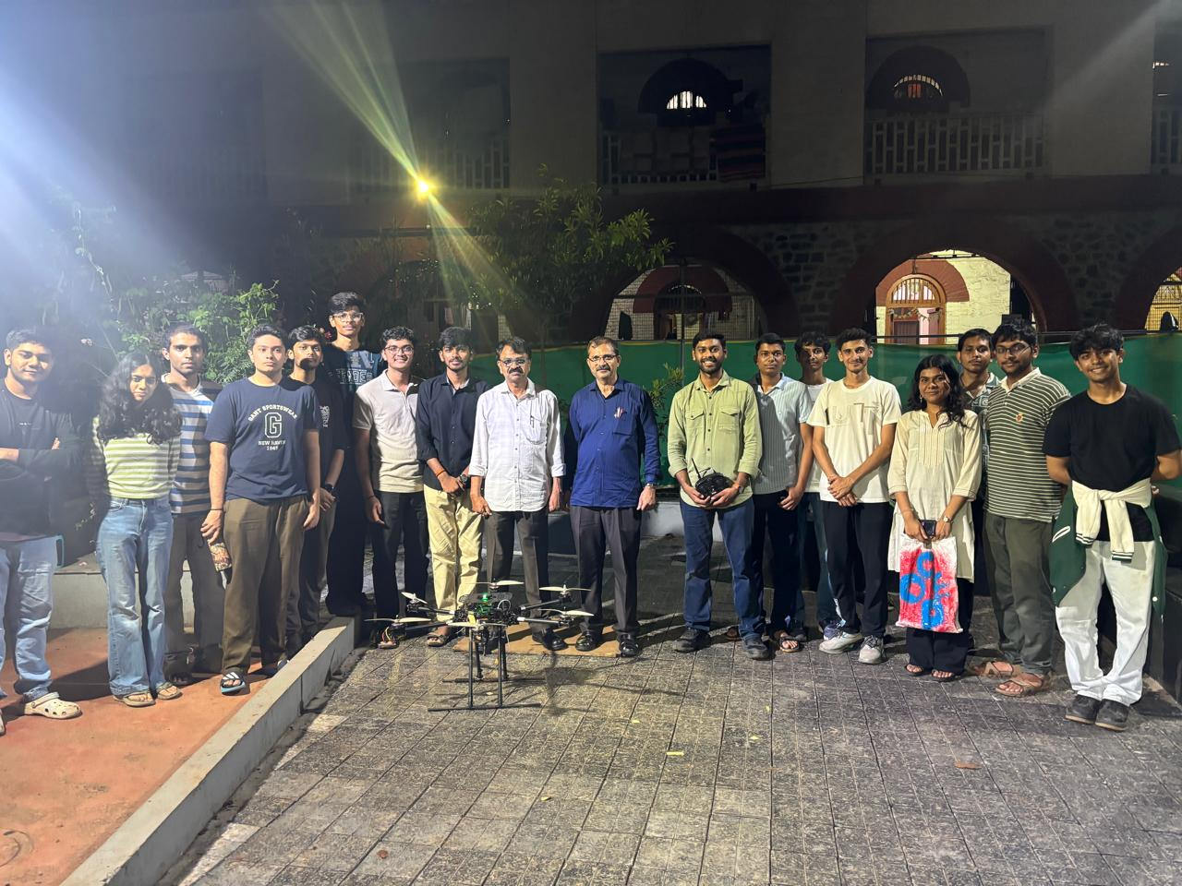
4. NIDAR 2025 Competition
Date: 10th – 17th January 2026
Location: Gautam Buddha University, Noida
Achievement: Silver Medal (Second Prize) – Business Strategy Pitch
Problem statement: Disaster Management requiring multi-agent deployment, edge-based sensor fusion, and targeted payload delivery.
Links to Presentation
- NIDAR PPT Link Folder

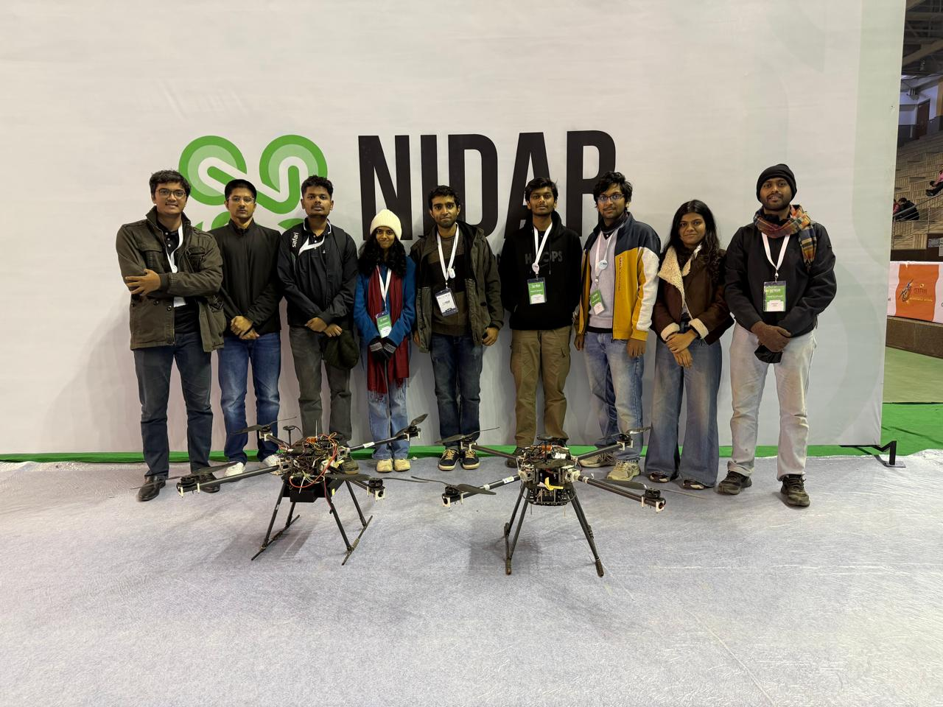
Technical Architecture:
- Two-agent system: Scout Drone (perception via Jetson Nano/Orin) + Delivery Drone (waypoint execution via Raspberry Pi).
- Perception pipeline at 25m altitude: YOLO-based human detection fused with Intel RealSense depth mapping and LiDAR distance estimation, combined with GPS coordinates to generate accurate geo-tags.
- 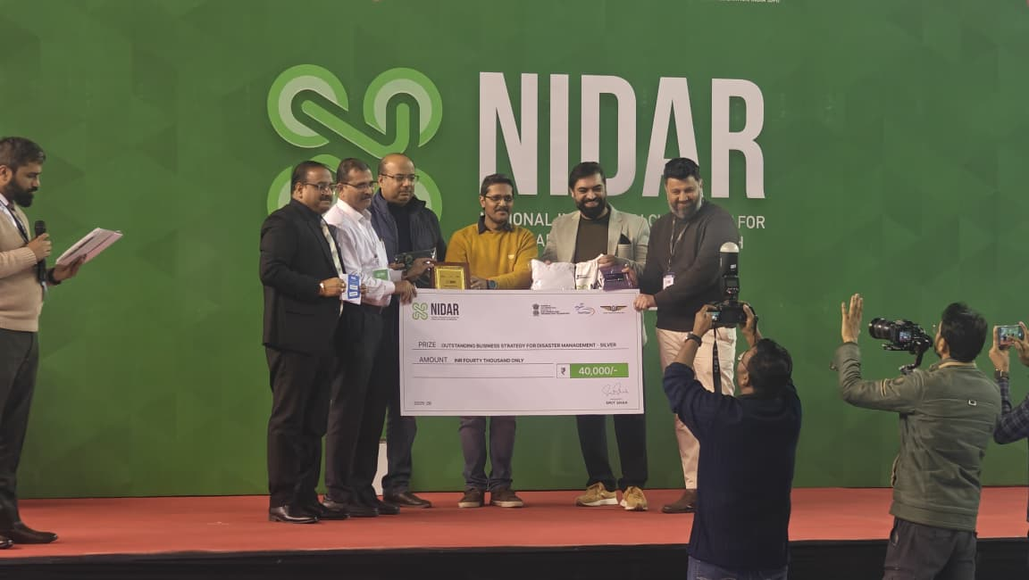
- Custom dual-drone web-based GCS: Flask servers (Ports 5000/5001) communicating with Pixhawks via pymavlink, aggregating live telemetry, map tracking, and GStreamer low-latency video into a central browser interface.

5. Republic Day Drone Show & Exhibition
Date: 26th January 2026
Location: COEP Main Building
High-precision, low-risk autonomous flight path executed to perform a synchronized flower shower over the national flag during the hoisting ceremony. Leveraged RTK positioning and magnetic payload drop mechanisms validated in the November logistics deployment. A public static exhibition also displayed the club's airframes, edge computing payloads, and custom GCS interfaces.
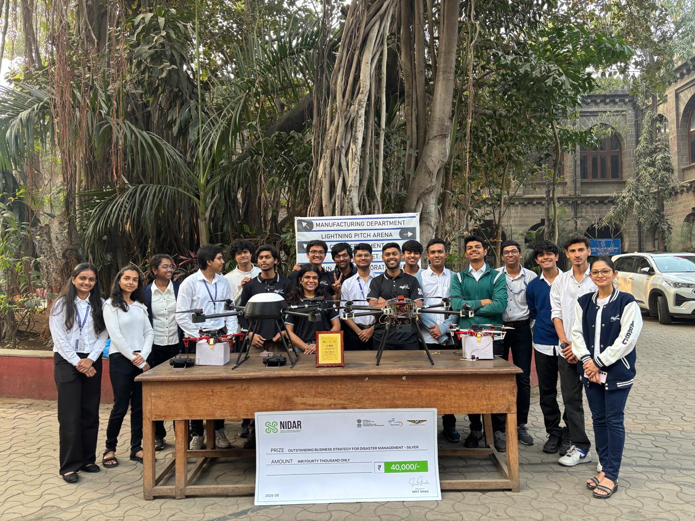

Strategic Blueprint & Future Roadmap 2026-27
ARSC is initiating a fundamental restructuring of its operational mandate — transitioning from an aeromodelling collective relying on Commercial-Off-The-Shelf (COTS) solutions to a 'House of Research and Innovation' rooted in First-Principles Engineering. The team is adopting the industry-standard V-Model of systems development (Design → Simulation → Fabrication → Verification via forensic .tlog/.ulog log analysis).

Core Technical Pillars
- Aeromechanics & Design — low-Reynolds number CFD analysis, FEA topology optimization for structural stiffness.
- Avionics & Telemetry — Link Budget calculations (Friis equations) for RF optimization; custom Power Distribution Boards with strict impedance matching.
- Software & GCS — polymorphic, mission-agnostic custom GCS dynamically adjusting UI based on MAVLink vehicle type.
- Robotics & Autonomy — full migration to ROS 2 (Humble/Iron); CNNs for vision-based navigation; ML-based vibration analysis for predictive hardware failure detection.

Flagship Research Tracks (Grand Challenges)
- Track Alpha – 'Sky-Mule' (UAM & Logistics): Hybrid VTOL platform for autonomous campus logistics. Target: NIDAR 2026 & SAE Aerothon.
- Track Beta – 'Cognitive Explorer' (Indoor Autonomy): GPS-denied drone with ROS 2 Active SLAM using A*/RRT* path planning via LiDAR and depth cameras. Target: Research Publication.
- Track Gamma – 'Swarm Nexus' (Networked Systems): Coordinated multi-agent flight with RTK-GPS and mesh networking. Target: Republic Day 2027 Drone Show.

Club Details
Secretary: Kshitij Rathi

